

|  |  |  |  |  |  |  |  |  |
| --- | --- | --- | --- | --- | --- | --- | --- | --- |
|  | | | | | | | | |
|  | | CSLR 51 : DBMS-LAB  LAB RECORD | | | | |  | |
|  |  | | | | | | |  |
|  | | | |  |  | | | |
|  | | | | Roll no. : 106119100Name : Rajneesh PandeySection : CSE-B |  | | | |
|  | | |  | | |  | | |

 Ex. No.:  01               Date:   13-08-21                  Week: 1

**Problem 1.** Consider the Following Database:

A software company wants to track project details

Employee(Empid , Empname, Address, Doj, Salary) : Empid as Primary key

Project (Projectno, Duration, Projectname) : Project no as Primary Key

Workson(Empid,Projno) :

Empid as Foreign key references Employee

Projectno as Foreign key references Project

**ER Diagram**

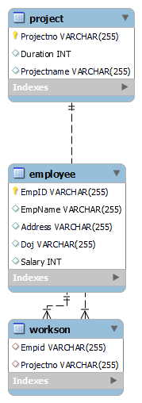

CREATE DATABASE companyDB;

1. Display the Employee details in the descending order based on name.

CREATE TABLE Employee(

  EmpID varchar(255) NOT NULL,

  EmpName varchar(255),

  Address varchar(255),

  Doj varchar(255),

  Salary int,

  UNIQUE (EmpID),

  PRIMARY KEY (EmpID)

  );

INSERT INTO Employee(EmpID, EmpName, Address, Doj, Salary)

VALUES

 ('001','Harry','3427 Hall Valley Drive','12/28/1984',59000),

 ('002','Wilson','3950 Rinehart Road','5/18/1983',42000),

 ('003','Mildred','4768 Scenicview Drive','6/21/1969',78000),

 ('004','Anderson','78 Heritage Road','10/21/1995',49000),

 ('005','Bob','856 Tenmile Road','10/13/1960',50000);

SELECT *

FROM Employee e

ORDER BY e.EmpName DESC;

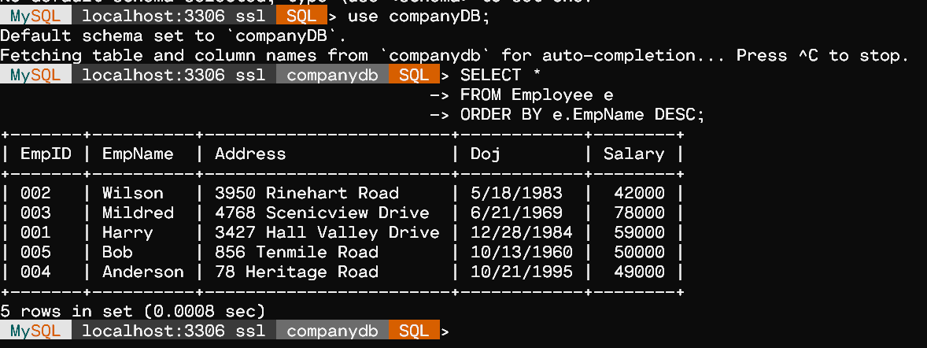

2. Display the project details if project id is given.

CREATE TABLE Project(

  Projectno varchar(255) NOT NULL,

  Duration int,

  Projectname varchar(255),

  UNIQUE (Projectno),

  PRIMARY KEY (Projectno)

  );

INSERT INTO Project(Projectno,Duration, Projectname)

VALUES

 ('P1',5,'WebSite'),

 ('P2',8,'Android App'),

 ('P3',10,'iOS App'),

 ('P4',12,'Machine Learning');

SELECT * FROM Project;

SELECT * FROM Project WHERE Projectno='P4';

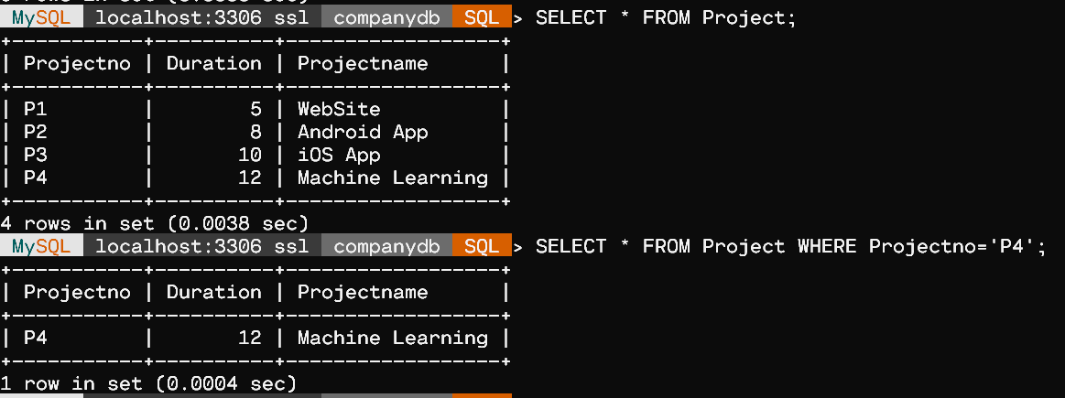

3. Display the employee names starting with ‘B'

SELECT EmpName

from Employee

where EmpName LIKE 'B%';

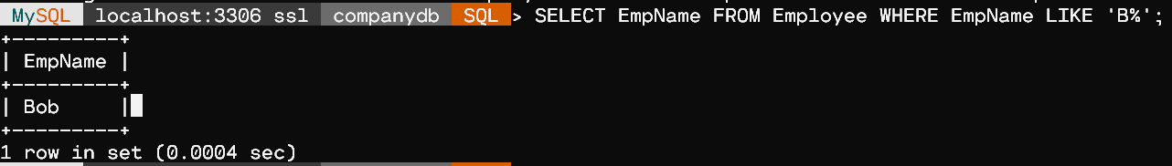

 4. Display the employee ID's working in a particular project if project no is given.

CREATE TABLE Workson(

  Empid varchar(255),

  Projectno  varchar(255),

  FOREIGN KEY (Empid) REFERENCES Employee(Empid),

  FOREIGN KEY (Projectno) REFERENCES Project(Projectno)

  );

INSERT INTO Workson(Projectno,Empid)

VALUES

  ('P3','002'),

  ('P2','004'),

  ('P1','003'),

  ('P4','001'),

  ('P2','005');

SELECT EmpID

FROM Workson

WHERE projectno = 'P2';

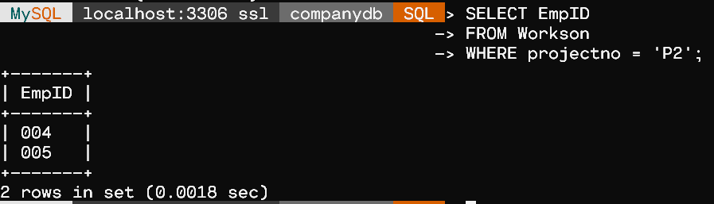

**Problem2.** Consider the Following Database:

Student(Rollno, Name, Marks(of 6 subjects),total) : Rollno as Primary key

Department(Deptid, Deptname, HOD name) and Deptid as Primary key

StudDep(Rollno, Deptid).

Rollno as foreign key references Student

Deptid as foreign key references Department

The total field is updated automatically

**ER Diagram:**

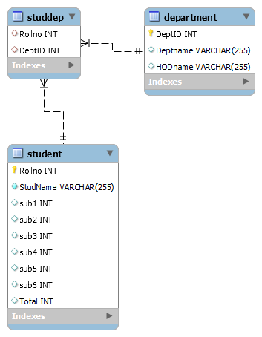

CREATE DATABASE collegeDB;

CREATE TABLE Student(

    Rollno int NOT NULL,

    StudName varchar(255) NOT NULL,

    sub1 int,

    sub2 int,

    sub3 int,

    sub4 int,

    sub5 int,

    sub6 int,

    Total int,

    UNIQUE (Rollno),

    PRIMARY KEY(Rollno)

);

CREATE TABLE Department(

    DeptID int NOT NULL,

    Deptname varchar(255),

    HODname varchar(255),

    UNIQUE (DeptID),

    PRIMARY KEY (DeptID)

);

CREATE TABLE StudDep(

    Rollno int,

    DeptID int,

    FOREIGN KEY (Rollno) REFERENCES Student(Rollno),

    FOREIGN KEY (DeptID) REFERENCES Department(DeptID)

);

1.Insert 10 student details and 3 department details. Insert details in the studdep table.

INSERT INTO Student(Rollno,StudName, sub1, sub2, sub3, sub4, sub5, sub6)

VALUES

 (1,'Amar',70,80,90,80,100,90),

 (2,'Shivam',80,90,80,100,90,70),

 (3,'Radha',80,100,90,70,70,40),

 (4,'Nitin',40,60,50,80,60,70),

 (5,'Ritik',50,50,60,100,90,70),

 (6,'Vaibhav',100,100,100,100,100,90),

 (7,'Kartik',10,4,50,80,100,90),

 (8,'Ram',80,90,80,100,90,70),

 (9,'Tom',90,80,100,90,50,90),

 (10,'Katy',90,80,100,90,100,100);

SET SQL_SAFE_UPDATES = 0;

UPDATE Student SET Total = sub1 + sub2 + sub3 + sub4 + sub5 + sub6;

INSERT INTO Department(DeptID,Deptname,HODname)

VALUES

 (1,'CSE','Dinesh'),

 (2,'Mech','Lakshmi'),

 (3,'ECE','Surya');

INSERT INTO StudDep(Rollno,DeptID)

VALUES

 (1,1),

 (2,1),

 (3,3),

 (4,2),

 (5,1),

 (6,2),

 (7,1),

 (8,3),

 (9,3),

 (10,2);

2.Display the Student details if deptid is given.

SELECT *

FROM Student

WHERE Rollno IN

(SELECT Rollno

FROM StudDep

WHERE DeptID=1

);

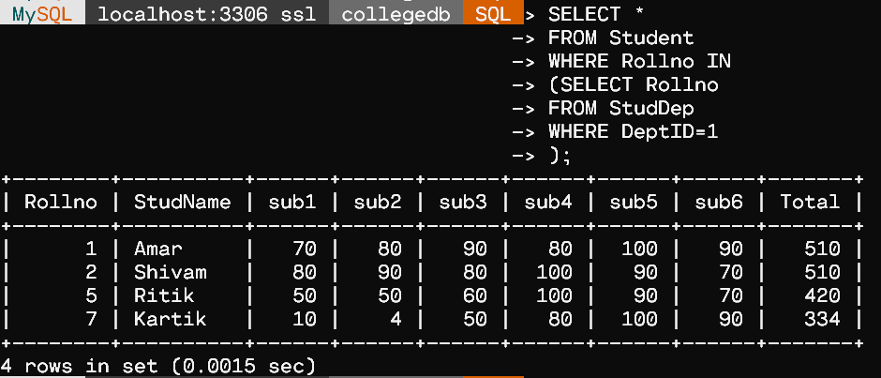

 3.Display the department details if rollno is given

SELECT *

FROM Department

WHERE DeptID IN

(SELECT DeptID

FROM StudDep

WHERE Rollno=5

);

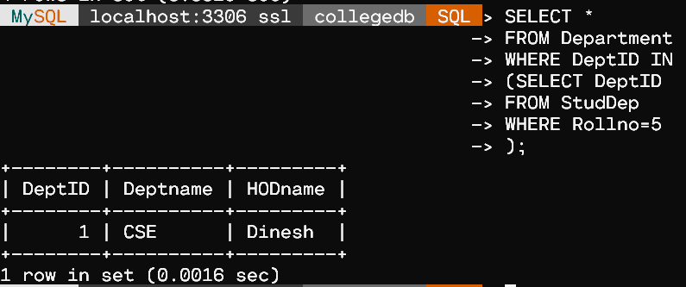

4.Display the student names who got total greater than 500

SELECT StudName

FROM Student

WHERE Total>500;

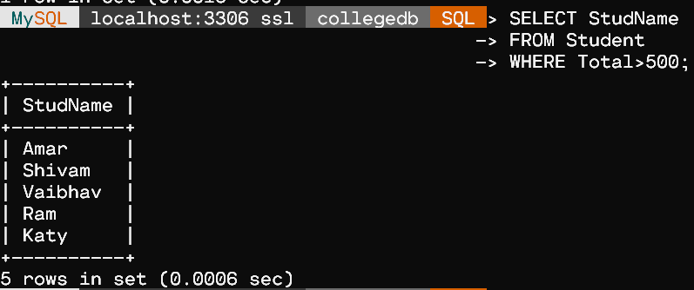

5.Display the HOD name of the CSE department

SELECT HODName

FROM Department

WHERE Deptname='CSE';

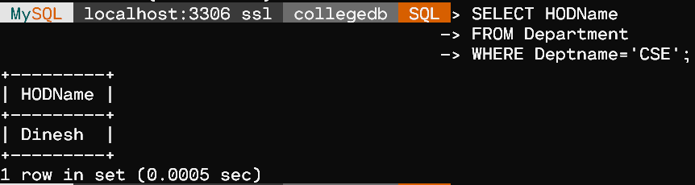

 6.Display the student rollnos of the CSE department

SELECT Rollno

FROM StudDep

WHERE DeptID IN

(SELECT DeptID

FROM Department

WHERE Deptname='CSE'

);

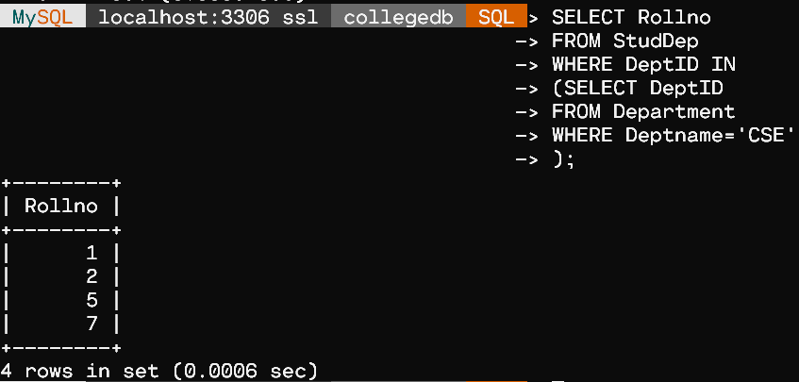

**Problem 3**.Consider the Following Database:

salesperson(ssn, name, start_year, dept_no)

ssn – Primary Key

trip(ssn, from_city, to_city, departure_date, return_date, trip_id))

ssn – Foreign key

trip_id – Primary key

salerep_expense(trip_id, expense_type,amount)

trip_id – Foreign key

The expense types are ‘TRAVEL’, ‘STAY’ and ‘FOOD’

**ER DIAGRAM**

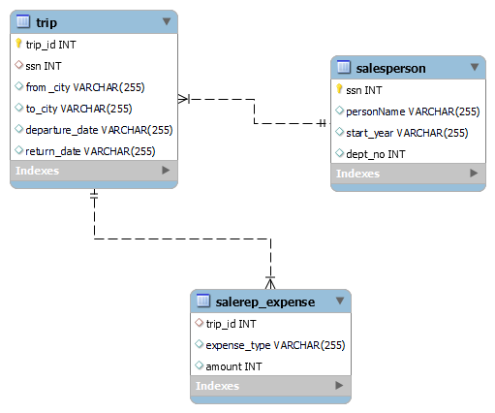

 CREATE DATABASE vacationDB;

CREATE TABLE salesperson(

  ssn int NOT NULL,

  personName varchar(255),

  start_year varchar(255),

  dept_no int,

  UNIQUE (ssn),

  PRIMARY KEY (ssn)

  );

CREATE TABLE trip(

  trip_id int NOT NULL,

  ssn int,

  from_city varchar(255),

  to_city varchar(255),

  departure_date varchar(255),

  return_date varchar(255),

  UNIQUE (trip_id),

  PRIMARY KEY (trip_id),

  FOREIGN KEY (ssn) REFERENCES salesperson(ssn)

  );

CREATE TABLE salerep_expense(

  trip_id int,

  expense_type  varchar(255),

/* The expense types are ‘TRAVEL’, ‘STAY’ and ‘FOOD’ */

  amount int,

  FOREIGN KEY (trip_id) REFERENCES trip(trip_id)

  );

INSERT INTO salesperson(ssn,personName,start_year,dept_no)

VALUES

 (1000,'Harry','12/28/1984',100),

 (2000,'Wilson','5/18/1983',200),

 (3000,'Mildred','6/21/1969',300),

 (4000,'Anderson','10/21/1995',400),

 (5000,'Bob','10/13/1960',500);

INSERT INTO trip(trip_id,from_city,to_city,departure_date,return_date,ssn)

VALUES

 (1,'Mandu','Sanchi','2021-09-13','2021-10-01',2000),

 (2,'Khajuraho','Chennai','2021-08-24','2021-09-27',1000),

 (3,'Ujjain','Bhopal','2021-11-01','2021-12-20',5000),

 (4,'Orchha','Indore','2021-12-27','2022-01-15',3000),

 (5,'Pachmarhi','Chennai','2021-11-23','2021-12-20',4000),

 (6,'Jammu','Chennai','2021-11-20','2021-12-20',4000);

INSERT INTO salerep_expense(trip_id,expense_type,amount)

VALUES

 (1,'TRAVEL',2000),

 (2,'TRAVEL',1500),

 (3,'TRAVEL',2100),

 (4,'TRAVEL',1300),

 (5,'TRAVEL',1800),

 (6,'TRAVEL',1000),

 (1,'STAY',500),

 (2,'STAY',600),

 (4,'STAY',620),

 (6,'STAY',600),

 (1,'FOOD',800),

 (2,'FOOD',100),

 (3,'FOOD',700),

 (4,'FOOD',600);

1.Give the details(all attributes of trip relation)for trips that exceed Rs2000

    SELECT trip_id,from_city,to_city,departure_date,return_date

    FROM

    (SELECT trip.trip_id,trip.from_city,trip.to_city,trip.departure_date,trip.return_date,sum(salerep_expense.amount) total

    FROM trip left join salerep_expense

    ON trip.trip_id = salerep_expense.trip_id

    GROUP BY trip.trip_id) data

    WHERE data.total>2000;

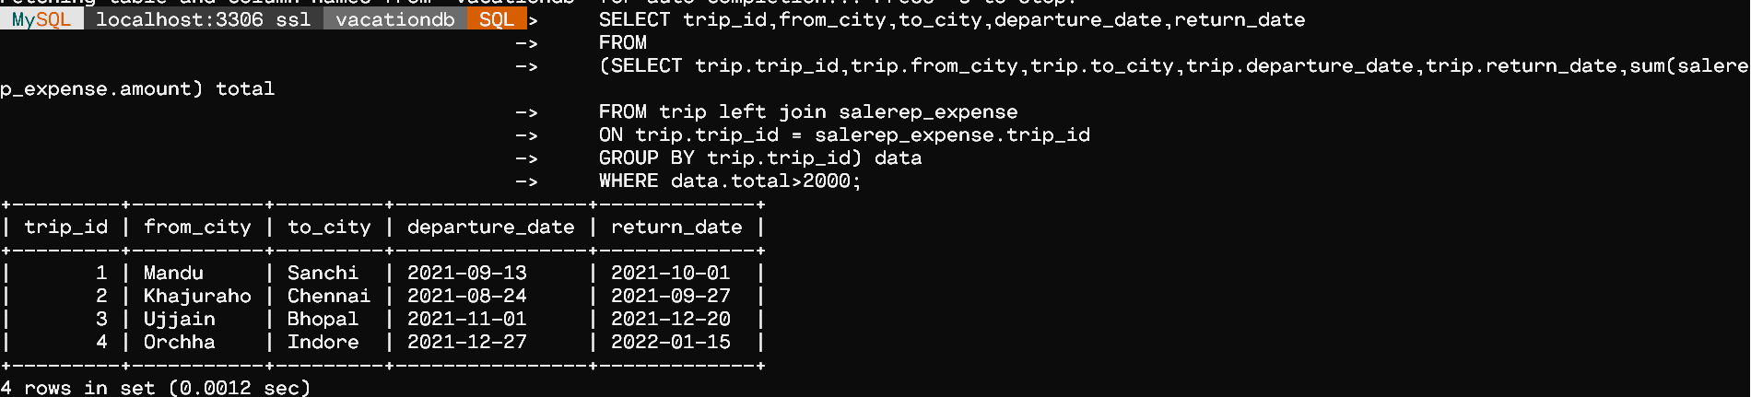

2.Print the ssn of salesperson who took trips to chennai more than once

    SELECT ssn

    FROM salesperson sp

    WHERE 1 <

        (SELECT COUNT(*)

         FROM trip

         WHERE ssn = sp.ssn AND to_city='Chennai');

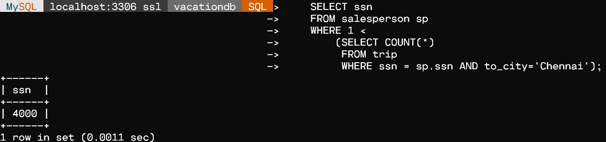

3.Print the total trip expenses incurred by the salesperson with ssn = 1000

    SELECT sum(salerep_expense.amount) total

    FROM trip left join salerep_expense

    ON trip.trip_id = salerep_expense.trip_id

    GROUP BY trip.ssn = 1000;

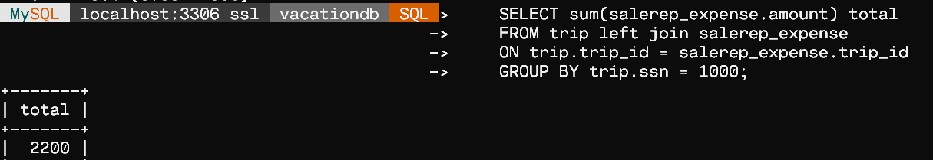

4.Display the salesperson details in the sorted order based on name

    SELECT *

    FROM salesperson sp

    ORDER BY sp.personName ASC;

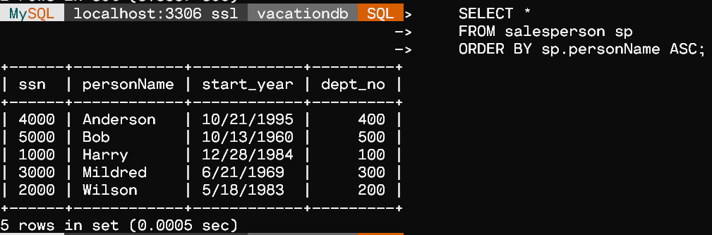

**Problem 4.** Consider the Following Database:

car(serial_no, model, manufacturer, price)

serial_no – Primary key

options(serial_no, option_name, price)

serial_no – Foreign key

sales(salesperson_id, serial_no, date, sale_price)

serial_no – Foreign key

salesperson_id – Foreign key

salesperson(salesperson_id, name, phone)

salesperson_id – Primary key

**ER DIAGRAM**

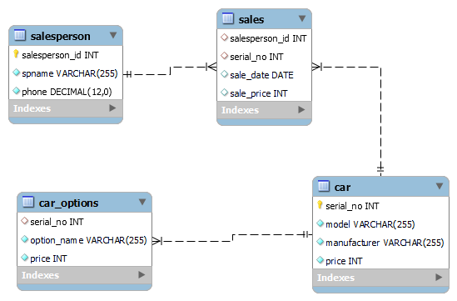

CREATE DATABASE carDB;

CREATE TABLE Car(

    serial_no int NOT NULL,

    model varchar(255) NOT NULL,

    manufacturer varchar(255) NOT NULL,

    price int NOT NULL,

    UNIQUE (serial_no),

    PRIMARY KEY(serial_no)

);

CREATE TABLE salesperson(

    salesperson_id int NOT NULL,

    spname varchar(255) NOT NULL,

    phone DECIMAL(12) NOT NULL,

    UNIQUE (salesperson_id),

    PRIMARY KEY(salesperson_id)

);

CREATE TABLE car_options(

    serial_no int,

    option_name varchar(255) NOT NULL,

    price int NOT NULL,

    FOREIGN KEY (serial_no) REFERENCES Car(serial_no)

);

CREATE TABLE sales(

    salesperson_id int,

    serial_no int,

    sale_date DATE,

    sale_price int,

    FOREIGN KEY (serial_no) REFERENCES Car(serial_no),

    FOREIGN KEY (salesperson_id) REFERENCES salesperson(salesperson_id)

);

INSERT INTO Car(serial_no,model,manufacturer,price)

VALUES

 (1,'Swift','Suzuki',700000),

 (2,'City','Honda',900000),

 (3,'Nano','Tata',500000),

 (4,'Fortuner','Toyota',1000000);

INSERT INTO salesperson(salesperson_id,spname,phone)

VALUES

 (1,'John',8168915356),

 (2,'Tom',9368570708),

 (3,'Martin',7895247308);

INSERT INTO car_options(serial_no,option_name,price)

VALUES

 (1,'Black',850000),

 (1,'Blue',760000),

 (1,'White',900000),

 (2,'Black',850000),

 (2,'Blue',760000),

 (4,'Blue',760000),

 (4,'White',900000);

INSERT INTO sales(salesperson_id,serial_no,sale_date,sale_price)

VALUES

 (2,1,'2021-01-15',850000),

 (1,2,'2021-04-07',750000),

 (3,3,'2021-03-23',600000),

 (1,4,'2021-03-12',900000);

1. For the sales person named ‘John’ list the following information for all the cars sold :

                serial no, manufacturer, sale_price

    SELECT *

    FROM Car

    WHERE serial_no IN(

        SELECT serial_no

        FROM sales

        WHERE salesperson_id=

            (SELECT salesperson_id FROM salesperson WHERE spname='John')

    );

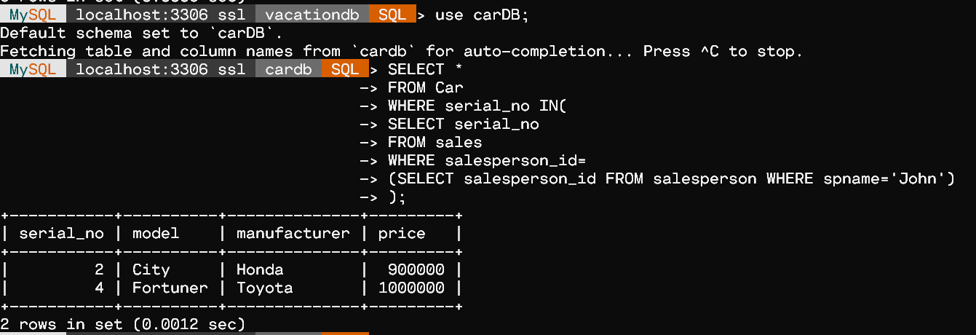

2.List the serial_no and model of cars that have no options

    SELECT serial_no,model

    FROM

    (SELECT Car.serial_no,Car.model,car_options.option_name

    FROM Car left join car_options

    ON Car.serial_no = car_options.serial_no

    GROUP BY Car.serial_no) data

    WHERE data.option_name IS NULL;

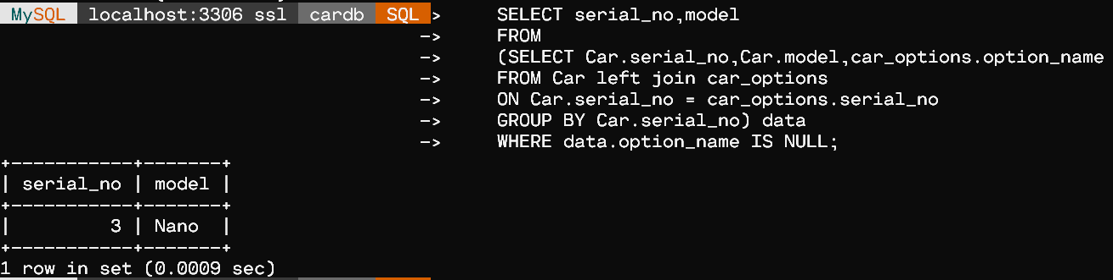

3.List the serial_no, model, sale_price for the cars that have optional parts.

    SELECT serial_no,model,SP

    FROM

    (SELECT Car.serial_no,Car.model,car_options.option_name, (SELECT sale_price FROM sales WHERE serial_no = Car.serial_no) SP

    FROM Car left join car_options

    ON Car.serial_no = car_options.serial_no

    GROUP BY Car.serial_no) data

    WHERE data.option_name IS NOT NULL;

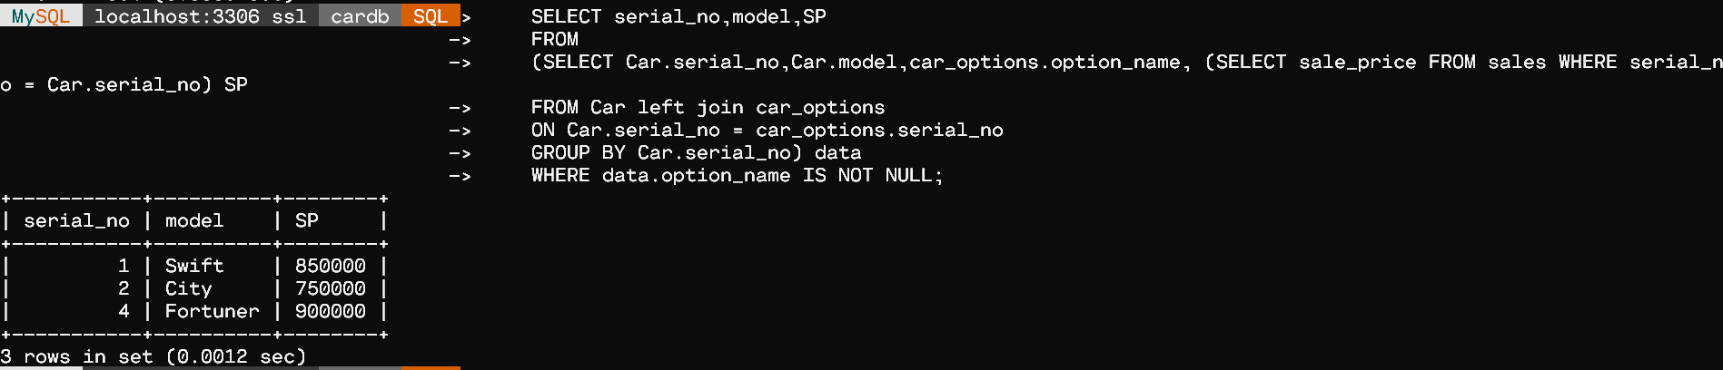

4.Modify the phone no of a particular sales person

    UPDATE salesperson

    SET phone = 8941999954

    WHERE spname='Tom';

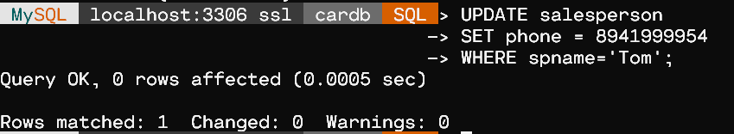

    SELECT * FROM salesperson;

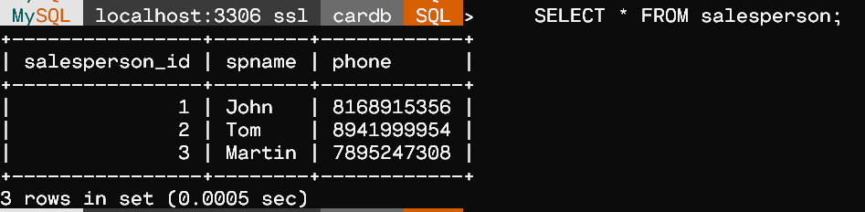

Ex. No.:  02               Date:   19-08-21                  Week:2

PROBLEM 1

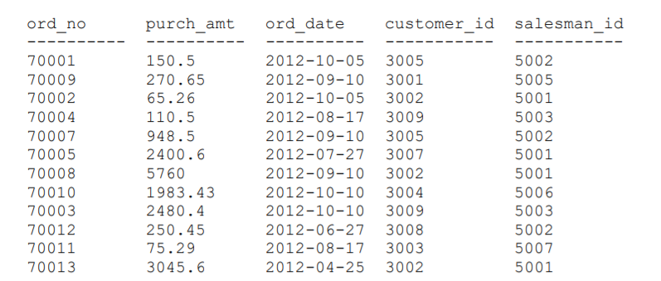

**ER Diagram :**

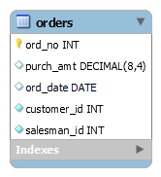

CREATE DATABASE purchaseDB;

CREATE TABLE orders(

  ord_no int NOT NULL,

  purch_amt DECIMAL(8,4),

  ord_date DATE,

  customer_id int NOT NULL,

  salesman_id int NOT NULL,

  PRIMARY KEY(ord_no)

  );

INSERT INTO orders(ord_no,purch_amt,ord_date, customer_id,salesman_id)

VALUES

(70001, 150.5, '2012-10-05', 3005, 5002),

(70009, 270.65, '2012-09-10', 3001, 5005),

(70002, 65.26, '2012-10-05', 3002, 5001),

(70004, 110.5, '2012-08-17', 3009, 5003),

(70007, 948.5, '2012-09-10', 3005, 5002),

(70005, 2400.6, '2012-07-27', 3007, 5001),

(70008, 5760, '2012-09-10', 3002, 5001),

(70010, 1983.43, '2012-10-10', 3004, 5006),

(70003, 2480.4, '2012-10-10', 3009, 5003),

(70012, 250.45, '2012-06-27', 3008, 5002),

(70011, 75.29, '2012-08-17', 3003, 5007),

(70013, 3045.6, '2012-04-25', 3002, 5001);

/* Queries */

SELECT * FROM orders;

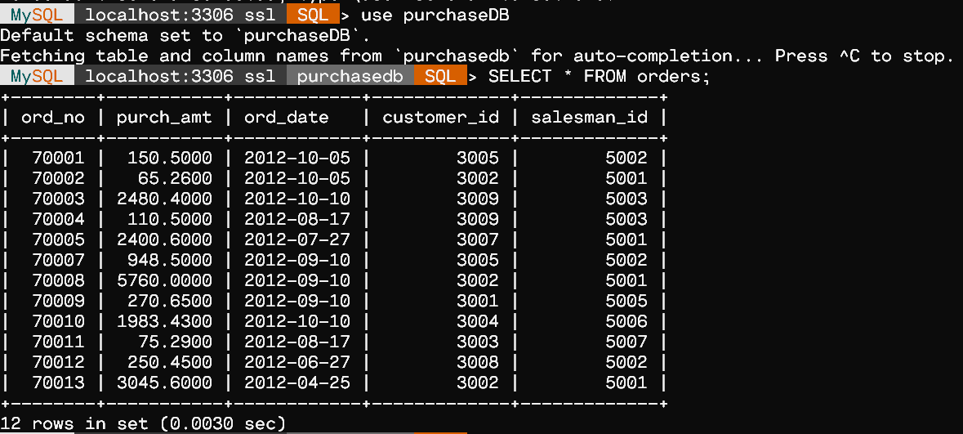

/* 1. From the given table, Write a SQL statement to get the minimum

purchase amount of all the orders. */

SELECT MIN(purch_amt)

FROM orders;

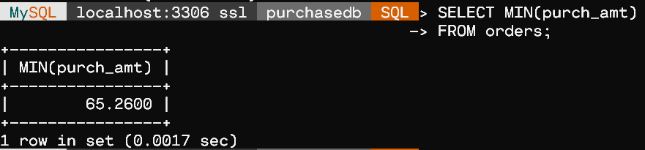

/* 2. From the given table, Write a SQL statement to get the maximum

purchase amount of all the orders. */

SELECT MAX(purch_amt)

FROM orders;

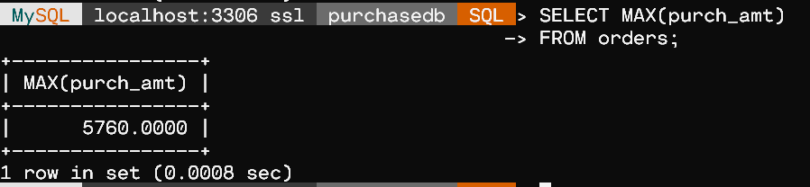

/* 3. From the given table, Write a SQL statement to get the total purchase

amount of all the orders.*/

SELECT SUM(purch_amt)

FROM orders;

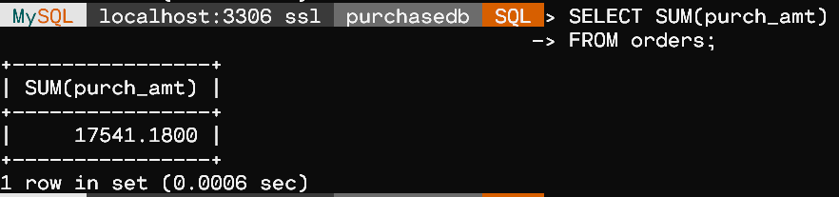

/* 4. From the given table,Write a SQL statement to get the average

purchase amount of all the orders. */

SELECT AVG(purch_amt)

FROM orders;

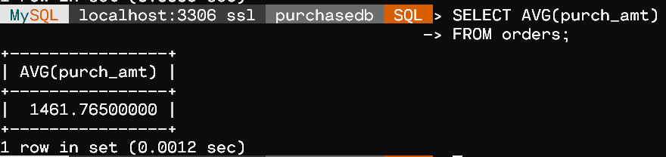

/* 5. From the given table, write a SQL query to count the number of

customers. Return number of customers. */

SELECT COUNT(*)

FROM orders;

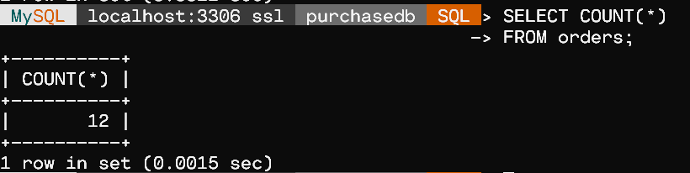

/* 6. In the above table, add a new column “warranty” which is six months

from the date of order.*/

ALTER TABLE orders

ADD warranty DATE default (adddate(ord_date, interval 6 month));



SELECT * FROM orders;

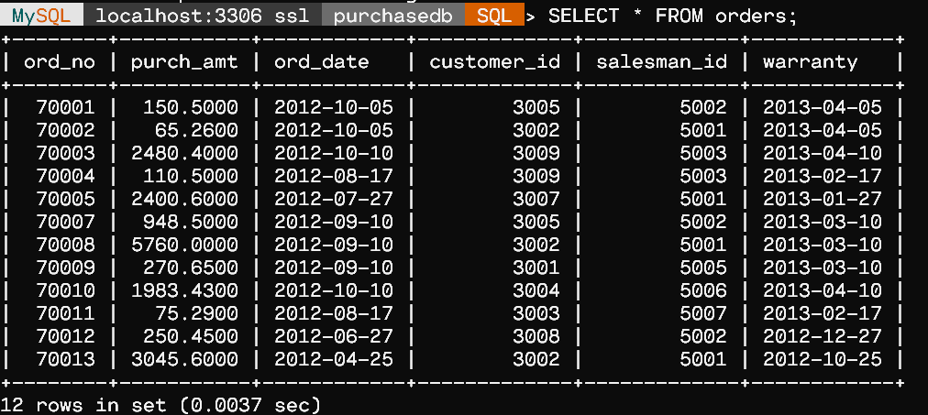

/* 7. From the given table, Find out the most recently purchased order and

least recently purchased order using the ord_date.*/

SELECT MIN(ord_date) AS LEAST_RECENTLY_USED, MAX(ord_date)

AS MOST_RECENTLY_USED from orders;

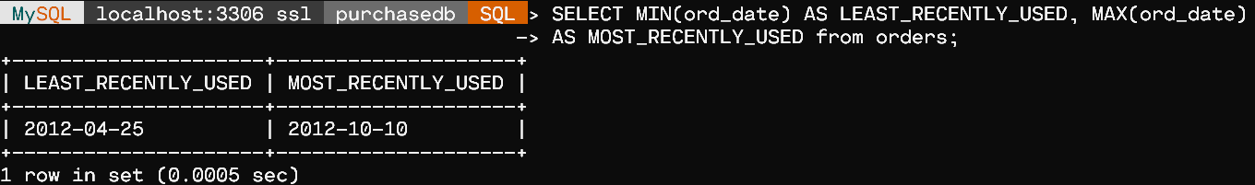

/* 8. From the given table, find and display the next day of order.*/

SELECT ord_no,ADDDATE(ord_date,INTERVAL 1 DAY)

AS NEXT_DAY FROM orders;

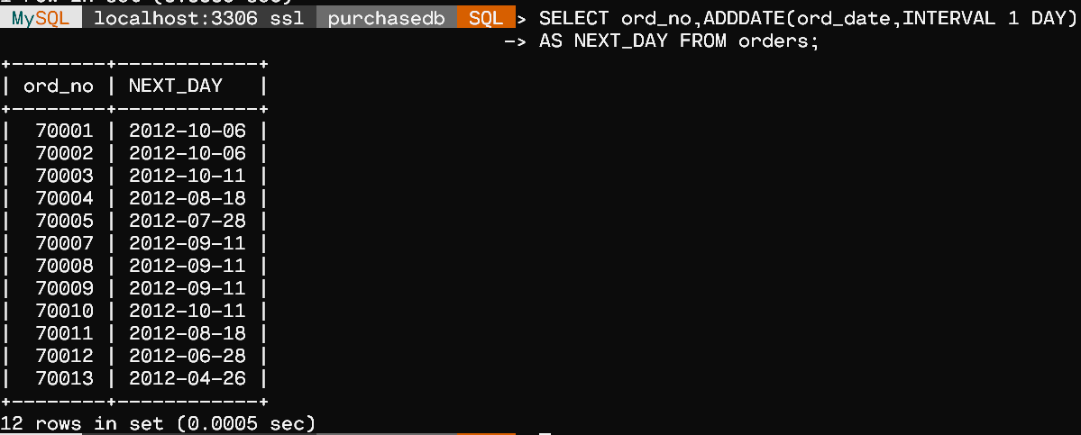

/* 9. From the given table, print the smallest and largest integer just smaller

and larger than the purchase amount.*/

SELECT ord_no, CEIL(purch_amt) AS JUST_BIGGER FROM orders;

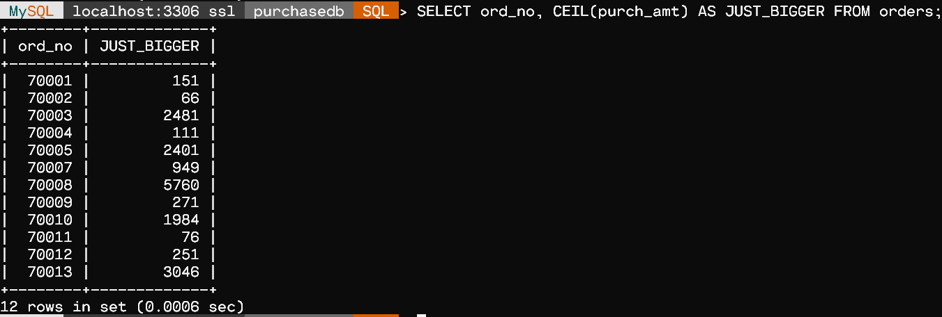

SELECT ord_no, FLOOR(purch_amt) AS JUST_SMALLER FROM orders;

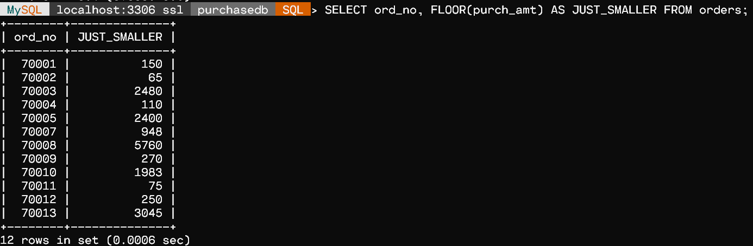

/*10. Explore the round function with various parameter settings on the column purchase amount.*/

- The ROUND() function rounds a number to a specified number of decimal places.

SELECT ord_no,ROUND(purch_amt, 3) AS ROUNDED_UPTO_2_DECIMAL FROM orders;

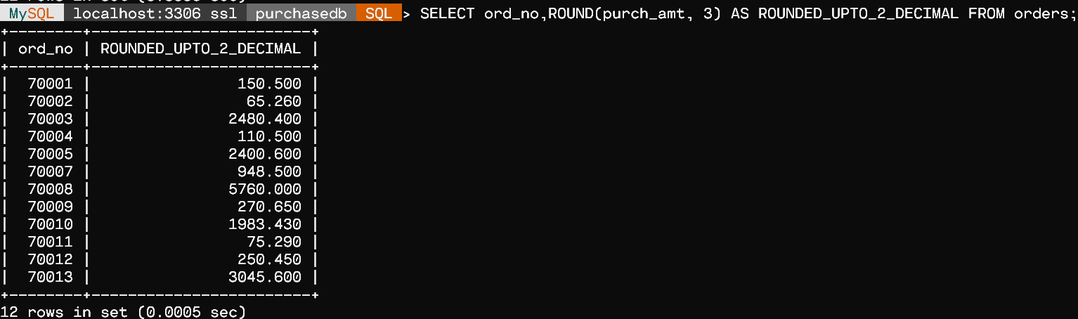

/* But If the 2nd Parameter is given Negative, then it rounds off upto Units Place,Tens.

SELECT ord_no,ROUND(purch_amt, -1) AS ROUNDED_UPTO_TENS FROM orders;

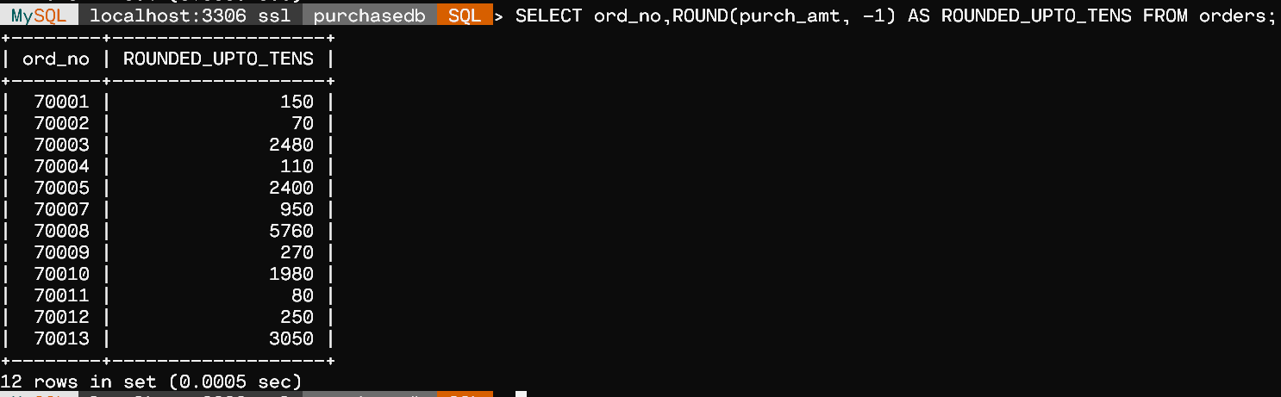

PROBLEM 2

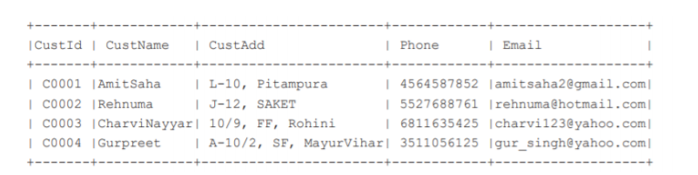

**ER Diagram :**

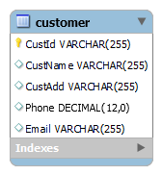

CREATE DATABASE customerDB;

CREATE TABLE customer(

CustId varchar(255) NOT NULL,

CustName varchar(255),

CustAdd varchar(255),

Phone DECIMAL(12),

Email varchar(255),

PRIMARY KEY(CustId)

);

INSERT INTO customer (CustId,CustName ,CustAdd ,Phone ,Email )

 VALUES

( 'C0001' ,'AmitSaha' , 'L-10, Pitampura' , 4564587852 ,'amitsaha2@gmail.com'),

( 'C0002' ,'Rehnuma', 'J-12, SAKET' ,5527688761 ,'rehnuma@hotmail.com'),

( 'C0003' ,'CharviNayyar', '10/9, FF, Rohini' , 6811635425 ,'charvi123@yahoo.com'),

( 'C0004' ,'Gurpreet' , 'A-10/2, SF, MayurVihar', 3511056125 ,'gur_singh@yahoo.com');

/* Queries */

SELECT * FROM customer;

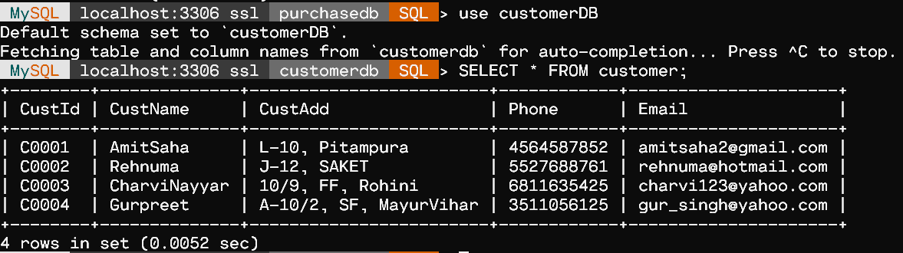

- 1. Display customer name in lower case and customer email in upper case from table CUSTOMER.

SELECT LOWER(CustName), UPPER(Email)

FROM customer;

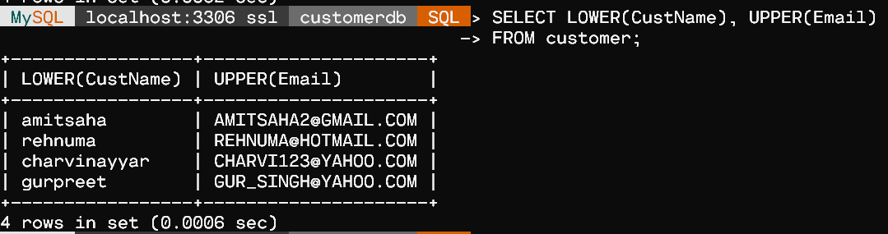

- 2. Display emails after removing the domain name extension “.com” from emails of the customers.

SELECT TRIM('.com' from Email) 'Email without .com'

FROM customer;

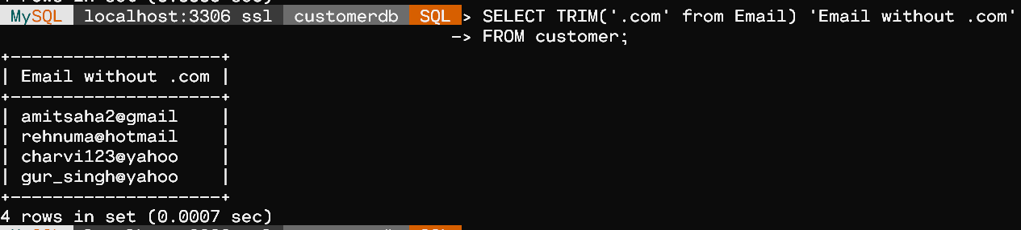

-- 3. Display the length of the customer name.

SELECT CustName, LENGTH(CustName)  'Length of Names'

FROM customer;

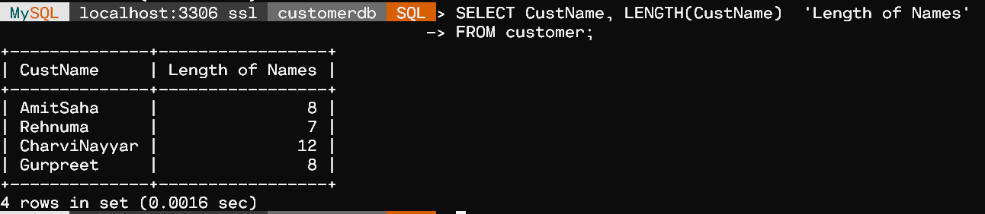

-- 4. Display the custid and CustName joined together and the numeric position of the letter A in the Customer name.

SELECT CONCAT(CustID,CustName) AS ID_AND_NAMES, LOCATE ('a',CustName) 'Position'

FROM customer;

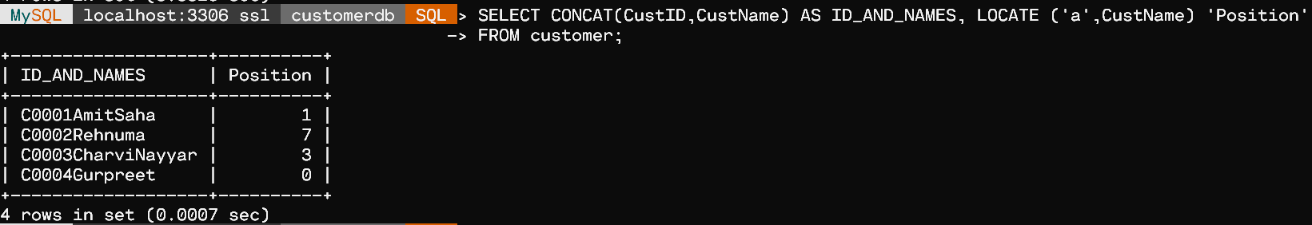

-- 5. Write a SQL statement to display the data for those customers whose names end with ‘a’.

SELECT * FROM customer WHERE CustName LIKE '%a';

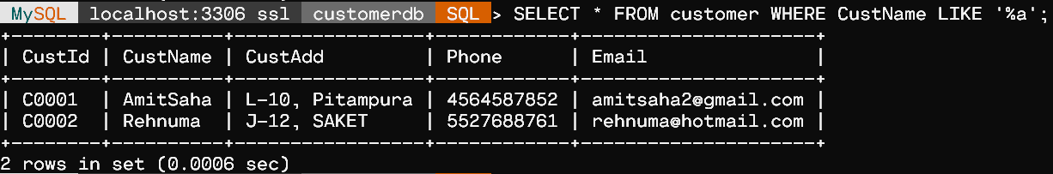

- 6. Extract a substring from email starting at position 2 and 3 characters long.

SELECT SUBSTRING(Email,2,3) 'Substring 3 len'

FROM customer;

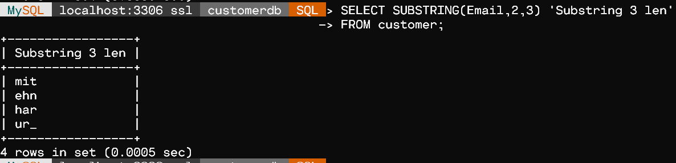

-- 7. Extract 20 character string from Customer Address starting with position 1.

SELECT SUBSTRING(CustAdd,1,20) 'Address 20 chars'

FROM customer;

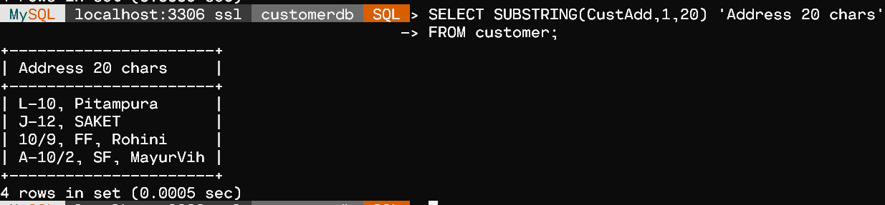

Ex. No.:  03              Date:   25-08-21                  Week:3

PROBLEM 1

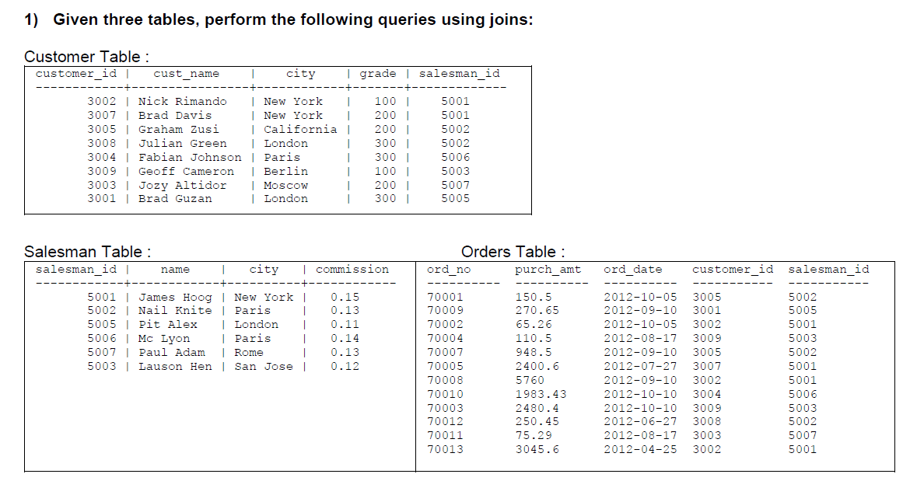

**ER Diagram :**

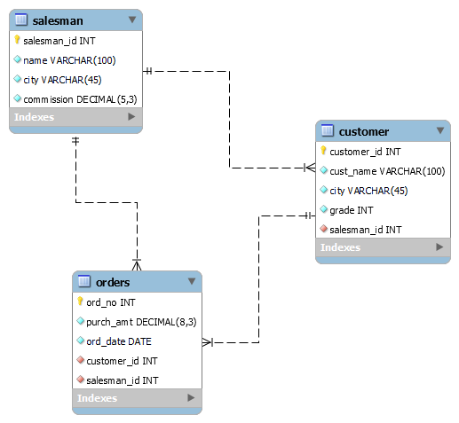

CREATE DATABASE salesDB;

CREATE TABLE salesman (

  `salesman_id` INT NOT NULL,

  `name` VARCHAR(100) NOT NULL,

  `city` VARCHAR(45) NOT NULL,

  `commission` DECIMAL(5,3) NOT NULL,

  PRIMARY KEY (`salesman_id`)

  );

CREATE TABLE customer (

  `customer_id` INT NOT NULL,

  `cust_name` VARCHAR(100) NOT NULL,

  `city` VARCHAR(45) NOT NULL,

  `grade` INT NOT NULL,

  `salesman_id` INT NOT NULL,

  PRIMARY KEY (`customer_id`),

  INDEX `salesman_id_idx` (`salesman_id` ASC) VISIBLE,

  CONSTRAINT `salesman_id`

    FOREIGN KEY (`salesman_id`)

    REFERENCES `salesDB`.`salesman` (`salesman_id`)

    ON DELETE NO ACTION

    ON UPDATE NO ACTION

    );

CREATE TABLE orders(

  `ord_no` INT NOT NULL,

  `purch_amt` DECIMAL(8,3) NOT NULL,

  `ord_date` DATE NOT NULL,

  `customer_id` INT NOT NULL,

  `salesman_id` INT NOT NULL,

    PRIMARY KEY (`ord_no`),

    FOREIGN KEY (`customer_id`)

    REFERENCES `salesDB`.`customer` (`customer_id`),

    FOREIGN KEY (`salesman_id`)

    REFERENCES `salesDB`.`salesman` (`salesman_id`)

    );

INSERT INTO salesman (`salesman_id`, `name`, `city`, `commission`)

VALUES

        ('5001', 'James Hoog', 'New York', '0.15'),

        ('5002', 'Nail Knite', 'Paris', '0.13'),

        ('5005', 'Pit Alex', 'London', '0.11'),

        ('5006', 'Mc Lyon', 'Paris', '0.14'),

        ('5007', 'Paul Adam', 'Rome', '0.13'),

        ('5003', 'Lauson Hen', 'San Jose', '0.12');

INSERT INTO customer (`customer_id`, `cust_name`, `city`, `grade`, `salesman_id`)

VALUES

        ('3002', 'Nick Rimando', 'New York', '100', '5001'),

        ('3007', 'Brad Davis', 'New York', '200', '5001'),

        ('3005', 'Graham Zusi', 'California', '200', '5002'),

        ('3008', 'Julian Green', 'London', '300', '5002'),

        ('3004', 'Fabian Johnson', 'Paris', '300', '5006'),

        ('3009', 'Geoff Cameroon', 'Berlin', '100', '5003'),

        ('3003', 'Jozy Altidor', 'Moscow', '200', '5007'),

        ('3001', 'Brad Guzan', 'London', '200', '5005');

INSERT INTO orders (`ord_no`, `purch_amt`, `ord_date`, `customer_id`, `salesman_id`)

VALUES

        ('70001', '150.5', '2012-10-05', '3005', '5002'),

        ('70009', '270.65', '2012-09-10', '3001', '5005'),

        ('70002', '65.26', '2012-10-05', '3002', '5001'),

        ('70004', '110.5', '2012-08-17', '3009', '5003'),

        ('70007', '948.5', '2012-09-10', '3005', '5002'),

        ('70005', '2400.6', '2012-07-27', '3007', '5001'),

        ('70008', '5760', '2012-09-10', '3002', '5001'),

        ('70010', '1983.43', '2012-10-10', '3004', '5006'),

        ('70003', '2480.4', '2012-10-10', '3009', '5003'),

        ('70012', '250.45', '2012-06-27', '3008', '5002'),

        ('70011', '75.29', '2012-08-17', '3003', '5007'),

        ('70013', '3045.6', '2012-04-25', '3002', '5001');

**Query :-**

Show Tables :

SELECT * FROM salesman;

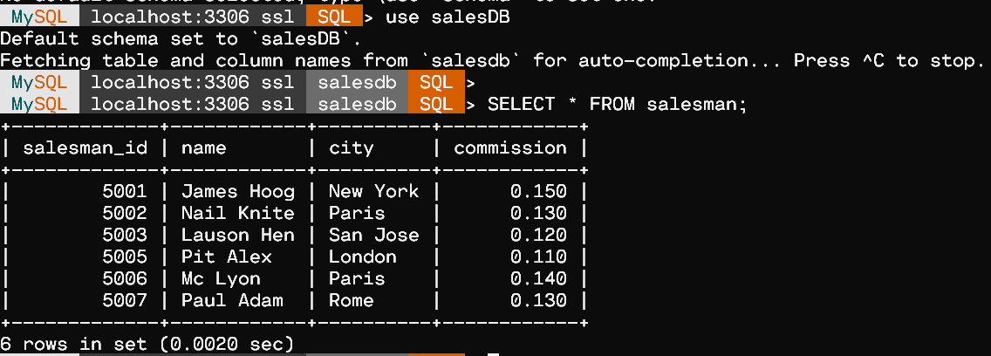

SELECT * FROM customer;

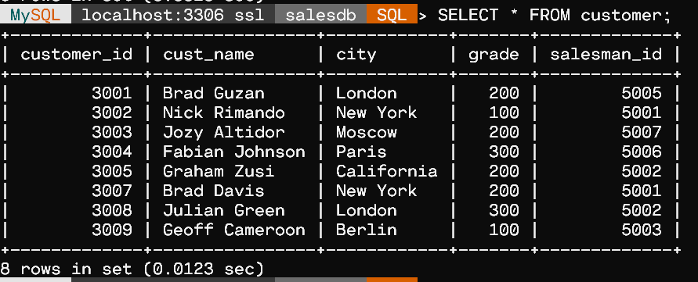

SELECT * FROM orders;

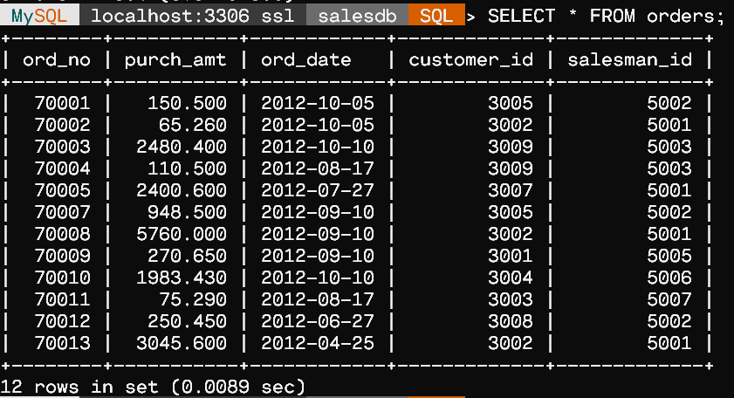

a) Write a SQL query to find those salespersons who received a commission from the company more than 12%.Return Customer Name,customercity, Salesman, commission (Use Inner join)

SELECT c.cust_name AS "Customer Name", c.city, s.name AS "Salesman", s.commission

  FROM customer c

  INNER JOIN salesman s

    ON c.salesman_id = s.salesman_id

  WHERE s.commission > 0.12;

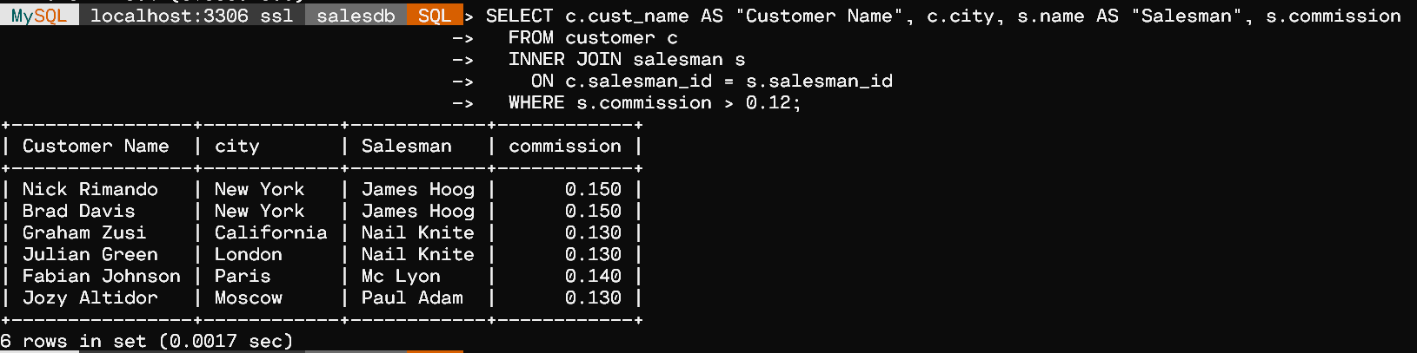

b) Write a SQL statement to make a report with customer name, city,order number, order date,and order amount in ascending order according to the order date to find that either any of the existing customers have placed no order or placed one or more orders. (Use left outer join)

SELECT c.cust_name AS "Customer Name", c.city, o.ord_no, o.ord_date, o.purch_amt

  FROM customer c

  LEFT OUTER JOIN orders o

    ON c.customer_id=o.customer_id

  ORDER BY o.ord_date;

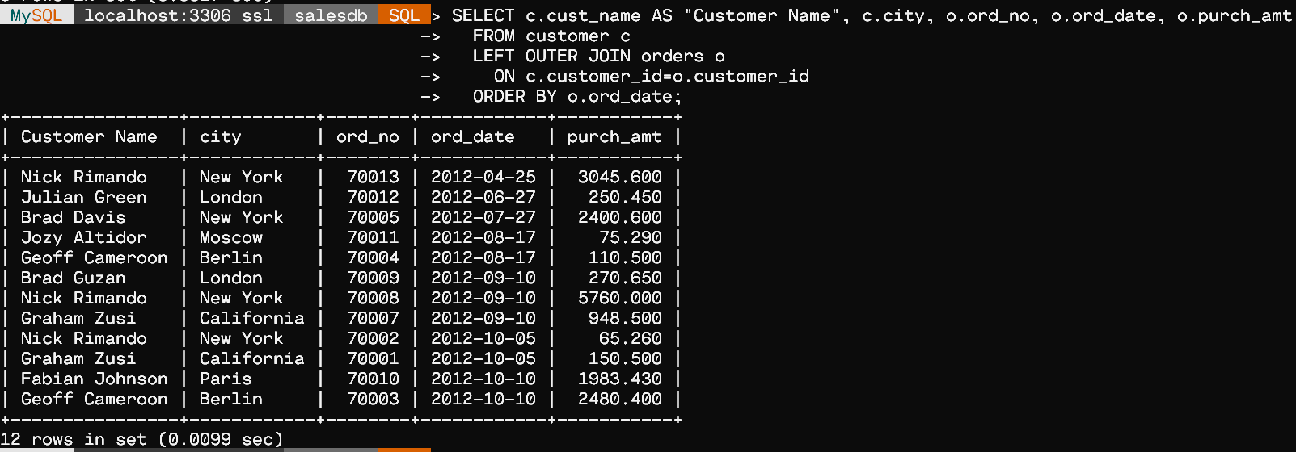

c) Write a SQL statement to make a report with customer name, city,order number, order date, order amount salesman name and commission tofind that either any of the existing customers have placed no orde or placed one or more orders by their salesman or by own.

SELECT c.cust_name AS "Customer Name",c.city,o.ord_no,o.ord_date,o.purch_amt,s.name AS "Salesman",

       s.commission

  FROM customer c

  LEFT OUTER JOIN orders o

    ON c.customer_id=o.customer_id

  LEFT OUTER JOIN salesman s

    ON c.salesman_id=s.salesman_id;

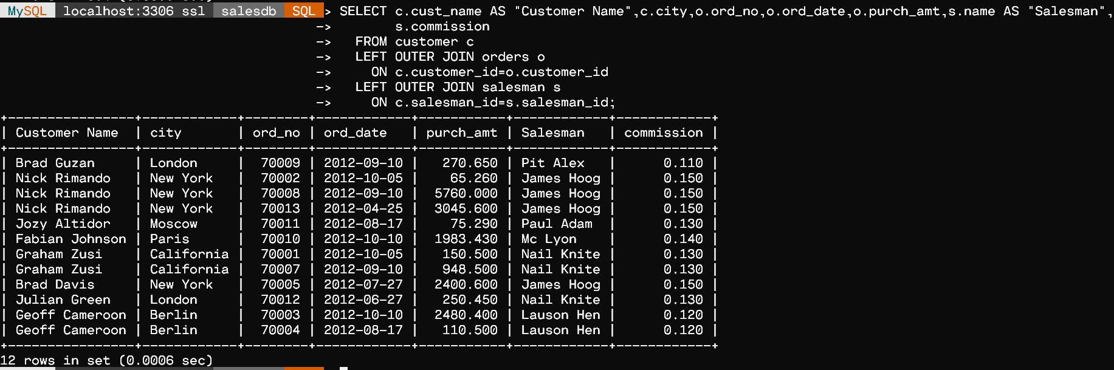

d) Write a SQL statement to make a list in ascending order for the salesmenwho works either for one or more customer or not yet join under and of the customers. (Use Right outer join)

SELECT s.name AS "Salesman"

  FROM salesman s

  RIGHT OUTER JOIN customer c

    ON s.salesman_id=c.salesman_id

  ORDER BY c.salesman_id ASC;

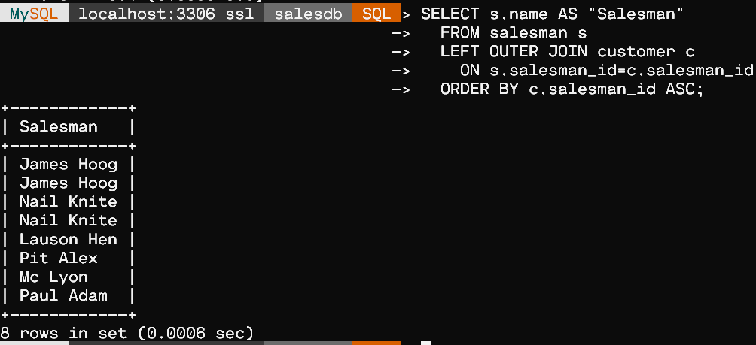

e) Write a SQL query to combine each row of salesman table with each row of customer table. (Use cross join)

SELECT *

    FROM salesman a

    CROSS JOIN customer b;

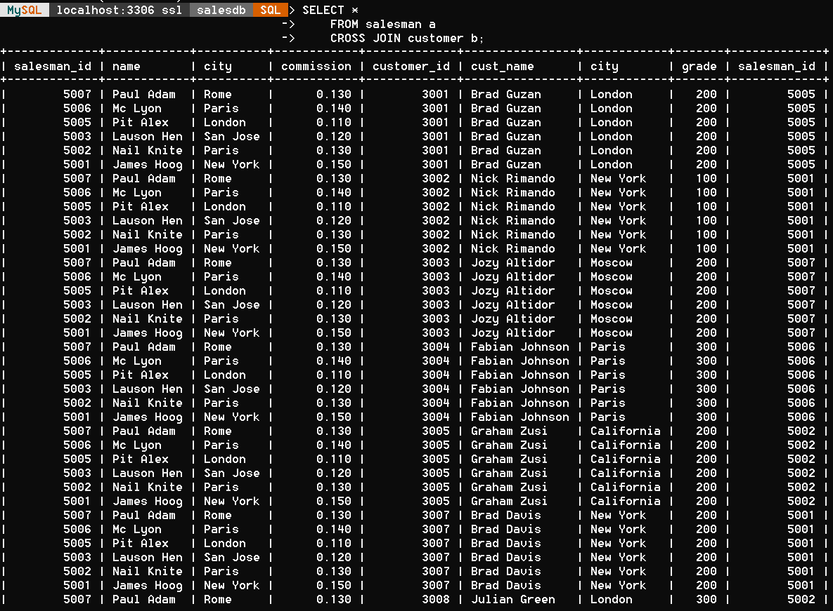

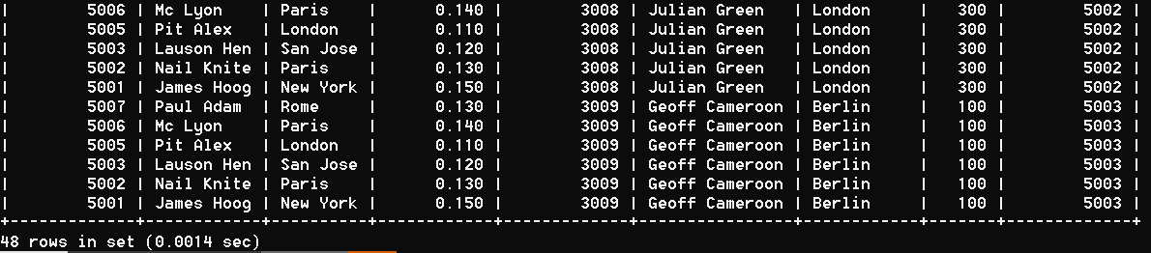

f) Write a SQL statement to make a cartesian product between salesman and customer i.e.each salesman will appear for all customer and vice versa for that salesman who belongs to a city.(Use cross join)

SELECT s.name AS "Salesman", c.cust_name AS "Customer Name"

    FROM salesman s

    CROSS JOIN customer c;

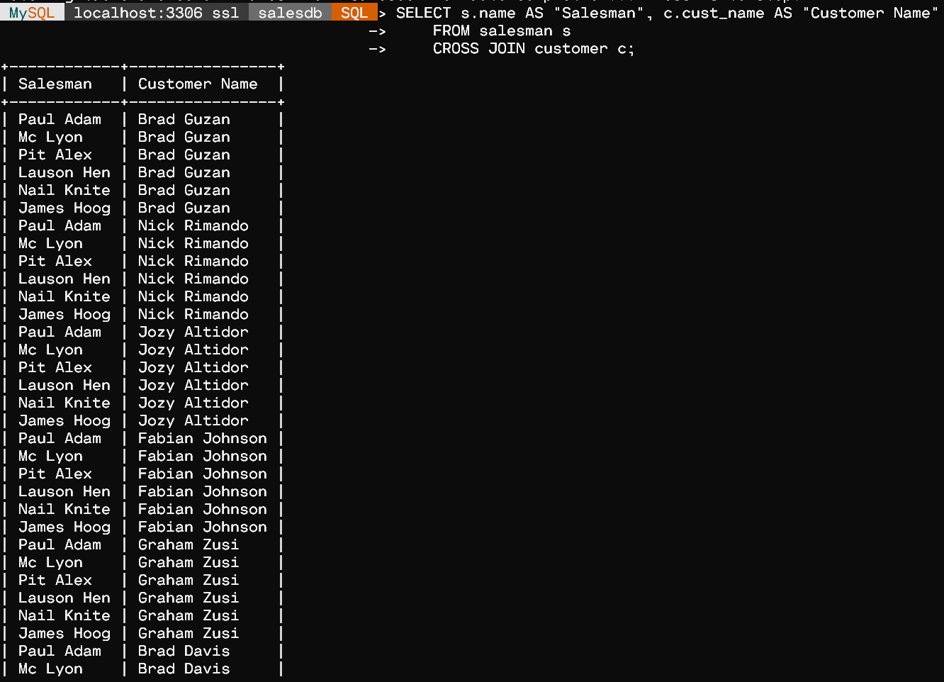 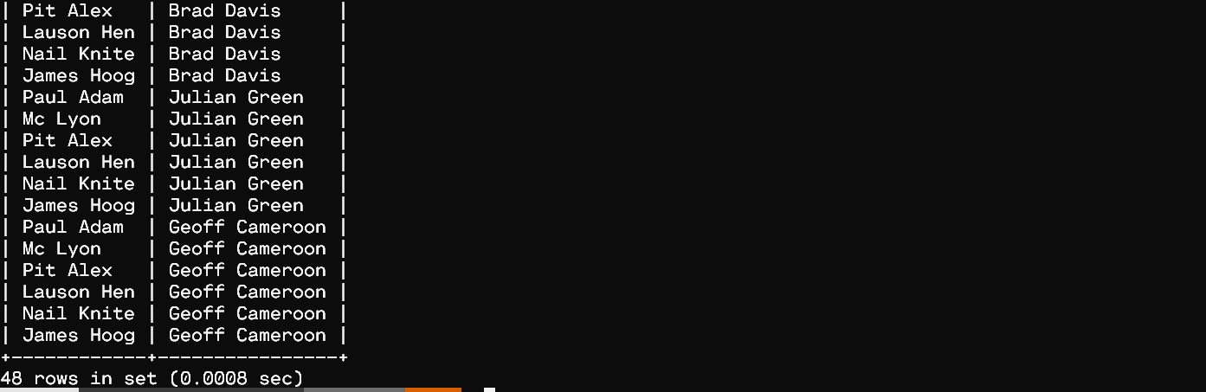

g) Write a SQL statement to make a list for the salesmen who either work for one or more customers or yet to join any of the customer.The customer may have placed, either one or more orders on or above order amount 2000 and must have a grade, or he may not have placed any order to the associated supplier. (Use left outer join and right outer join)

SELECT s.name AS "Salesman"

  FROM salesman s

  LEFT OUTER JOIN customer c

    ON s.salesman_id=c.salesman_id

  RIGHT OUTER JOIN orders o

    ON c.customer_id=o.customer_id

  WHERE o.purch_amt >= 2000

    AND grade IS NOT NULL;

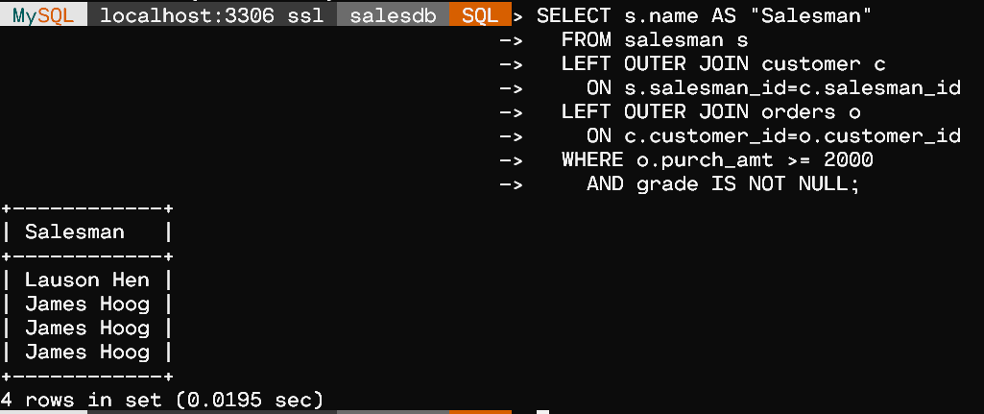

PROBLEM 2

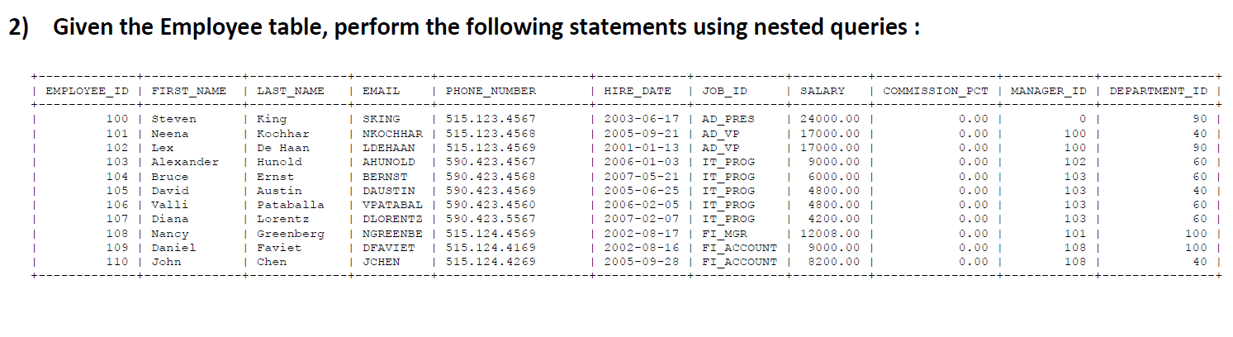

**ER Diagram :**

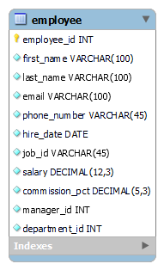

CREATE DATABASE employeeDB;

CREATE TABLE `employee`(

  `employee_id` INT NOT NULL,

  `first_name` VARCHAR(100) NOT NULL,

  `last_name` VARCHAR(100) NOT NULL,

  `email` VARCHAR(100) NOT NULL,

  `phone_number` VARCHAR(45) NOT NULL,

  `hire_date` DATE NOT NULL,

  `job_id` VARCHAR(45) NOT NULL,

  `salary` DECIMAL(12,3) NOT NULL,

  `commission_pct` DECIMAL(5,3) NOT NULL,

  `manager_id` INT NOT NULL,

  `department_id` INT NOT NULL,

  PRIMARY KEY (`employee_id`)

  );

INSERT INTO employee

(`employee_id`, `first_name`, `last_name`, `email`, `phone_number`, `hire_date`, `job_id`, `salary`, `commission_pct`, `manager_id`, `department_id`)

VALUES

        ('100', 'Steven', 'King', 'SKING', '515.123.4567', '2003-06-17', 'AD_PRES', 24000.00, '0.00', '0', '90'),

        ('101', 'Neena', 'Kochhar', 'NKOCHHAR ', '515.123.4568 ', ' 2005-09-21 ', 'AD_VP', 17000.00, '0.00', '100', '40'),

        ('102', 'Lex', 'De Haan', 'LDEHAAN', '515.123.4569', '2001-01-13 ', 'AD_VP', 17000.00, '0.00', '100', '90'),

        ('103', 'Alexander', 'Hunold', 'AHUNOLD', '590.423.4567', '2006-01-03', 'IT_PROG', 9000.00, '0.00', '102', '60'),

        ('104', 'Bruce', 'Ernst', 'BERNST', '590.423.4568 ', '2007-05-21', 'IT_PROG', 6000.00, '0.00', '103', '60'),

        ('105', 'David', 'Austin', 'DAUSTIN', '590.423.4569', '2005-06-25', 'IT_PROG', 4800.00, '0.00', '103', '40'),

        ('106', 'Valli', 'Pataballa', 'VPATABAL', '590.423.4560', '2006-02-05', 'IT_PROG', 4800.00, '0.00', '103', '60'),

        ('107', 'Diana', 'Lorentz', 'DLORENTZ', '590.423.5567', '2007-02-07', 'IT_PROG', 4200.00, '0.00', '103', '60'),

        ('108', 'Nancy', 'Greenberg', 'NGREENBE', '515.124.4569', '2002-08-17', 'FI_MGR', 12008.00, '0.00', '101', '100'),

        ('109', 'Daniel', 'Faviet', 'DFAVIET', '515.124.4169', '2002-08-16', 'FI_ACCOUNT', 9000.00, '0.00', '108', '100'),

        ('110', 'John', 'Chen', 'JCHEN', '515.124.4269', '2005-09-28', 'FI_ACCOUNT', 8200.00, '0.00', '108', '40');

-- Query :-

-- Show Tables :

    SELECT * FROM employee;

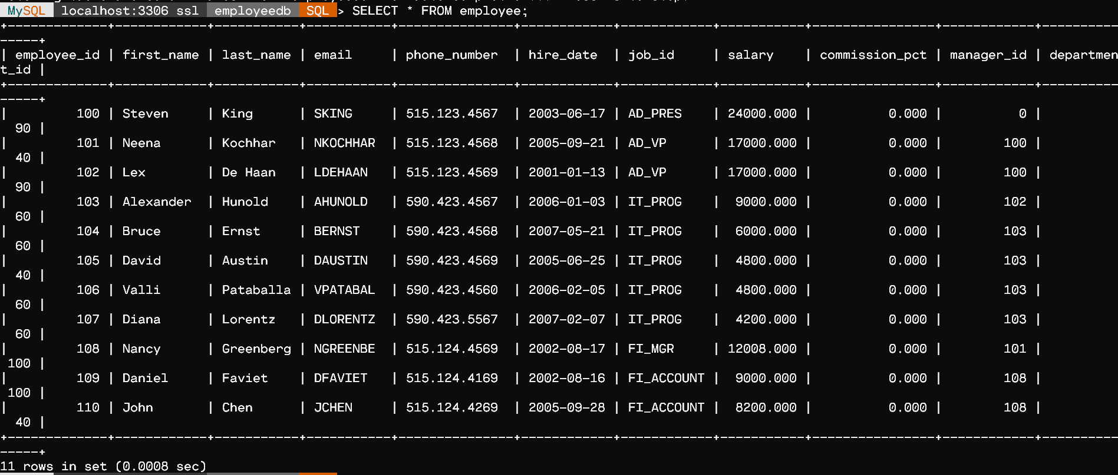

a) Write a query to display the employee name (first name and last name) and department for all employees for any existence of those employees whose salary is more than 3700.

    SELECT first_name, last_name, department_id

        FROM employee

        WHERE EXISTS (SELECT *

              FROM employee

              WHERE salary > 3700.00);

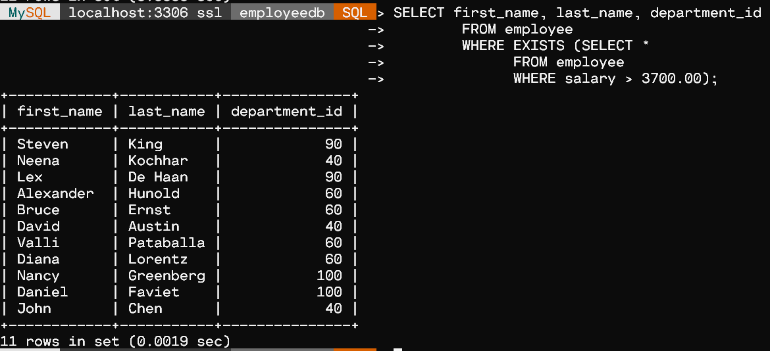

b) Write a query to display the department id and the total salary for those departments which contains at least one employee.

    SELECT department_id,

           SUM(salary) AS Total_Salary

    FROM employee

    WHERE department_id IN (SELECT DISTINCT department_id FROM employee)

    GROUP BY department_id;

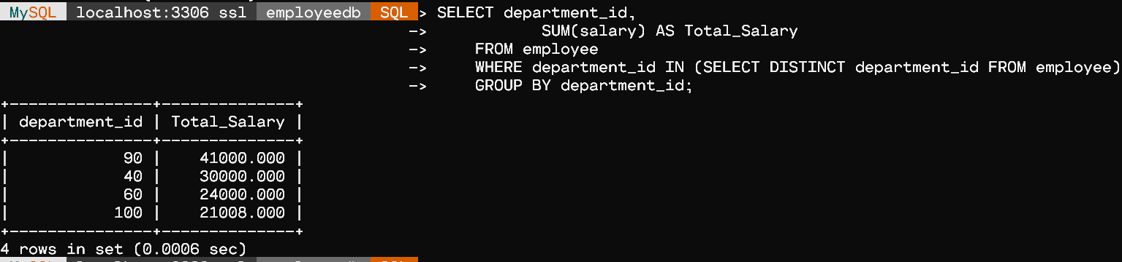

c) Write a subquery that returns a set of rows to find all departments that do actually have one or more employees assigned to them.

    SELECT DISTINCT department_id FROM employee;

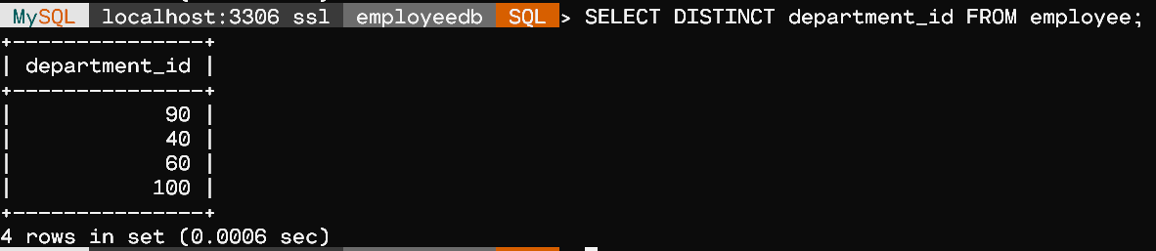

d) Write a query in SQL to display the first and last name, salary, and department ID for all those employees who earn more than the average salary and arrange the list in descending order on salary.

    SELECT first_name, last_name, salary, department_id

      FROM employee

      WHERE salary > (SELECT AVG(salary)

                FROM employee)

      ORDER BY salary DESC;

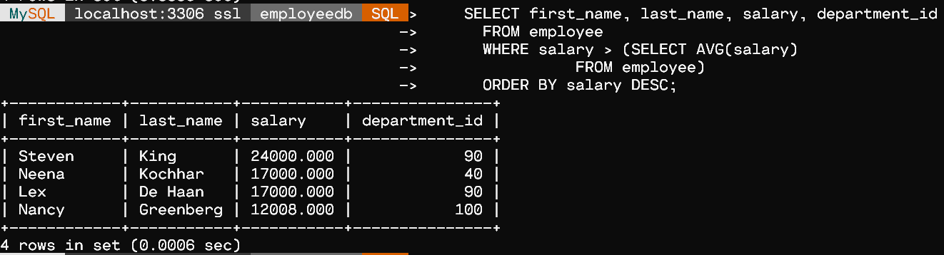

e) Write a query in SQL to display the first and last name, salary, and department ID for those employees who earn more than the maximum salary of a department which ID is 40.

      SELECT first_name, last_name, salary, department_id

          FROM employee

          WHERE salary > (SELECT MAX(salary)

                    FROM employee

                            WHERE department_id = 40);

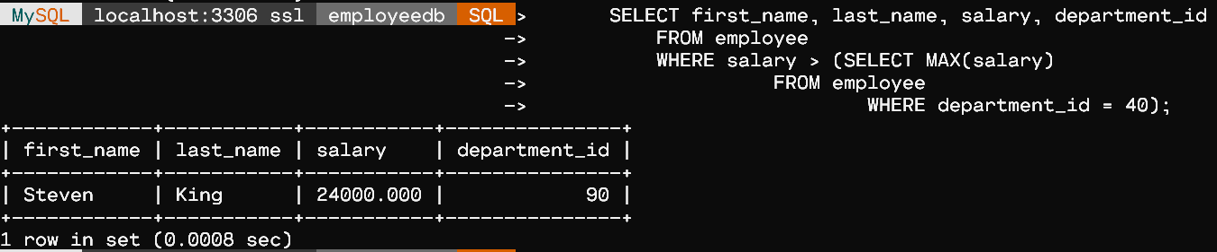

Ex. No.:  04               Date:   02-09-21                  Week:4

# PROBLEM 1

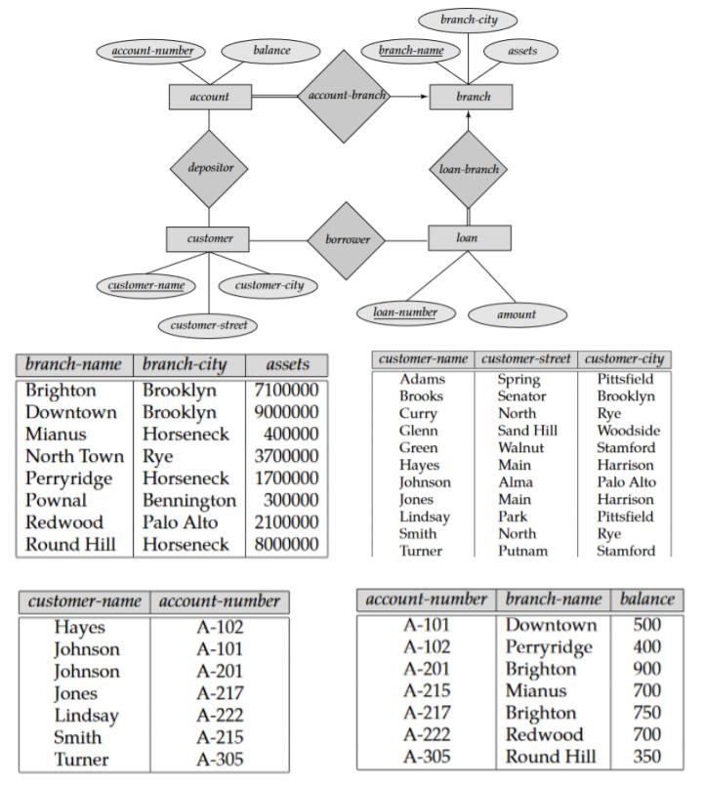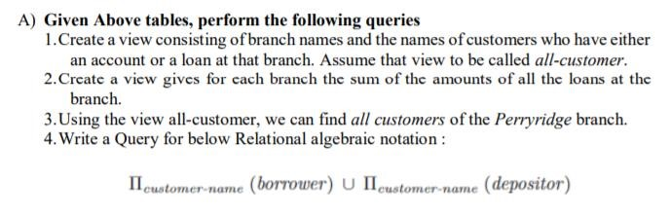

**ER Diagram :**

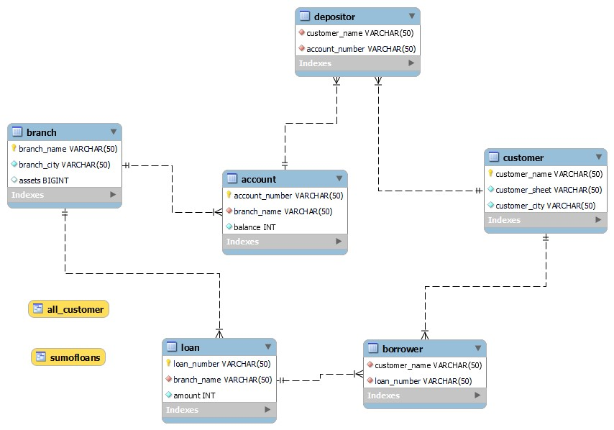

CREATE DATABASE bankDB;

USE bankDB;

CREATE TABLE branch

( branch_name varchar(50) PRIMARY KEY, branch_city varchar(50) NOT NULL, assets bigint

);

CREATE TABLE account

( account_number varchar(50) PRIMARY KEY, branch_name varchar(50) NOT NULL, balance INT NOT NULL, foreign key(branch_name) references branch(branch_name)

);

CREATE TABLE loan

( loan_number varchar(50) PRIMARY KEY, branch_name varchar(50) NOT NULL, amount INT NOT NULL, foreign key(branch_name) references branch(branch_name)

);

CREATE TABLE customer

( customer_name varchar(50) PRIMARY KEY, customer_sheet varchar(50) NOT NULL, customer_city varchar(50) NOT NULL

);

CREATE TABLE depositor

( customer_name varchar(50) NOT NULL, account_number varchar(50) NOT NULL, foreign key(customer_name) references customer(customer_name), foreign key(account_number) references account(account_number)

);

CREATE TABLE borrower

( customer_name varchar(50) NOT NULL, loan_number varchar(50) NOT NULL, foreign key(customer_name) references customer(customer_name), foreign key(loan_number) references loan(loan_number) ); insert into branch values

('Brighton','Brooklyn',7100000),

('Downtown','Brooklyn',9000000),

('Mianus','Horseneck',400000),

('North Town','Rye',3700000),

('Perryridge','Horseneck',1700000),

('Pownal','Bennington',300000),

('Redwood','Palo Alto',2100000),

('Round Hill','Horseneck',8000000);

insert into account values

('A-101','Downtown',500),

('A-102','Perryridge',400),

('A-201','Brighton',900), ('A-215','Mianus',700),

('A-217','Brighton',750),

('A-222','Redwood',700),

('A-305','Round Hill',350);

insert into loan values

('L-11','Round Hill',900),

('L-14','Downtown',1500),

('L-15','Perryridge',1500),

('L-16','Perryridge',1300),

('L-17','Downtown',1000),

('L-23','Redwood',2000),

('L-93','Mianus',500);

insert into customer values

('Adams','Spring','Pittsfield'),

('Brooks','Senator','Brooklyn'),

('Curry','North','Rye'),

('Glenn','Sand Hill','Woodside'), ('Green','Walnut','Stamford'),

('Hayes','Main','Harrison'),

('Johnson','Alma','Palo Alto'),

('Jones','Main','Harrison'),

('Lindsay','Park','Pittsfield'),

('Smith','North','Rye'),

('Turner','Putnam','Stamford'),

('Williams','Nassau','Princeton');

insert into depositor values

('Hayes','A-102'),

('Johnson','A-101'),

('Johnson','A-201'), ('Jones','A-217'),

('Lindsay','A-222'),

('Smith','A-215'),

('Turner','A-305');

insert into borrower values

('Adams','L-16'),

('Curry','L-93'),

('Hayes','L-15'),

('Johnson','L-14'),

('Jones','L-17'),

('Smith','L-11'),

('Smith','L-23'),

('Williams','L-17');

/*---------------------------- Querys----------------------------- */

customer;

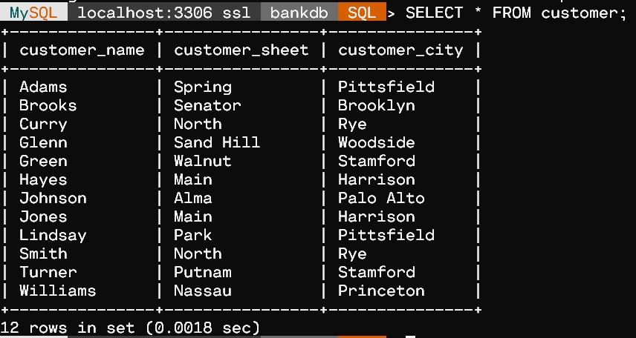

SELECT * FROM depositor;

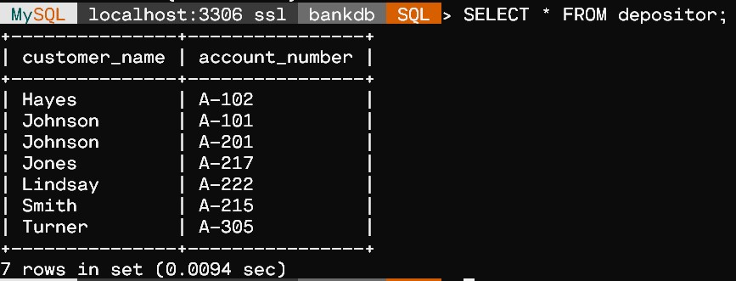

branch;

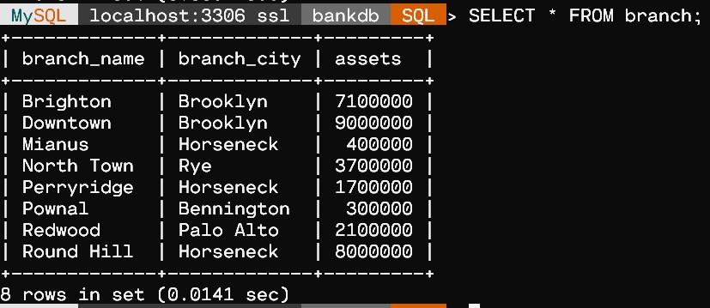

SELECT * FROM account;

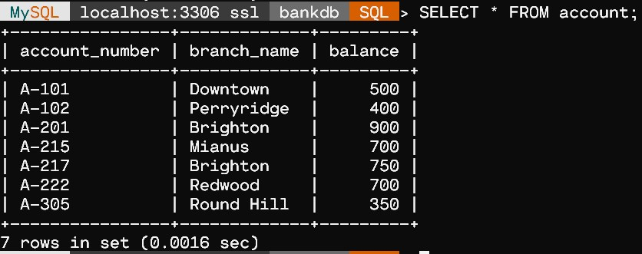

SELECT * FROM loan;

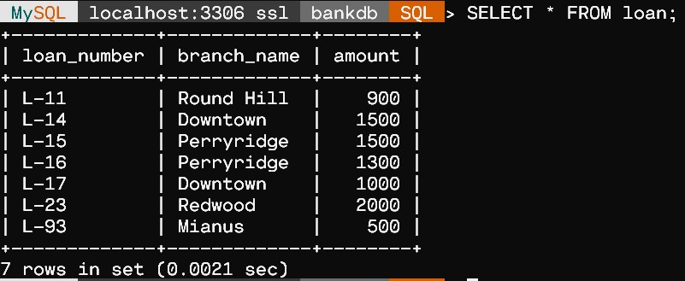

borrower;

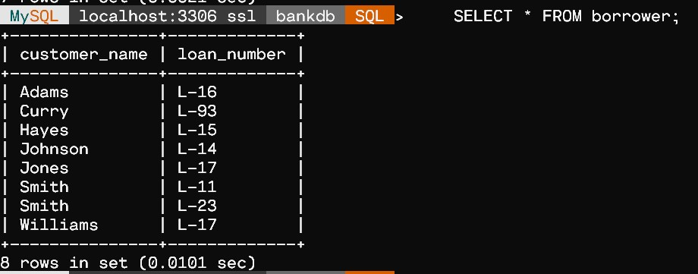

/*1.Create a view consisting of branch names and the names of custome rs who have either an account or a loan at that branch.

Assume that view to be called all-customer.*/

create view all_customer as select branch_name , customer_name from depositor , account where depositor.account_number = account.account_number union

(select branch_name , customer_name from borrower , loan where borrower.loan_number = loan.loan_number);

-- For Output select * from all_customer;

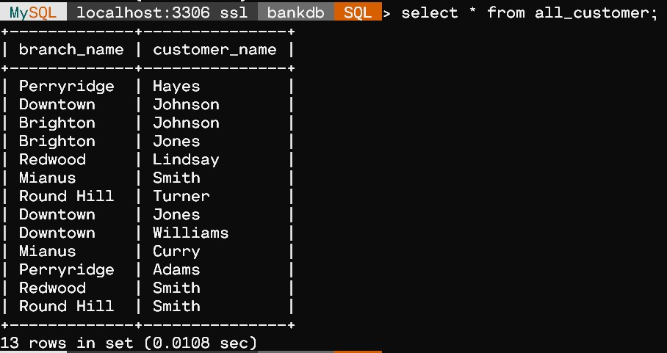

/*2.Create a view gives for each branch the sum of the amounts of all the loans at the branch.*/

create view sumOfLoans as select branch_name , sum(amount) from loan group by branch_name; -- For Output select * from sumOfLoans;

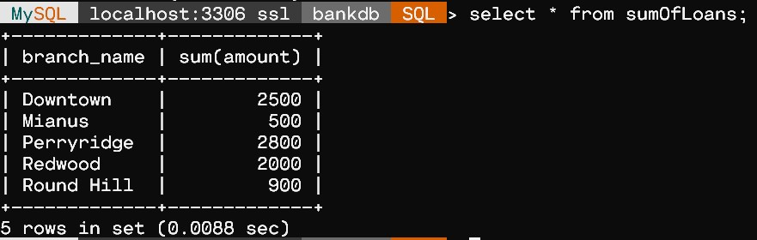

/*3.Using the view allcustomer, we can find all customers of the Perryridge branch.*/

select customer_name from all_customer where branch_name = "Perryridge";

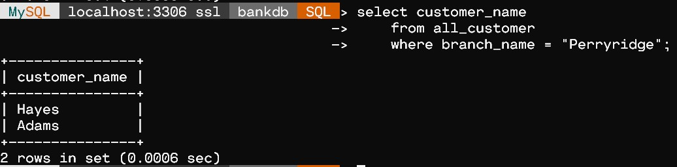

/*4.Write a Query for below Relational algebraic notation :*/

select depositor.customer_name from depositor union

(select borrower.customer_name from borrower);

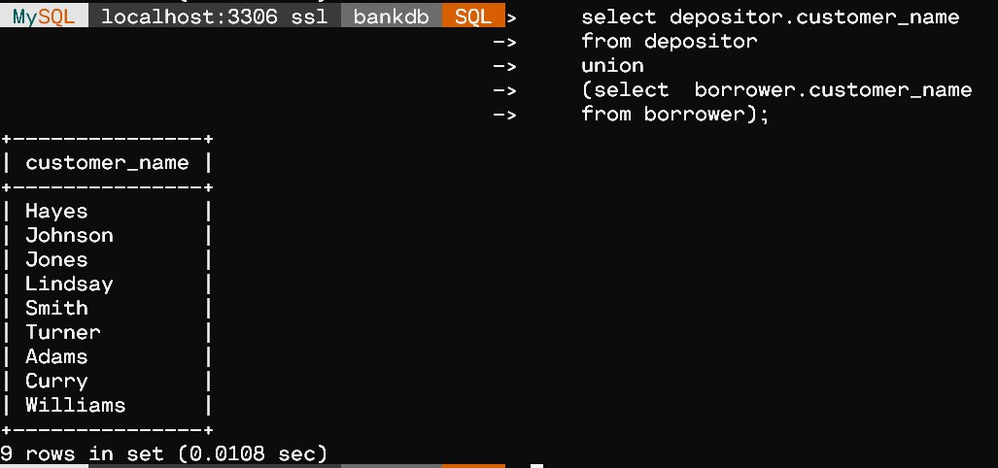

# PROBLEM 2

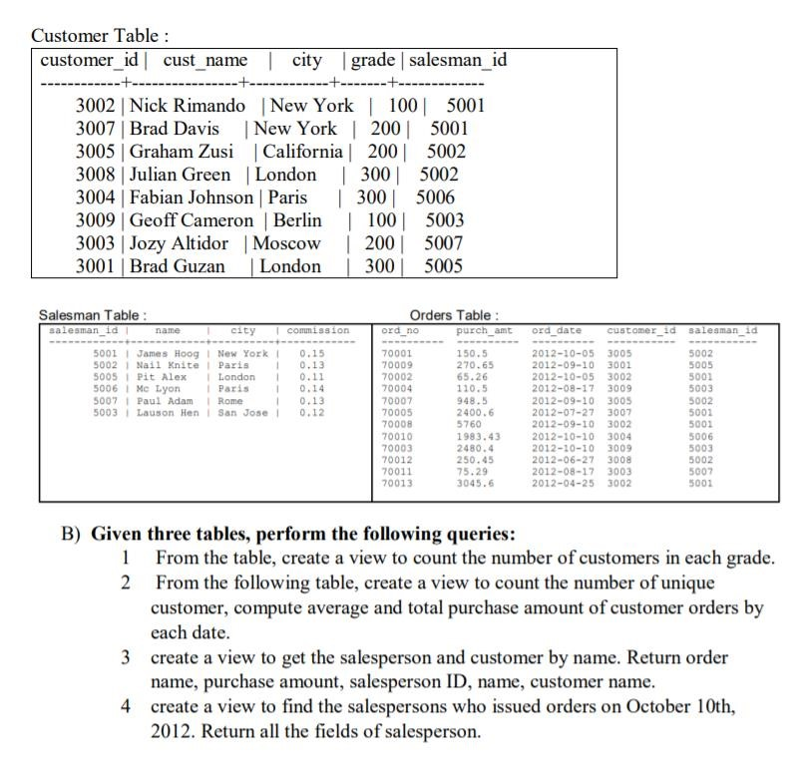

**ER Diagram :**

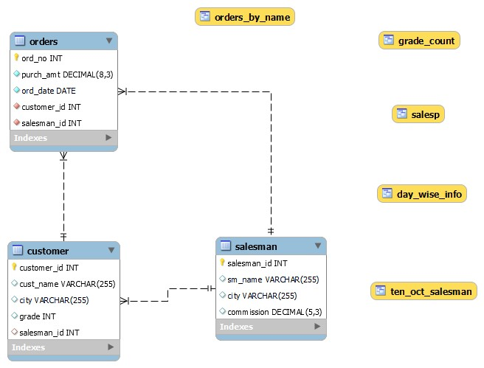

CREATE DATABASE orderDB;

USE orderDB;

CREATE TABLE salesman( salesman_id int NOT NULL, sm_name varchar(255), city varchar(255), commission DECIMAL(5,3), UNIQUE (salesman_id),

PRIMARY KEY (salesman_id)

);

INSERT INTO salesman (salesman_id, sm_name, city, commission)

VALUES

('5001', 'James Hoog', 'New York', '0.15'),

('5002', 'Nail Knite', 'Paris', '0.13'),

('5005', 'Pit Alex', 'London', '0.11'),

('5006', 'Mc Lyon', 'Paris', '0.14'),

('5007', 'Paul Adam', 'Rome', '0.13'),

('5003', 'Lauson Hen', 'San Jose', '0.12');

CREATE TABLE customer( customer_id int NOT NULL, cust_name varchar(255), city varchar(255), grade int, salesman_id int,

UNIQUE (customer_id),

PRIMARY KEY (customer_id),

FOREIGN KEY (salesman_id) REFERENCES salesman(salesman_id)

);

INSERT INTO customer(customer_id, cust_name, city,

grade, salesman_id)

VALUES

(3002 , 'Nick Rimando' , 'New York' , 100 , 5001),

(3007 , 'Brad Davis' , 'New York' , 200 , 5001),

(3005 , 'Graham Zusi' , 'California' , 200 , 5002),

(3008 , 'Julian Green' , 'London' , 300 , 5002),

(3004 , 'Fabian Johnson' , 'Paris' , 300 , 5006),

(3009 , 'Geoff Cameron' , 'Berlin' , 100 , 5003),

(3003 , 'Jozy Altidor' , 'Moscow' , 200 , 5007),

(3001 , 'Brad Guzan' , 'London' , 300 , 5005);

CREATE TABLE orders( ord_no INT NOT NULL, purch_amt DECIMAL(8,3) NOT NULL, ord_date DATE NOT NULL, customer_id INT NOT NULL, salesman_id INT NOT NULL,

PRIMARY KEY (ord_no),

FOREIGN KEY (customer_id) REFERENCES customer(customer_id), FOREIGN KEY (salesman_id) REFERENCES salesman(salesman_id)

);

INSERT INTO orders (ord_no, purch_amt, ord_date, customer_id, salesma n_id) VALUES

('70001', '150.5', '2012-10-05', '3005', '5002'),

('70009', '270.65', '2012-09-10', '3001', '5005'),

('70002', '65.26', '2012-10-05', '3002', '5001'),

('70004', '110.5', '2012-08-17', '3009', '5003'),

('70007', '948.5', '2012-09-10', '3005', '5002'),

('70005', '2400.6', '2012-07-27', '3007', '5001'),

('70008', '5760', '2012-09-10', '3002', '5001'),

('70010', '1983.43', '2012-10-10', '3004', '5006'),

('70003', '2480.4', '2012-10-10', '3009', '5003'),

('70012', '250.45', '2012-06-27', '3008', '5002'),

('70011', '75.29', '2012-08-17', '3003', '5007'), ('70013', '3045.6', '2012-04-25', '3002', '5001');

/*------------------------Queries--------------------------*/

SELECT * FROM customer;

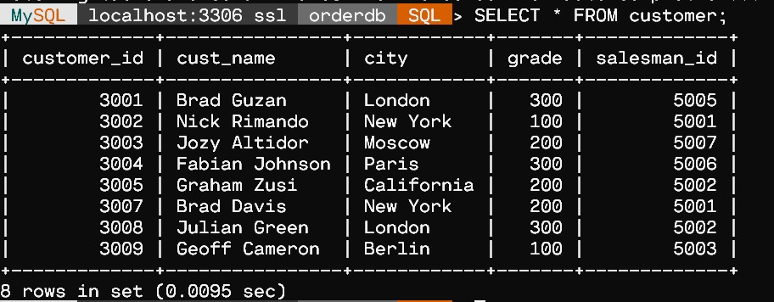

SELECT * FROM salesman;

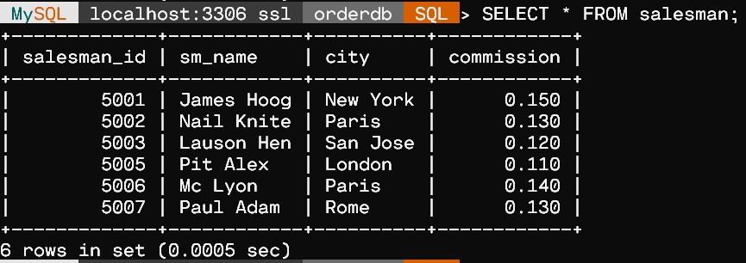

SELECT * FROM orders;

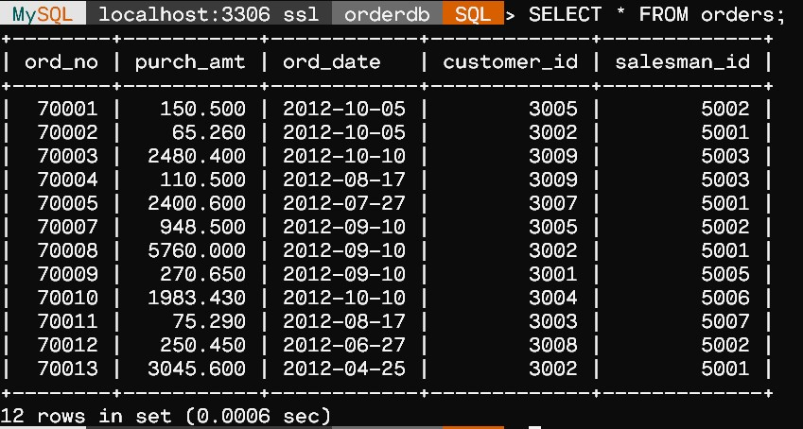

-

- 1 From the table, create a view to count the number of customers in each grade.

CREATE VIEW Grade_Count (Grade, Number)

AS SELECT grade, COUNT(*)

FROM customer GROUP BY grade;

SELECT * FROM Grade_Count;

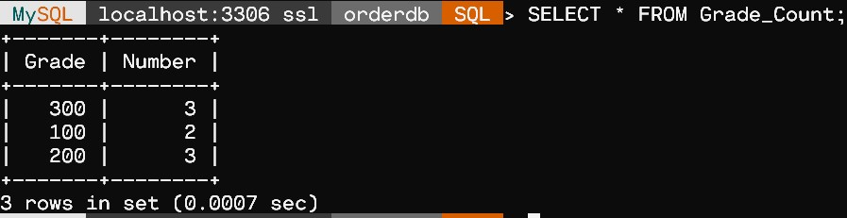

/* 2 From the following table, create a view to count the number of u nique customer, compute average and total purchase amount of customer order s by

each date. */

CREATE VIEW Day_Wise_Info (Ord_Date, Unique_Cust, Avg_Purch, Tota l_Purch)

AS SELECT ord_date, COUNT(DISTINCT customer_id),

AVG(purch_amt), SUM(purch_amt)

FROM orders

GROUP BY ord_date;

SELECT * FROM Day_Wise_Info;

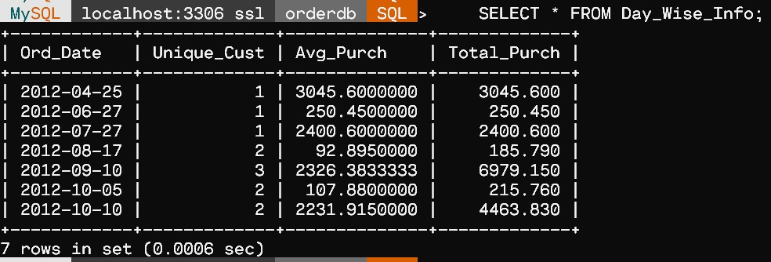

/* 3 create a view to get the salesperson and customer by name. Retur n order name, purchase amount, salesperson ID, name, customer name. */ CREATE VIEW Orders_by_Name (Ord_No,Purch_Amt,Salesman_ID, Salesma n_Name, Cust_Name)

AS SELECT ord_no, purch_amt, a.salesman_id, sm_name, cust_name

FROM orders a, customer b, salesman c

WHERE a.customer_id = b.customer_id

AND a.salesman_id = c.salesman_id;

SELECT * FROM Orders_by_Name;

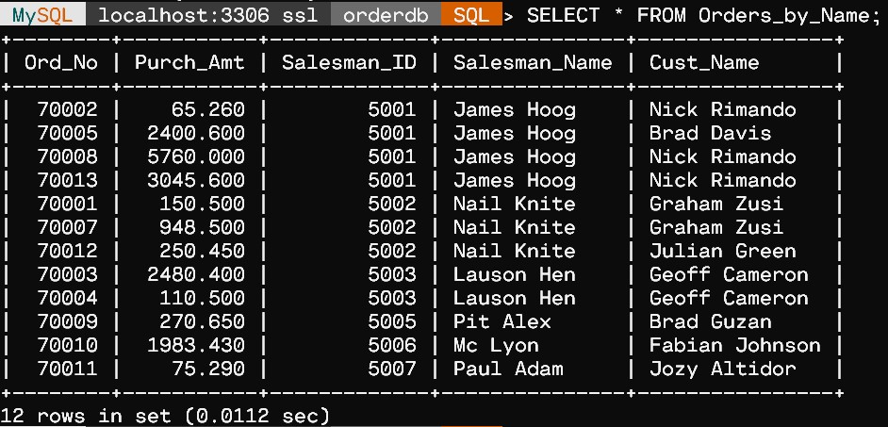

/* 4 create a view to find the salespersons who issued orders on Octo ber 10th,

2012. Return all the fields of salesperson. */

CREATE VIEW Ten_Oct_Salesman (Salesman_ID, Salesman_Name, City, C ommission) AS SELECT *

FROM salesman

WHERE salesman_id IN

(SELECT salesman_id

FROM orders WHERE ord_date = '2012-10-10');

SELECT * FROM Ten_Oct_Salesman;

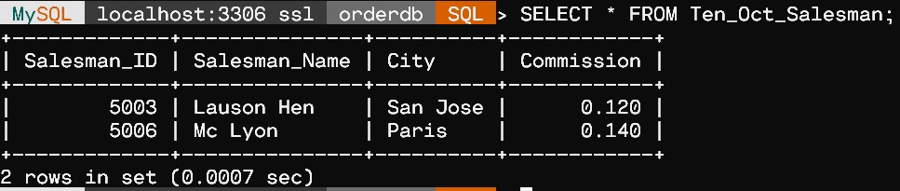

Ex. No.:  05               Date:   08-09-21                  Week:5

PROBLEM 1

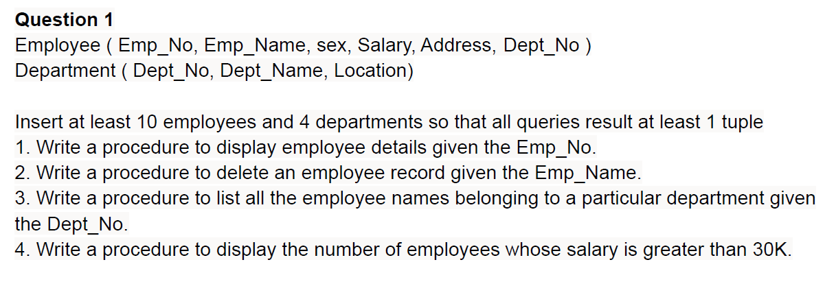

**ER Diagram :**

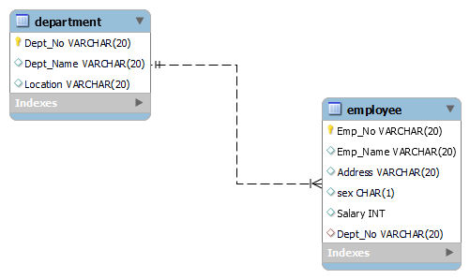

CREATE DATABASE CompanyDB;

USE CompanyDB;

CREATE TABLE Department  (

    Dept_No VARCHAR (20) PRIMARY KEY,

    Dept_Name VARCHAR (20),

    Location VARCHAR (20)

);

CREATE TABLE Employee (

    Emp_No VARCHAR (20) PRIMARY KEY,

    Emp_Name VARCHAR (20),

    Address VARCHAR (20),

    sex CHAR (1),

    Salary INTEGER,

    Dept_No VARCHAR (20),

    foreign key (Dept_No) REFERENCES Department (Dept_No)

);

INSERT INTO Department

    VALUES

        (1,'ACCOUNTS','Trichy'),

        (2,'IT','Chennai'),

        (3,'ECE','Salem'),

        (4,'ISE','Coimbatore'),

        (5,'CSE','Chennai');

INSERT INTO Employee

 VALUES

       ('ECE01','PREETI','BANGALORE','F', 40000,3),

       ('CSE01','JAMES','BANGALORE','M', 50000,5),

       ('CSE02','HEARN','BANGALORE','M', 70000,5),

       ('CSE03','EDWARD','MYSORE','M', 50000,5),

       ('CSE04','PAVAN','MANGALORE','M', 15000,5),

       ('CSE05','GIRISH','MYSORE','M', 20000,5),

       ('CSE06','NEHA','BANGALORE','F', 80000,5),

       ('ACC01','AHANA','MANGALORE','F', 35000,1),

       ('ACC02','SANTHOSH','MANGALORE','M', 30000,1),

       ('ISE01','VEENA','MYSORE','M', 10000,4),

       ('IT01','NAGESH','BANGALORE','M', 50000,2);

/*------------Queries-------------*/

SELECT * FROM Department;

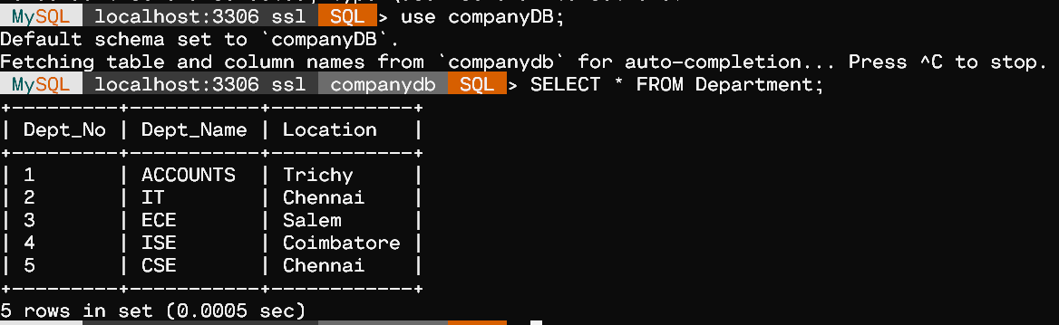

SELECT * FROM Employee;

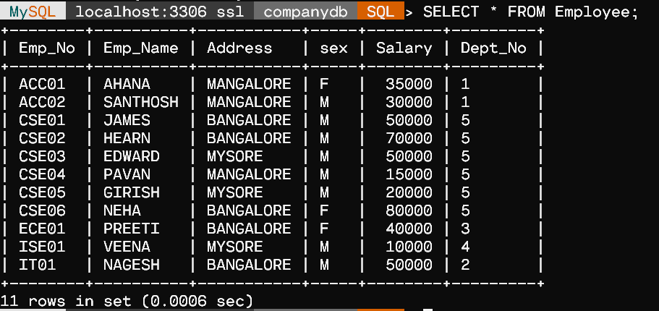

/*1.Write a procedure to display employee details given the Emp_No.*/

DELIMITER $$

CREATE PROCEDURE display_Emp(IN X VARCHAR(20))

    BEGIN

        SELECT * FROM Employee

        WHERE Emp_No=X;

    END$$

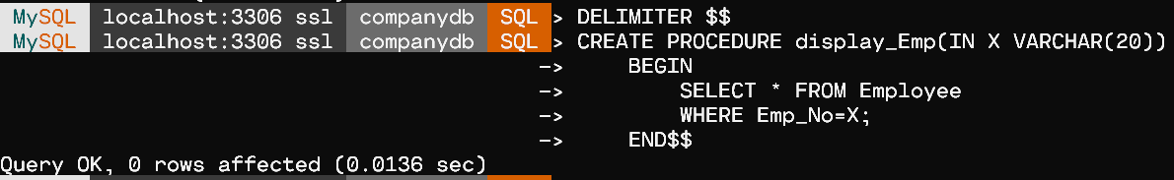

CALL display_Emp('CSE05')$$

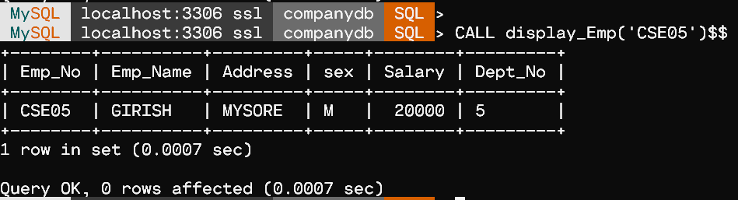

/*2.Write a procedure to delete an employee record given the Emp_Name.*/

DELIMITER //

CREATE PROCEDURE delete_Emp(IN NAME VARCHAR(20))

    BEGIN

        SET SQL_SAFE_UPDATES = 0;

        DELETE FROM Employee WHERE Emp_Name=NAME;

        SET SQL_SAFE_UPDATES = 1;

    END//

CALL delete_Emp('VEENA')//

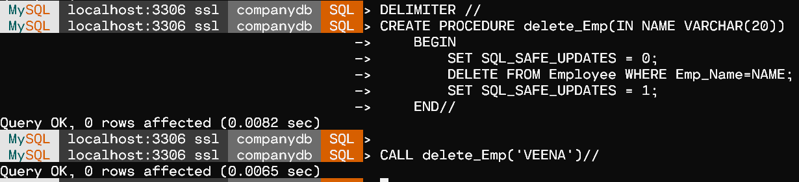

SELECT * FROM Employee//

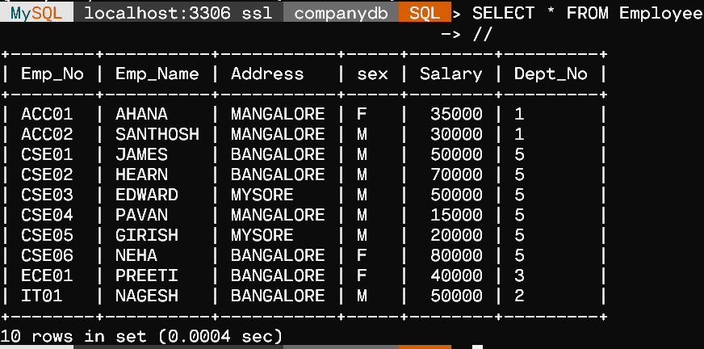

/*3. Write a procedure to list all the employee names belonging to a particular department given the Dept_No.*/

DELIMITER %%

CREATE PROCEDURE list_Emp(IN X INT)

    BEGIN

        SELECT * FROM Employee

        WHERE Dept_No=X;

    END%%

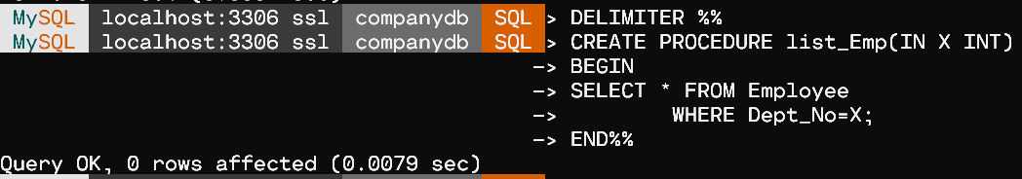

CALL list_Emp(1)%%

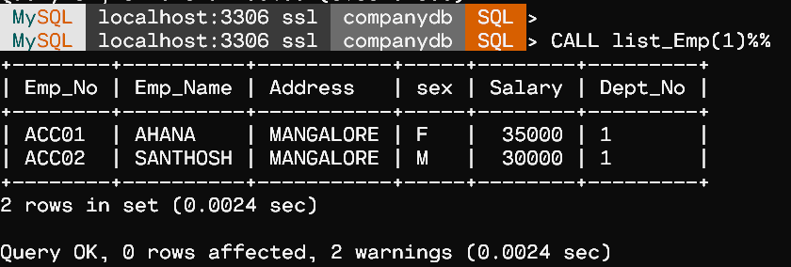

/*4. Write a procedure to display the number of employees whose salary is greater than 30K.*/

DELIMITER &&

CREATE PROCEDURE num_Emp()

    BEGIN

        SELECT COUNT(*) FROM Employee

        WHERE Salary>30000;

    END&&

CALL num_Emp()&&

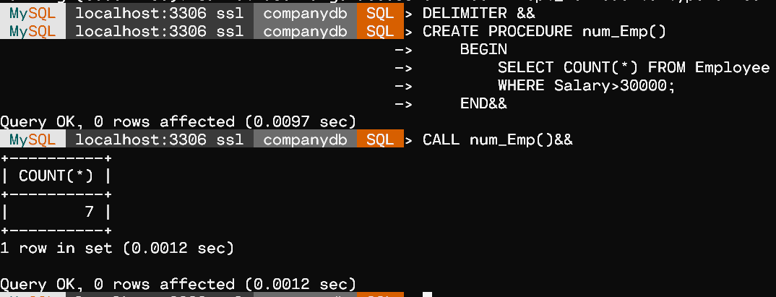

PROBLEM 2

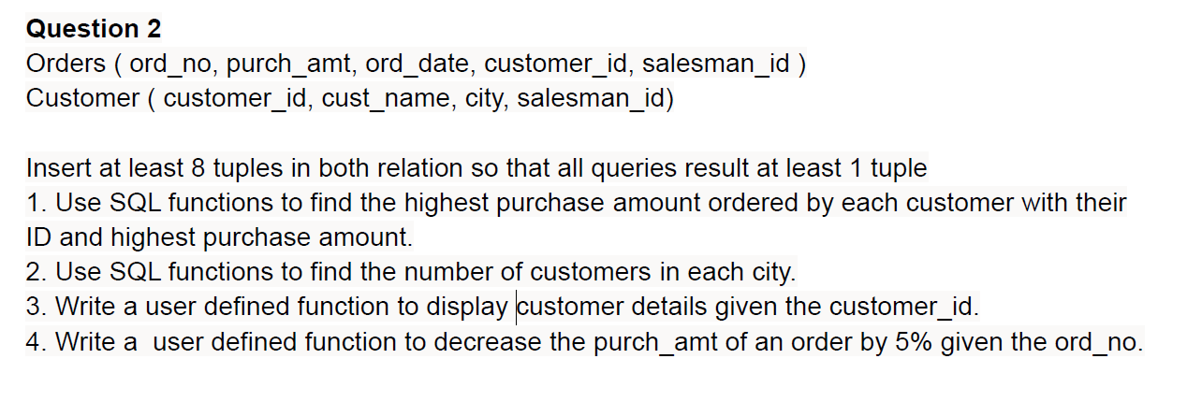

**ER Diagram :**

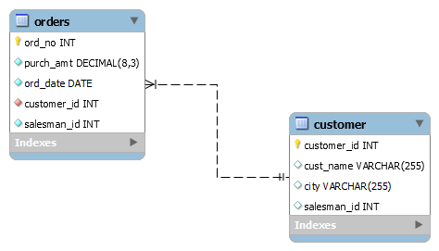

CREATE DATABASE orderDB;

USE orderDB;

CREATE TABLE customer(

    customer_id int NOT NULL,

    cust_name varchar(255),

    city varchar(255),

    salesman_id int,

    UNIQUE (customer_id),

    PRIMARY KEY (customer_id)

);

INSERT INTO customer

 VALUES

    (3002 , 'Nick Rimando' , 'New York' , 5001),

    (3007 , 'Brad Davis' , 'New York'  , 5001),

    (3005 , 'Graham Zusi' , 'California' , 5002),

    (3008 , 'Julian Green' , 'London' , 5002),

    (3004 , 'Fabian Johnson' , 'Paris' , 5006),

    (3009 , 'Geoff Cameron' , 'Berlin' , 5003),

    (3003 , 'Jozy Altidor' , 'Moscow' , 5007),

    (3001 , 'Brad Guzan' , 'London' , 5005);

CREATE TABLE orders(

    ord_no INT NOT NULL,

    purch_amt DECIMAL(8,3) NOT NULL,

    ord_date DATE NOT NULL,

    customer_id INT NOT NULL,

    salesman_id INT NOT NULL,

    PRIMARY KEY (ord_no),

    FOREIGN KEY (customer_id) REFERENCES customer(customer_id)

    );

INSERT INTO orders

 VALUES

    ('70001', '150.5', '2012-10-05', '3005', '5002'),

    ('70009', '270.65', '2012-09-10', '3001', '5005'),

    ('70002', '65.26', '2012-10-05', '3002', '5001'),

    ('70004', '110.5', '2012-08-17', '3009', '5003'),

    ('70007', '948.5', '2012-09-10', '3005', '5002'),

    ('70005', '2400.6', '2012-07-27', '3007', '5001'),

    ('70008', '5760', '2012-09-10', '3002', '5001'),

    ('70010', '1983.43', '2012-10-10', '3004', '5006'),

    ('70003', '2480.4', '2012-10-10', '3009', '5003'),

    ('70012', '250.45', '2012-06-27', '3008', '5002'),

    ('70011', '75.29', '2012-08-17', '3003', '5007'),

    ('70013', '3045.6', '2012-04-25', '3002', '5001');

        /*------------- Queries---------------- */

SET GLOBAL log_bin_trust_function_creators = 1;

SELECT * FROM customer;

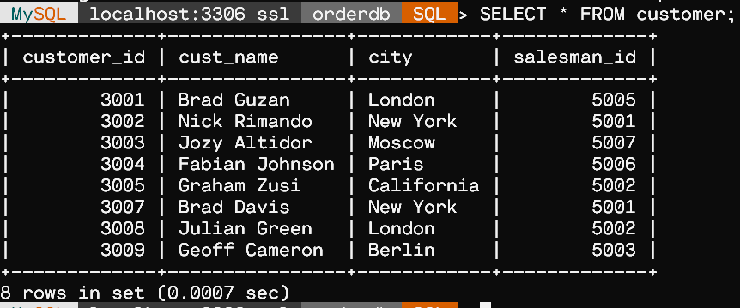

SELECT * FROM orders;

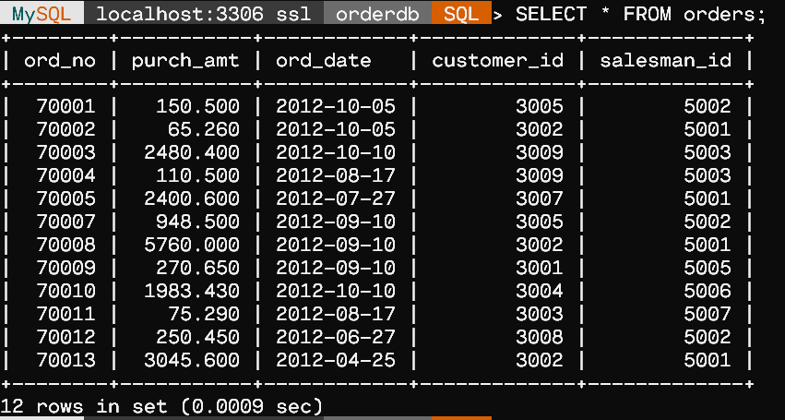

/*  1. Use SQL functions to find the highest purchase amount ordered by

       each customer with their ID and highest purchase amount */

SELECT customer_id,MAX(purch_amt) AS highest_purch_amt

FROM orders

GROUP BY customer_id;

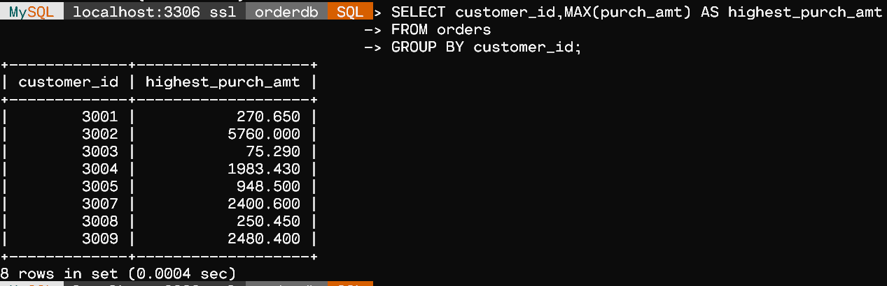

-  2. Use SQL functions to find the number of customers in each city.

SELECT city,COUNT(customer_id) AS num_of_cust

FROM customer

GROUP BY city;

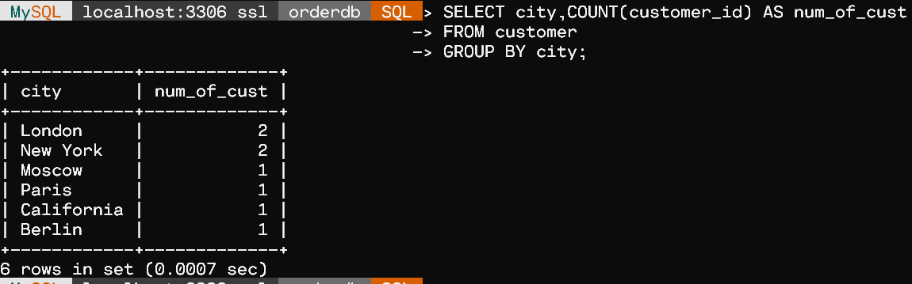

-  3. Write a user defined function to display customer details given the customer_id.

DELIMITER %%

CREATE FUNCTION display_cust(c int)

RETURNS varchar(255)

    BEGIN

        DECLARE ret_val varchar(255);

        SELECT cust_name INTO ret_val FROM customer

        WHERE customer_id=c;

        RETURN ret_val;

    END%%

SELECT display_cust(3002)%%

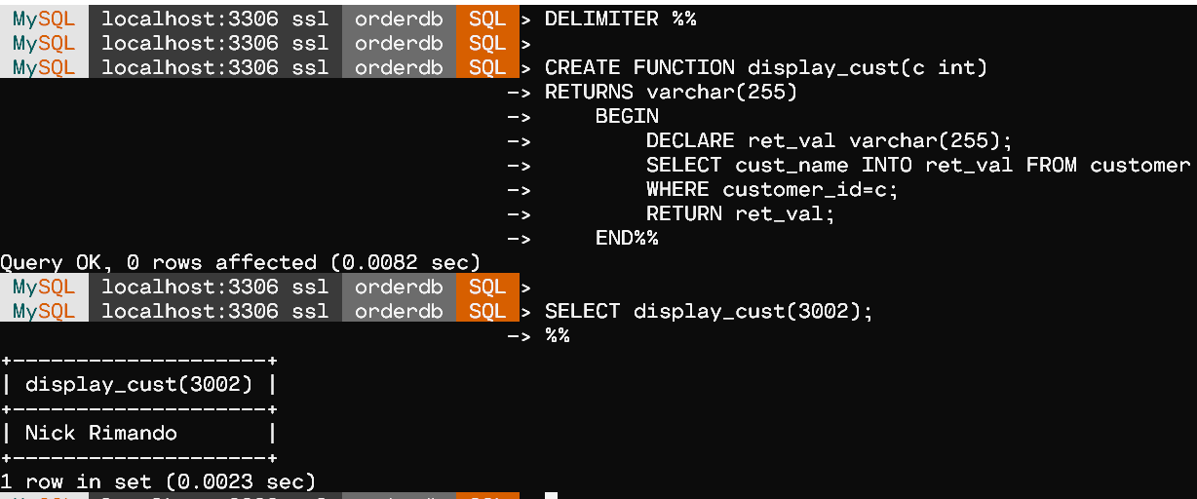

-  4. Write a user defined function to decrease the purch_amt of an order by 5% given the ord_no.

DELIMITER $$

CREATE FUNCTION decrease_purch_amt( ord_no int)

RETURNS DECIMAL(8,3) DETERMINISTIC

BEGIN

    DECLARE Reduced_purch_amt DECIMAL(8,3);

    SELECT 0.95 * purch_amt INTO Reduced_purch_amt FROM orders WHERE orders.ord_no = ord_no;

    RETURN Reduced_purch_amt;

END$$

SELECT decrease_purch_amt(70009)$$

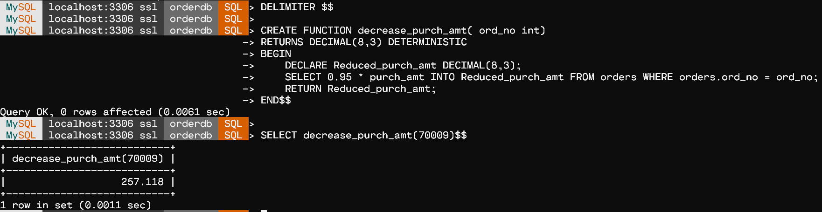

Ex. No.:  06               Date:   16-09-21                  Week:6

PROBLEM 1

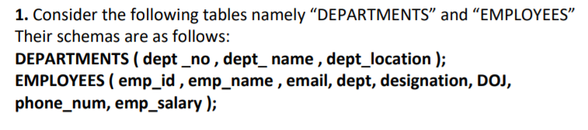

**ER-Diagram**



CREATE DATABASE CompanyDB;

USE CompanyDB;

CREATE TABLE Departments  (

    dept_id VARCHAR (20) NOT NULL PRIMARY KEY,

    dept_name VARCHAR (20),

    dept_location VARCHAR (20)

);

CREATE TABLE Employees (

  emp_id INT NOT NULL PRIMARY KEY,

  emp_name VARCHAR(100),

  email VARCHAR(100),

  dept_id  INT,

  designation VARCHAR(100),

  doj DATE,

  phone_num VARCHAR(45),

  emp_salary DECIMAL(12,3)

);

create table messages

(

    id int(11) not null auto_increment primary key,

    message varchar(255) default null,

    time timestamp null default current_timestamp on update current_timestamp

);

/** ----------------------------- Queries -------------------------------**/

-- Create a trigger for:-

-- a) Calculating the number of rows inserted so far.

delimiter //

create trigger trig1A

 before insert on departments

  for each row

  set @dept_rows = @dept_rows+1//

set @dept_rows = 0//

delimiter ;

insert into departments

values

    ('1', 'sales', 'chennai'),

    ('2', 'marketing', 'bombay'),

    ('3', 'management', 'bengaluru');

SELECT @dept_rows;

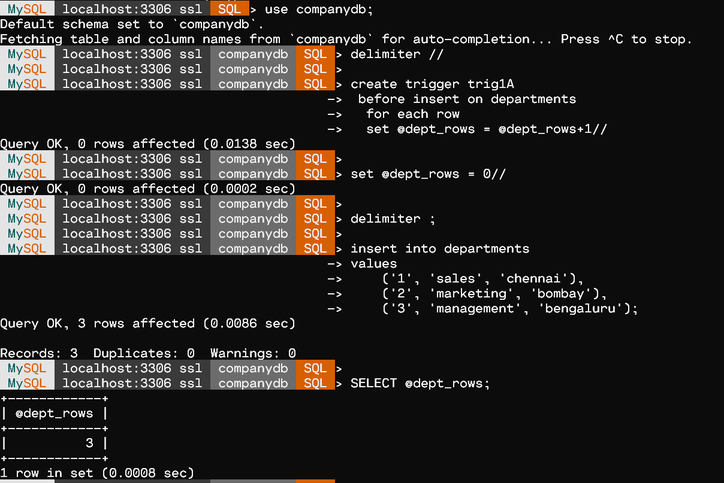

-- b) Displays message prior to insert operation on Employee Table

delimiter //

create trigger display_message before insert on employees

    for each row

    begin

    insert into messages (message) values('Inserted Row in Employees');

    end;//

delimiter ;

insert into employees

values

    ('100','timber', 'timber@gmail.com','1', 'salseman', '2019-01-12', '9842042345', '100000'),

    ('101','jaanu', 'jaanu@gmail.com', '2', 'senior manager', '2020-01-01', '9865161122', '15000'),

    ('102','jen', 'jen@gmail.com', '3', 'junior manager', '2019-10-12', '9042842344', '60000'),

    ('103','jack', 'jack@gmail.com', '2', 'assistant', '2016-03-01', '9498853055', '50000');

SELECT * FROM messages;

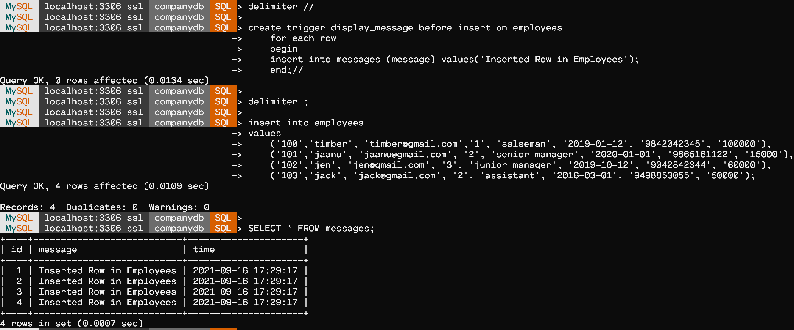

-- c) Ensuring that the Employee Table does not contain duplicates or null value in the Name column

delimiter //

create trigger NULL_val_trigger before insert on employees

for each row

begin

    if (exists(select 1 from employees where emp_name = new.emp_name or new.emp_name is null))

    then

    signal sqlstate '45001' set message_text = "INSERT failed due to duplicate or null emp_name";

    end if;

end//

insert into employees

  values ('104', 'jen', 'xjen@gmail.com', '3', 'junior manager', '2019-09-10', '7561994181', '62000')//

delimiter ;

select * from employees;

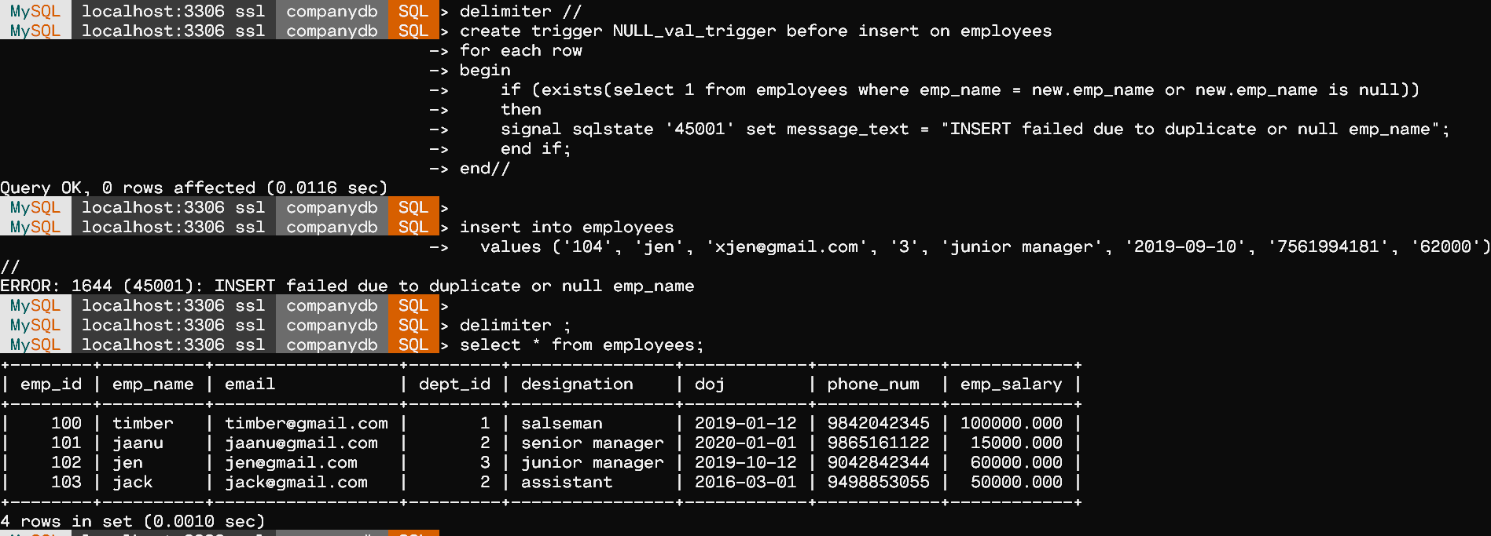

-- d) To insert Employee details into Employee Table only of DOJ > 2018

DELIMITER //

CREATE TRIGGER NOT_BELOW_2018

    BEFORE INSERT

    ON EMPLOYEES

    FOR EACH ROW

BEGIN

    IF(NEW.doj < '2018-01-01') THEN

        SIGNAL SQLSTATE VALUE '45000' SET MESSAGE_TEXT = 'EMPLOYEE BELOW 2018 DOJ CANNOT BE INSERTED';

    END IF;

END //

insert into employees

 values (104, 'raj', 'rajx@gmail.com', '2', 'field officer', '2017-03-10','9680988342','34000')//

DELIMITER ;

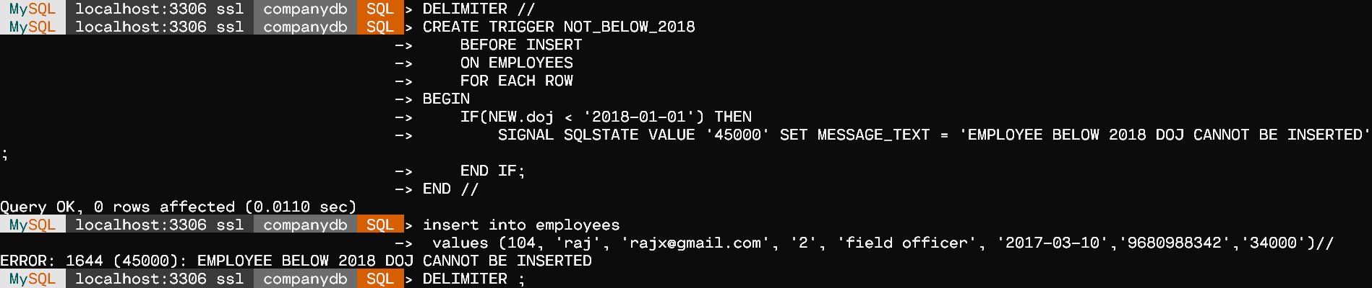

-- e) To Prevent any Employee Named Tom to be inserted into the table

DELIMITER //

create trigger prevent_name before insert on employees

    for each row

    begin

    if new.emp_name = "tom" then signal sqlstate '45000' set message_text= "tom is prohibited from insertion !!!";

    end if;

    end//

DELIMITER ;

insert into employees values

  ('107', 'tom', 'tommy@gmail.com', '6', 'assistant doctor', '2020-02-22', '7373558197','25000');

select * from employees;

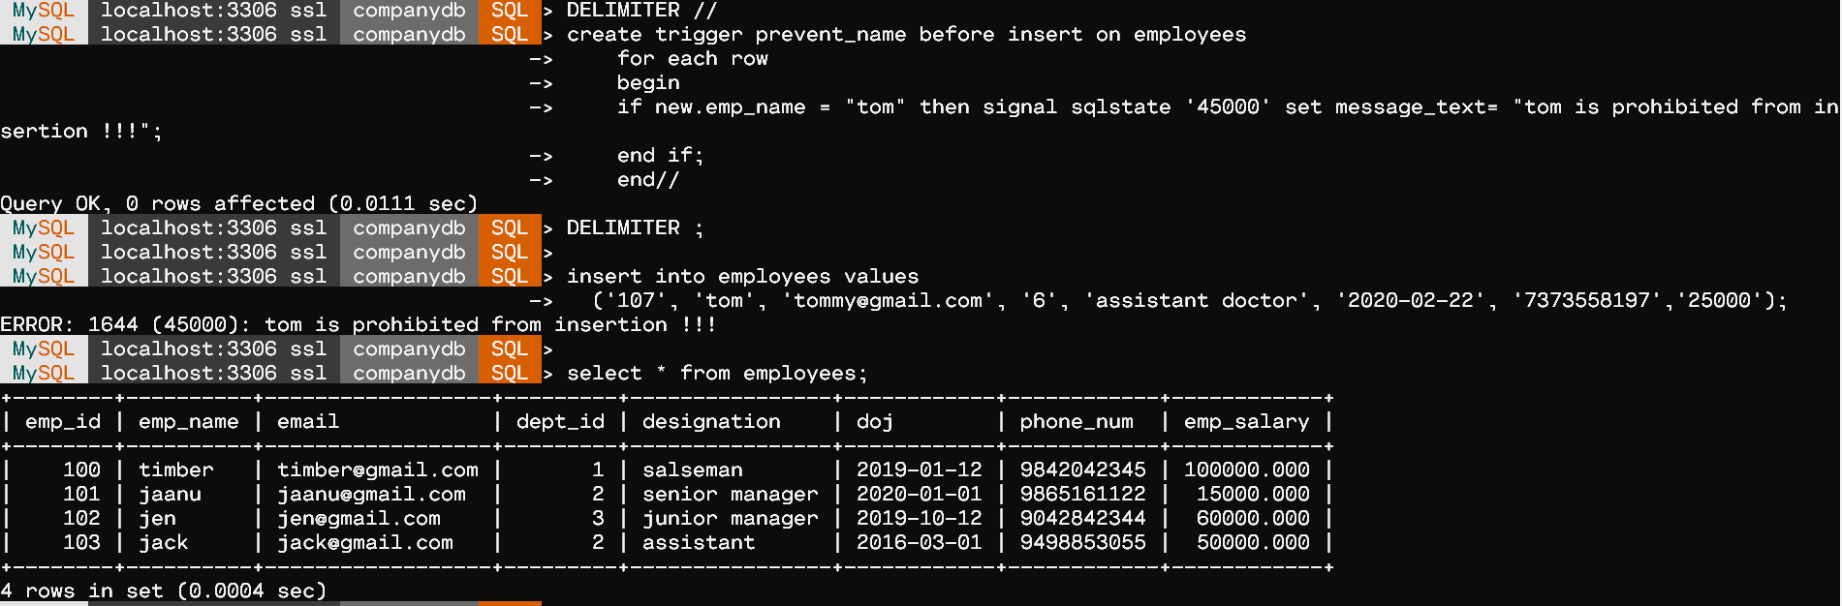

PROBLEM 2

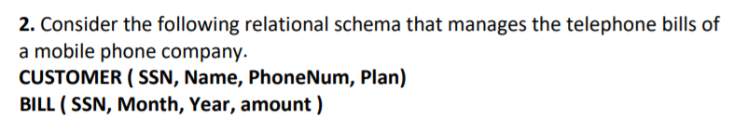



CREATE DATABASE customerDB;

USE customerDB;

create table customer

(

    ssn int primary key,

    name varchar(30),

    phone_no varchar(30),

    plan varchar(30)

);

create table bill

(

    ssn int not null,

    foreign key (ssn) references customer(ssn),

    month int not null,

    year int not null,

    amount int not null

);

create table calls

(

    from_ssn int,

    to_ssn int,

    month int,

    year int,

    amount int,

    foreign key(from_ssn) references customer(ssn),

    foreign key(to_ssn) references customer(ssn)

);

-- a. That Adds +91 to all phone numbers as a prefix in the Customer Table.

 delimiter //

 create trigger trig2A

    before insert on customer

    for each row

    begin

    set new.phone_no = concat("+91",new.phone_no);

    end;//

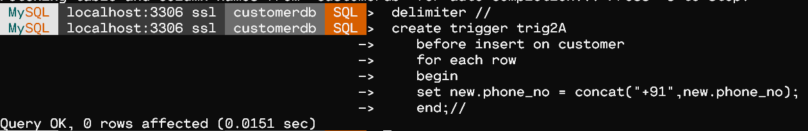

-- b. Write a trigger that after each phone call updates the customer's bill.

delimiter //

create trigger trig2B after insert on calls

    for each row

    update bill

    set bill.amount = bill.amount + new.amount

    where bill.year = new.year

    and bill.month = new.month

    and bill.ssn = new.from_ssn;//

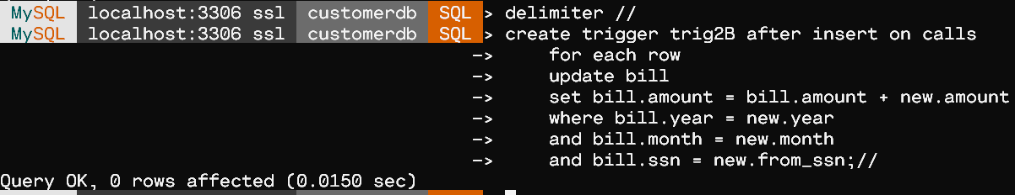

 -- c. Write a trigger to not insert bill older than 2020 (year > 2020).

 delimiter //

create trigger trig2C before insert on bill

    for each row

    begin

    if new.year < 2020 then signal sqlstate '45003' set message_text = "Bill year must be >= 2020 !!!";

    end if;

    end;//

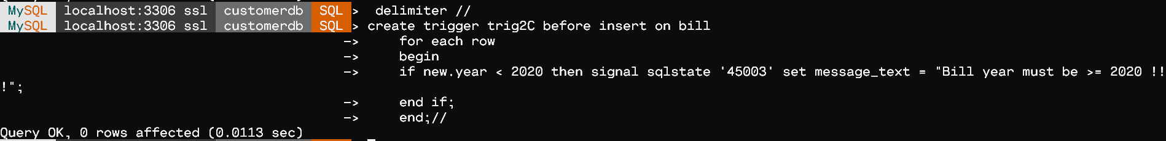

Ex. No.:  07               Date:   23-09-21                  Week:7

CODE

-------------------------------------------------------------------------

/*

CSLR-51 : DBMS LAB-7

Roll no. : 106119100

Name : Rajneesh Pandey

Section : CSE-B

*/

#include <bits/stdc++.h>

using namespace std;

vector<string> ans;

vector<int> mapps;

vector<int> nodes;

string relationship_alpha;

int relationship_alpha_len;

int dependency;

unordered_map<int, int> depends;

unordered_map<char, int> alpha_to_int;

unordered_map<int, char> int_to_alpha;

string mask_to_string(const int &mask)

{

    string str = "";

    for (int i = 0; i < relationship_alpha_len; i++)

    {

        if ((mask >> i) & 1)

            str += int_to_alpha[i];

    }

    return str;

}

int string_to_mask(const string &s)

{

    int mask = 0;

    for (auto &ch : s)

    {

        mask |= (1 << alpha_to_int[ch]);

    }

    return mask;

}

void init()

{

    cout << "Enter attributes in the Relationship: \n";

    cin >> relationship_alpha;

    relationship_alpha_len = relationship_alpha.length();

    mapps.assign(1 << relationship_alpha_len, 0);

    for (int i = 0; i < (1 << relationship_alpha_len); i++)

        mapps[i] = i;

    for (int i = 0; i < relationship_alpha_len; i++)

    {

        alpha_to_int[relationship_alpha[i]] = i;

        int_to_alpha[i] = relationship_alpha[i];

    }

    cout << "Enter total number of dependencies :\n";

    cin >> dependency;

    cout << "Enter dependencies : \n";

    for (int i = 0; i < dependency; i++)

    {

        cout<< i + 1 << " : ";

        string lhs, rhs;

        cin >> lhs >> rhs;

        depends[string_to_mask(lhs)] = depends[string_to_mask(lhs)] | string_to_mask(rhs);

    }

    cout << "\n\nFinished taking inputs.........\n";

    cout << "Processing.........\n";

}

/* C+ = C; while (there is changes to C+)

    { do (for each functional dependency X->Y in F) { if (X⊆C+) then C+= C+∪Y } }

*/

int get_closures(int mask)

{

    int c = mask;

    int prevc = 0;

    while (c != prevc)

    {

        prevc = c;

        for (auto &ele : depends)

        {

            if ((c & ele.first) == ele.first)

                c |= ele.second;

        }

    }

    return c;

}

void get_closures_all()

{

    for (int i = 0; i < (1 << relationship_alpha_len); i++)

    {

        mapps[i] = get_closures(i);

    }

}

void get_keys()

{

    bool found = false;

    int total = (1 << relationship_alpha_len) - 1;

    for (int len = 1; len <= relationship_alpha_len; len++)

    {

        vector<int> perm(relationship_alpha_len, 0);

        for (int t = relationship_alpha_len - len; t < relationship_alpha_len; perm[t++] = 1)

            ;

        do

        {

            int mask = 0;

            for (int i = 0; i < relationship_alpha_len; i++)

                if (perm[i])

                    mask |= (1 << i);

            if (mapps[mask] == total)

            {

                found = true;

                ans.push_back(mask_to_string(mask));

            }

        } while (next_permutation(perm.begin(), perm.end()));

        if (found)

            break;

    }

    cout << "\nCandicate Keys are: \n";

    for (auto &cands : ans)

        cout << cands << " ";

}

int main()

{

    init();

    get_closures_all();

    get_keys();

    return 0;

}

---------------------------------------------------------------

Problem 1

1. Consider the relation scheme R = {E, F, G, H, I, J, K, L, M, N} and the set of functional dependencies {{E, F} -> {G}, {F} -> {I, J}, {E, H} -> {K, L}, K -> {M}, L -> {N}} on R. What is the key for R?

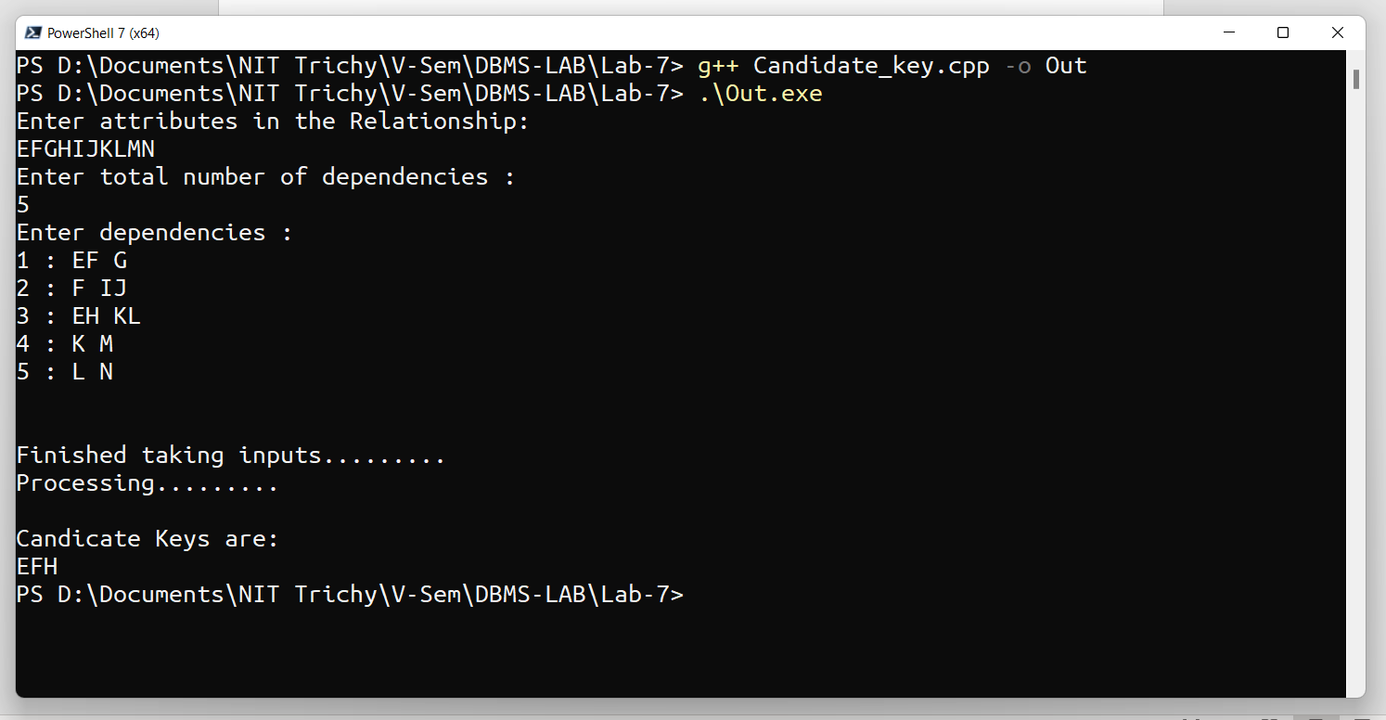

Problem 2

Consider a relation scheme R = (A, B, C, D, E, H) on which the following functional dependencies hold: {A–>B, BC–> D, E–>C, D–>A}. What are the candidate keys of R? write a c program to find it.

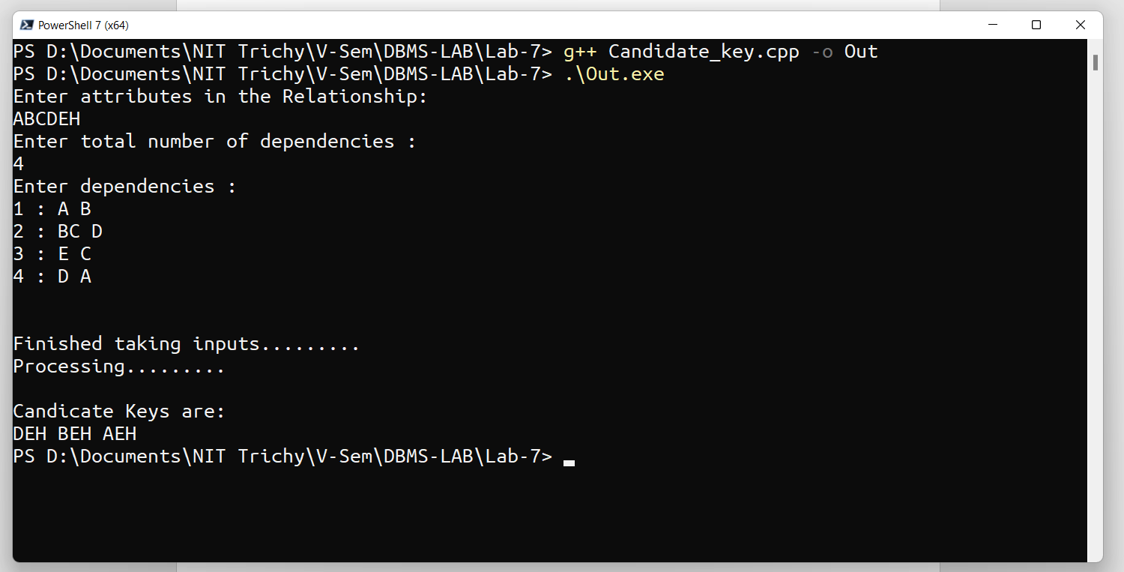

Ex. No.:  08               Date:   20-10-21                  Week:8

Design a simple database for Online Shopping Cart using Python to access the back-end MySQL database. The online shopping cart must contain the following modules.

import mysql.connector

from datetime import date, datetime

mydb = mysql.connector.connect(*host*="localhost", *user*='root', *password*='12345')

mycursor = mydb.cursor()

mycursor.execute("DROP DATABASE shopDB")

mycursor.execute("CREATE DATABASE shopDB")

mycursor.execute("USE shopDB")

mycursor.execute("Create table product(id int PRIMARY KEY, name varchar(20),category varchar(20), quantity int, price float, discount float, manf date,exp date)")

cont = "T"

opt = 0

while (cont == "t" or cont == "T"):

    opt = *int*(input("1. insert\n2.find\n3.search_in_category\n4.update\n5.provide_discount\n6.delete\n7.notification\nEnter your choice: "))

    if (opt == 1):

        insert_record()

    elif(opt == 2):

        find_record()

    elif(opt == 3):

        search_category()

    elif(opt == 4):

        update_record()

    elif(opt == 5):

        provide_discount()

    elif(opt == 6):

        delete_record()

    elif(opt == 7):

        notify()

    else:

        print("invalid option")

    cont = input("do you want to continue(T/F): ")

1.The insert module must be able to accept the prod_id(primary key),product name, category, quantity, price, discount, date of manufacture and date of expiry and store it in the database.

*def* insert_record():

        prod_id = *int*(input("Enter id: "))

        name = input("Enter name: ")

        category = input("Enter category: ")

        quantity = *int*(input("Enter quantity: "))

        price = *float*(input("Enter price in RS: "))

        discount = *float*(input("Enter discount in %: "))

        inputDate = input("Enter the date in format 'dd/mm/yy' : ")

        day1, month1, year1 = (inputDate.split('/'))

        manf = date(*int*(year1), *int*(month1), *int*(day1))

        inputDate = input("Enter the date in format 'dd/mm/yy' : ")

        day, month, year = inputDate.split('/')

        exp = date(*int*(year), *int*(month), *int*(day))

        sql = "INSERT INTO product(id, name, category, quantity, price, discount,manf, exp) values (%s, %s, %s, %s, %s, %s, %s, %s)"

        val = (prod_id, name, category, quantity, price, discount, manf, exp)

        mycursor.execute(sql, val)

        mydb.commit()

        print("record inserted")

Input/ Output :

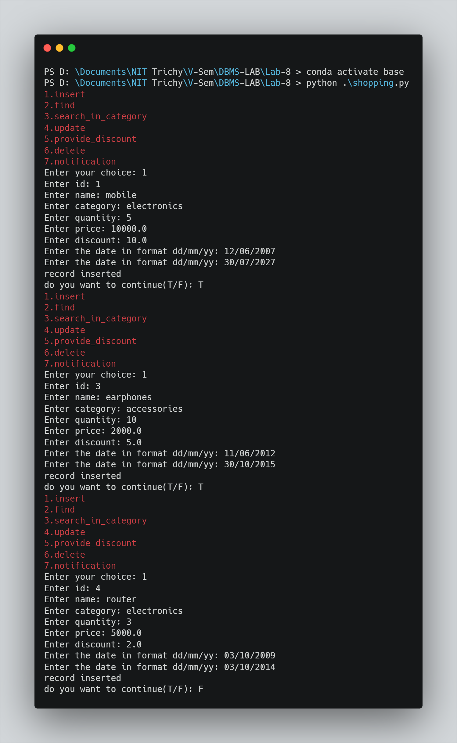

2.The find module must be able to accept the name of the product and display all the details of the product.

*def* find_record():

        name = input("Enter name: ")

        sql = *f*'SELECT * FROM product WHERE name = "{name}"'

        mycursor.execute(sql)

        myresult = mycursor.fetchall()

        if (len(myresult) == 0):

            print("no records")

        else:

            for x in myresult:

                print(x)

Input/Output :

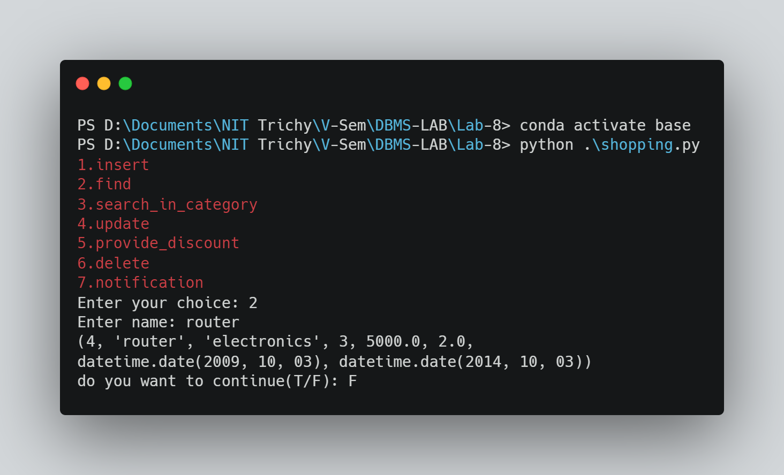

3.The search_in_category module must be able to accept the name of the category and display all the details of the products in the categories.

*def* search_category():

        category = input("Enter category: ")

        sql = *f*'SELECT * FROM product WHERE category = "{category}"'

*# que = (category)*

        print(sql)

        mycursor.execute(sql)

        myresult = mycursor.fetchall()

        if (len(myresult) == 0):

            print("no records")

        else:

            for x in myresult:

                print(x)

Input/Output :

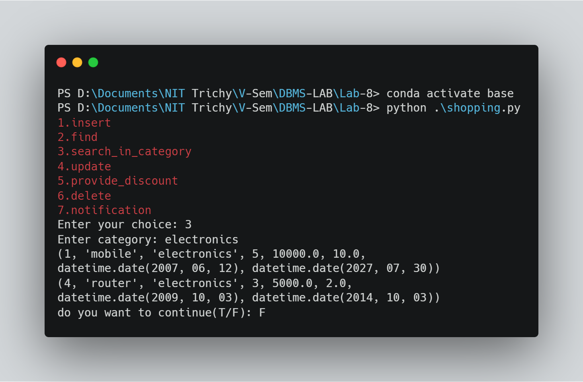

4.The update module must be able to update the price of the products.

*def* update_record():

        prod_id = *int*(input("Enter id: "))

        price = *float*(input("Enter price: "))

        sql = *f*'UPDATE product SET price = "{price}" WHERE id = "{prod_id}"'

*# val = (price, prod_id)*

        mycursor.execute(sql)

        mydb.commit()

        print("record updated")

Input/Output :

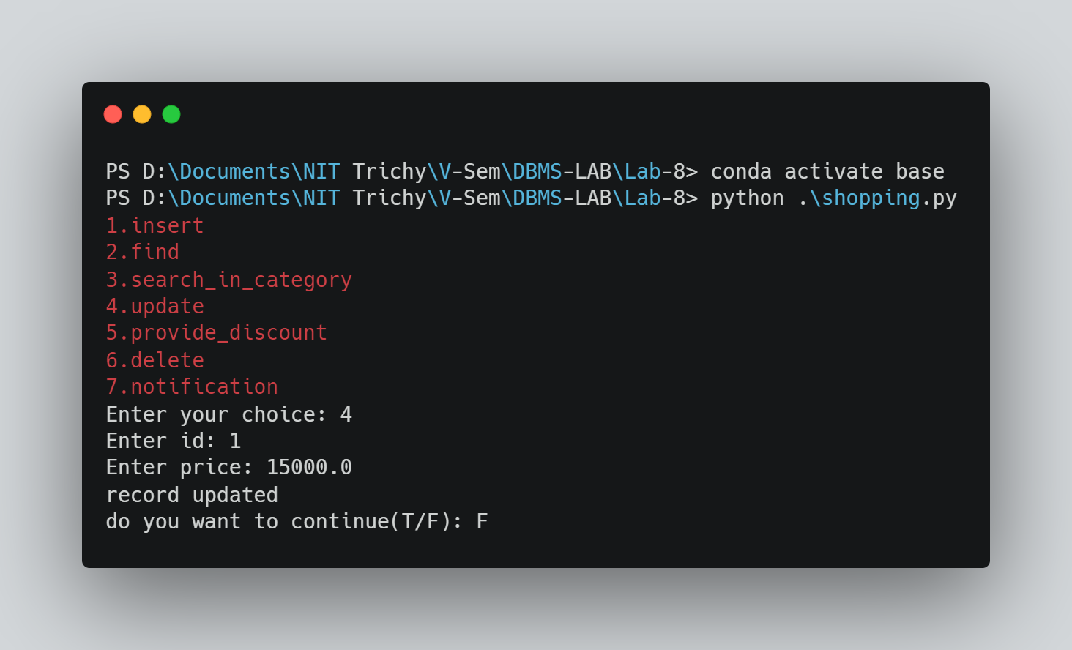

5.The provide_discount module must be able to provide the discount of the products in a particular category.

*def* provide_discount():

        category = input("Enter category: ")

        sql = *f*'SELECT name, discount FROM product WHERE category = "{category}"'

*# que = (category)*

        mycursor.execute(sql)

        myresult = mycursor.fetchall()

        if (len(myresult) == 0):

            print("no records")

        else:

            for x in myresult:

                print(x[0]+' : %d'%x[1])

Input/Output :

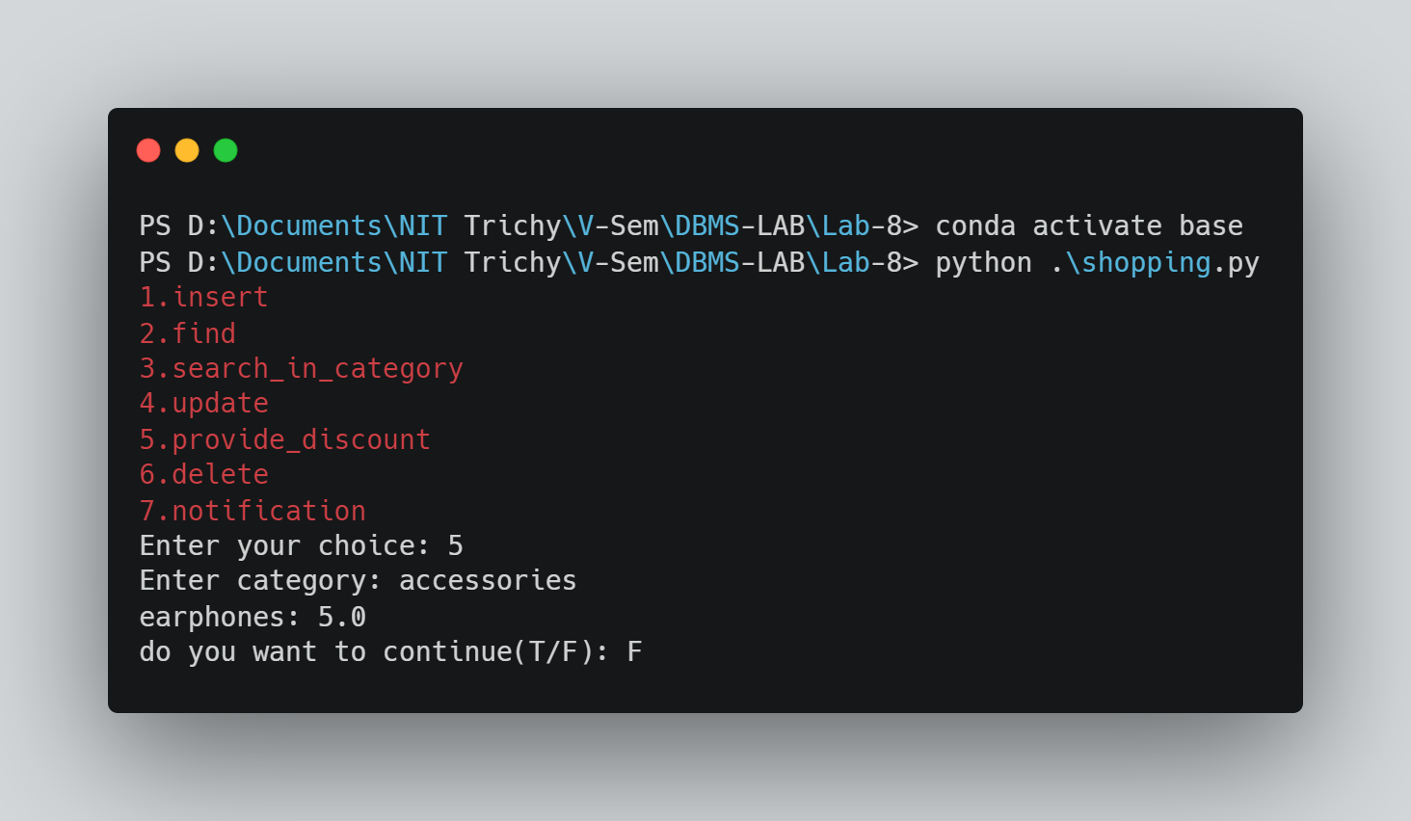

6.The delete_module must be able to delete/ cancel the product if the expiry date is not valid.

*def* delete_record():

        mycursor.execute('SELECT * FROM product')

        myresult = mycursor.fetchall()

        if (len(myresult) == 0):

            print("no records")

        else:

            for x in myresult:

                if (x[7] < datetime.now().date()):

                    print("record with id %d deleted" % x[0])

        sql = *f*"DELETE FROM product WHERE id = {x[0]}"

        mycursor.execute(sql)

        mydb.commit()

Input/Output :

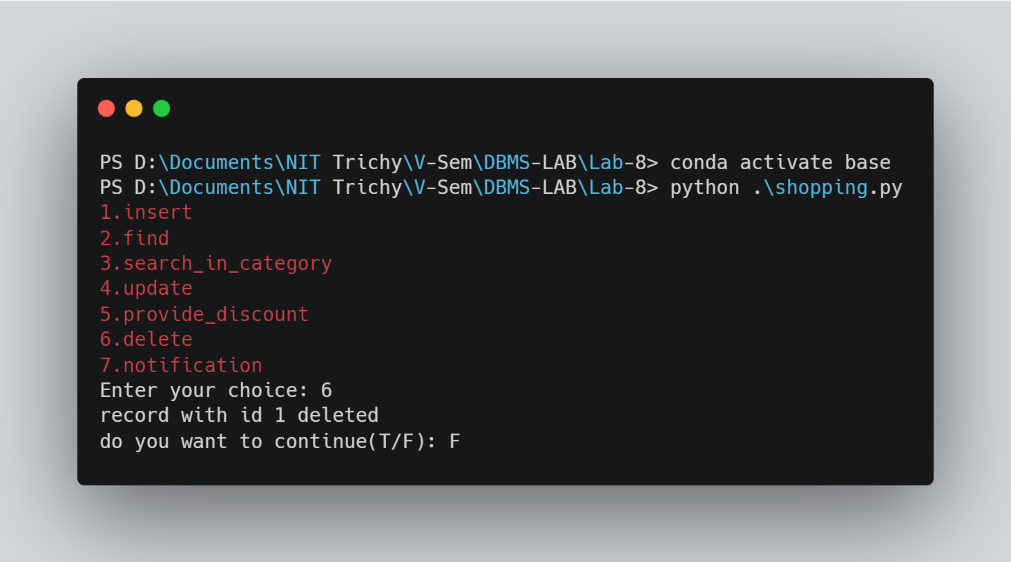

7.The notification_module must indicate free shipping if the total product price exceeds Rs.1000.

*def* notify():

        prod_id = *int*(input("Enter id: "))

        sql = *f*'SELECT price, discount FROM product WHERE id = {prod_id}'

        que = (prod_id)

        mycursor.execute(sql, que)

        myresult = mycursor.fetchall()

        if (len(myresult) == 0):

            print("no records")

        else:

             s = 0

             for x in myresult:

                s += x[0]

                s -= (x[0]*x[1]*0.01)

             if (s > 1000):

               print("Free shipping")

             else:

               print("no free shipping")

Input/Output :

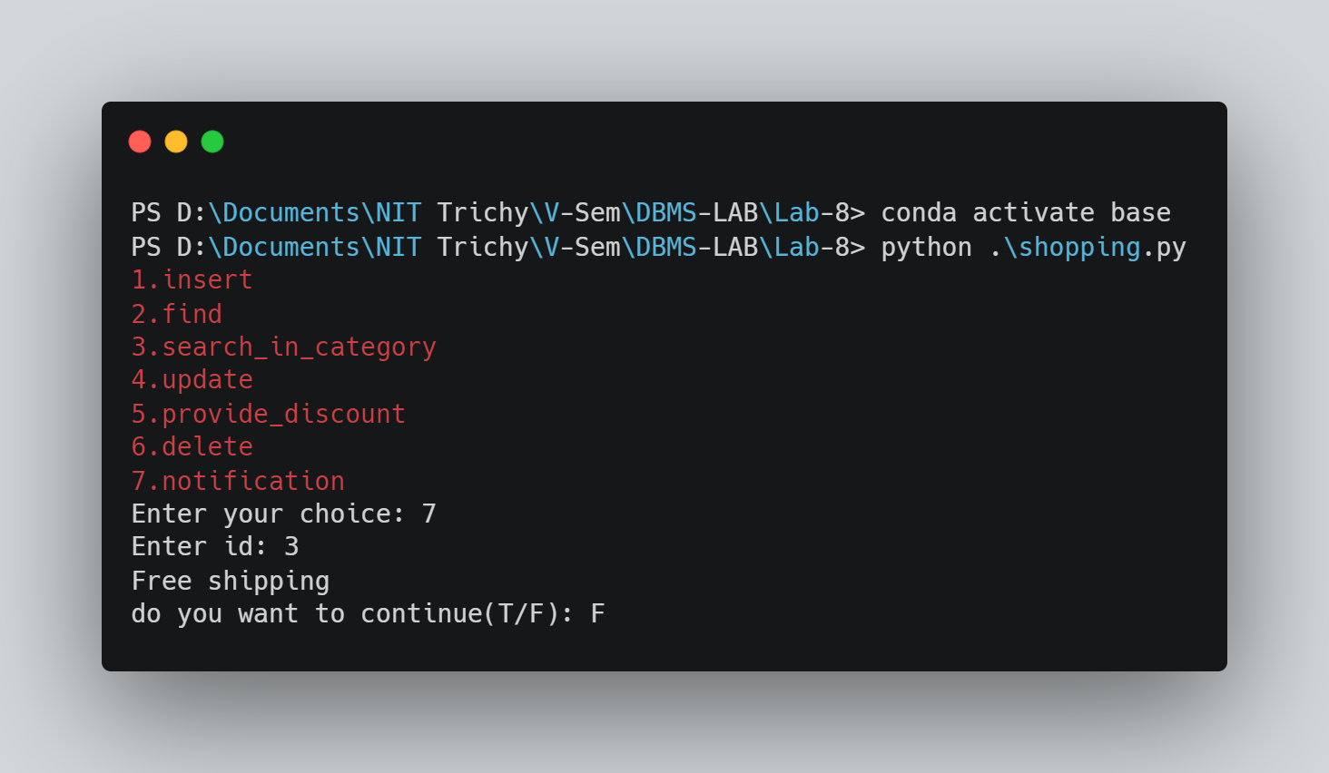

Ex. No.:  09              Date:   20-10-21                  Week:9

1)

a. Demonstrating DTD:

**1. filename :** *bookstore.dtd*

<!ELEMENT bookstore (book+)>

<!ELEMENT book (title,author,category,isbn,publisher,edition,price)>

<!ELEMENT title (#PCDATA)>

<!ELEMENT author (#PCDATA)>

<!ELEMENT category (#PCDATA)>

<!ELEMENT isbn (#PCDATA)>

<!ELEMENT publisher (#PCDATA)>

<!ELEMENT edition (#PCDATA)>

<!ELEMENT price (#PCDATA)>

**2. filename :** *bookstore.xml*

<?xml version="1.0"?>

<!DOCTYPE bookstore SYSTEM "bookstore.dtd">

    <bookstore>

            <book>

                <title>XML Developer's Guide</title>

                <author>Gambardella, Matthew</author>

                <category>textbook</category>

                <isbn>111111</isbn>

                <publisher>wiley</publisher>

                <edition>second</edition>

                <price>20.00</price>

            </book>

            <book>

                <title>Maeve Ascendant</title>

                <author>Corets, Eva</author>

                <category>textbook</category>

                <isbn>222222</isbn>

                <publisher>tata</publisher>

                <edition>second</edition>

                <price>60.00</price>

            </book>

            <book>

                <title>Midnight Rain</title>

                <author>Ralls, Kim</author>

                <category>fiction</category>

                <isbn>333333</isbn>

                <publisher>O'relilly</publisher>

                <edition>second</edition>

                <price>100.00</price>

            </book>

    </bookstore>

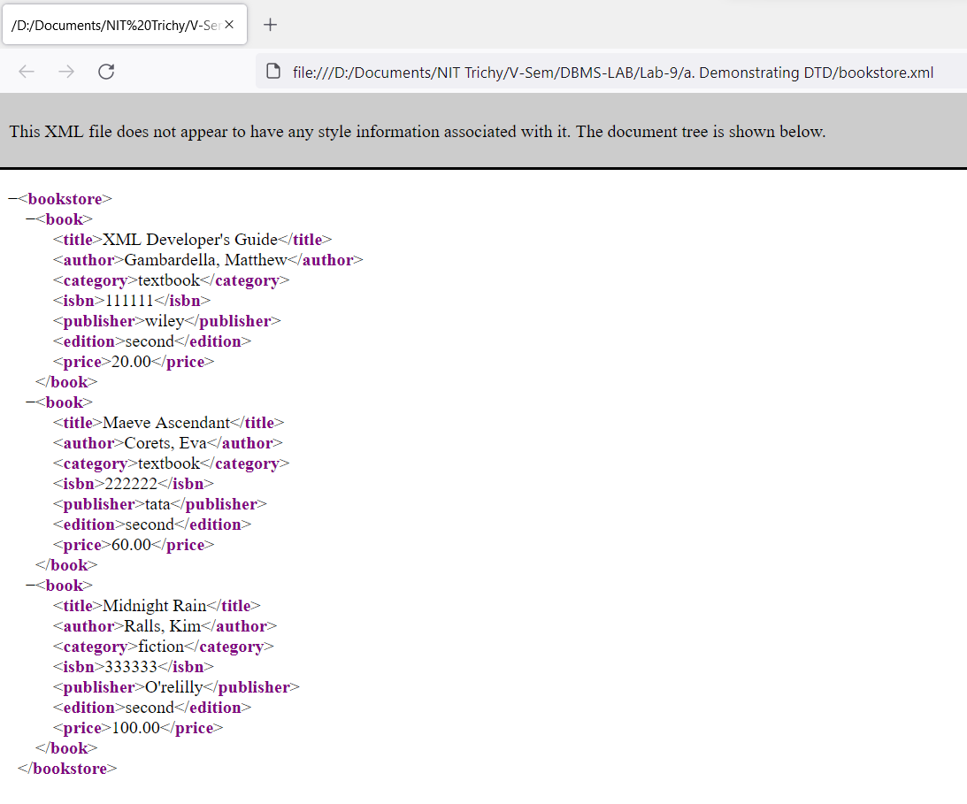

b. Demonstrating XSD:

**1. filename :** *bookstore.xml*

<?xml version="1.0" encoding="iso-8859-1"?>

<xs:schema xmlns:xs="http://www.w3.org/2001/XMLSchema">

    <xs:element name="bookstore">

        <xs:complexType>

            <xs:sequence>

               <xs:element name="book" minOccurs="1" maxOccurs="unbounded" />

            </xs:sequence>

        </xs:complexType>

    </xs:element>

    <xs:element name="book">

        <xs:complexType>

            <xs:sequence>

                <xs:element ref="title" minOccurs="1" maxOccurs="1" />

                <xs:element ref="author" minOccurs="1" maxOccurs="1" />

                <xs:element ref="category" minOccurs="1" maxOccurs="1" />

                <xs:element ref="isbn" minOccurs="1" maxOccurs="1" />

                <xs:element ref="publisher" minOccurs="1" maxOccurs="1" />

                <xs:element ref="edition" minOccurs="1" maxOccurs="1" />

                <xs:element ref="price" minOccurs="1" maxOccurs="1" />

            </xs:sequence>

        </xs:complexType>

    </xs:element>

    <xs:element name="title" type="xs:string" />

    <xs:element name="author" type="xs:string" />

    <xs:element name="category" type="xs:string" />

    <xs:element name="isbn" type="xs:string" />

    <xs:element name="publisher" type="xs:string" />

    <xs:element name="edition" type="xs:string" />

    <xs:element name="price" type="xs:string" />

</xs:schema>

**2. filename :** *bookstore.css*

bookstore {

  color: orange;

}

book {

  color: Red;

}

title {

  color: blue;

  font-weight: bold;

  margin-left: 10pt;

  display: block;

}

author {

  color: red;

  font-weight: bold;

  margin-left: 10pt;

}

category {

  color:grey;

  font-weight: bold;

  margin-left: 10pt;

}

isbn {

  color: green;

  font-weight: bold;

  margin-left: 10pt;

}

edition {

  color: red;

  font-weight: bold;

  margin-left: 10pt;

}

publisher {

  color: green;

  font-weight: bold;

  margin-left: 10pt;

}

**3. filename :** *bookstore.xsl*

<?xml version="1.0"?>

<?xml-stylesheet type="text/css" href="bookstore.css"?>

<bookstore xmlns:xsi="http:www.w3.org/2001/xmlschema-instance" xsi:noNamespaceSchemaLocation="bookstore.xsd">

    <book>

        <title>XML Developer's Guide</title>

        <author>Gambardella, Matthew</author>

        <category>textbook</category>

        <isbn>111111</isbn>

        <publisher>wiley</publisher>

        <edition>second</edition>

        <price>20.00</price>

    </book>

    <book>

        <title>Maeve Ascendant</title>

        <author>Corets, Eva</author>

        <category>textbook</category>

        <isbn>222222</isbn>

        <publisher>tata</publisher>

        <edition>second</edition>

        <price>60.00</price>

    </book>

    <book>

        <title>Midnight Rain</title>

        <author>Ralls, Kim</author>

        <category>fiction</category>

        <isbn>333333</isbn>

        <publisher>O'relilly</publisher>

        <edition>second</edition>

        <price>100.00</price>

    </book>

</bookstore>

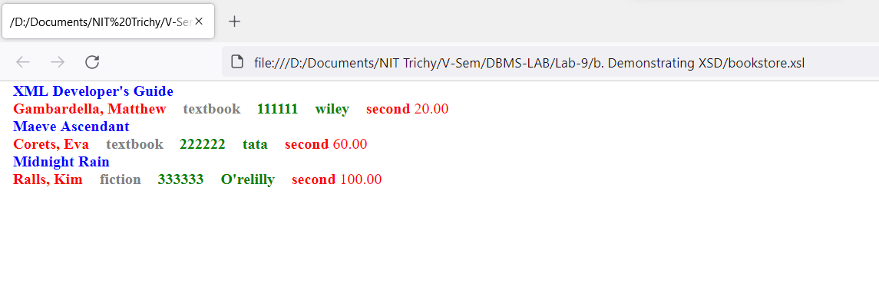

c. Demonstrating XSL:

**1. filename :** *bookstore.xsl*

<xsl:stylesheet version="1.0" xmlns:xsl="http://www.w3.org/1999/XSL/Transform">

    <xsl:template match="/">

        <html>

            <head>

                <title>bookstore</title>

            </head>

            <body>

                <table border="1">

                    <tr>

                        <th>title</th>

                        <th>author</th>

                        <th>category</th>

                        <th>isbn</th>

                        <th>publisher</th>

                        <th>edition</th>

                        <th>price</th>

                    </tr>

                    <xsl:for-each select="/bookstore/book">

                        <tr>

                            <td bgcolor="green">

                                <xsl:value-of select="title" />

                            </td>

                            <td bgcolor="red">

                                <xsl:value-of select="author" />

                            </td>

                            <td bgcolor="grey">

                                <xsl:value-of select="category" />

                            </td>

                            <td bgcolor="cyan">

                                <xsl:value-of select="isbn" />

                            </td>

                            <td bgcolor="yellow">

                                <xsl:value-of select="publisher" />

                            </td>

                            <td bgcolor="silver">

                                <xsl:value-of select="edition" />

                            </td>

                            <td bgcolor="blue">

                                <xsl:value-of select="price" />

                            </td>

                        </tr>

                    </xsl:for-each>

                </table>

            </body>

        </html>

    </xsl:template>

</xsl:stylesheet>

**2. filename :** *bookstore.xml*

<?xml-stylesheet type="text/xsl"  href="bookstore.xsl"?>

<bookstore>

    <book>

        <title>XML Developer's Guide</title>

        <author>Gambardella, Matthew</author>

        <category>textbook</category>

        <isbn>111111</isbn>

        <publisher>wiley</publisher>

        <edition>second</edition>

        <price>20.00</price>

    </book>

    <book>

        <title>Maeve Ascendant</title>

        <author>Corets, Eva</author>

        <category>textbook</category>

        <isbn>222222</isbn>

        <publisher>tata</publisher>

        <edition>second</edition>

        <price>60.00</price>

    </book>

    <book>

        <title>Midnight Rain</title>

        <author>Ralls, Kim</author>

        <category>fiction</category>

        <isbn>333333</isbn>

        <publisher>O'relilly</publisher>

        <edition>second</edition>

        <price>100.00</price>

    </book>

</bookstore>

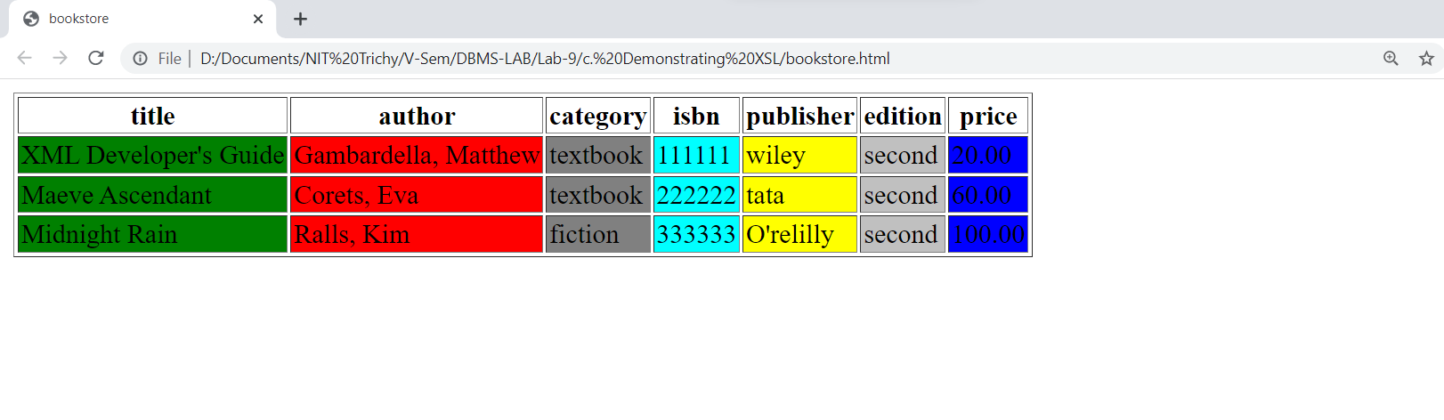

2 ) Perform the following queries using XPath :

1. Find the title and price of non-fiction books with a price more than 50 USD

***Xpath query*** : /**bookstore**/**book**[**category**!="fiction" and **price**>50.00]/(**title** | **isbn**)

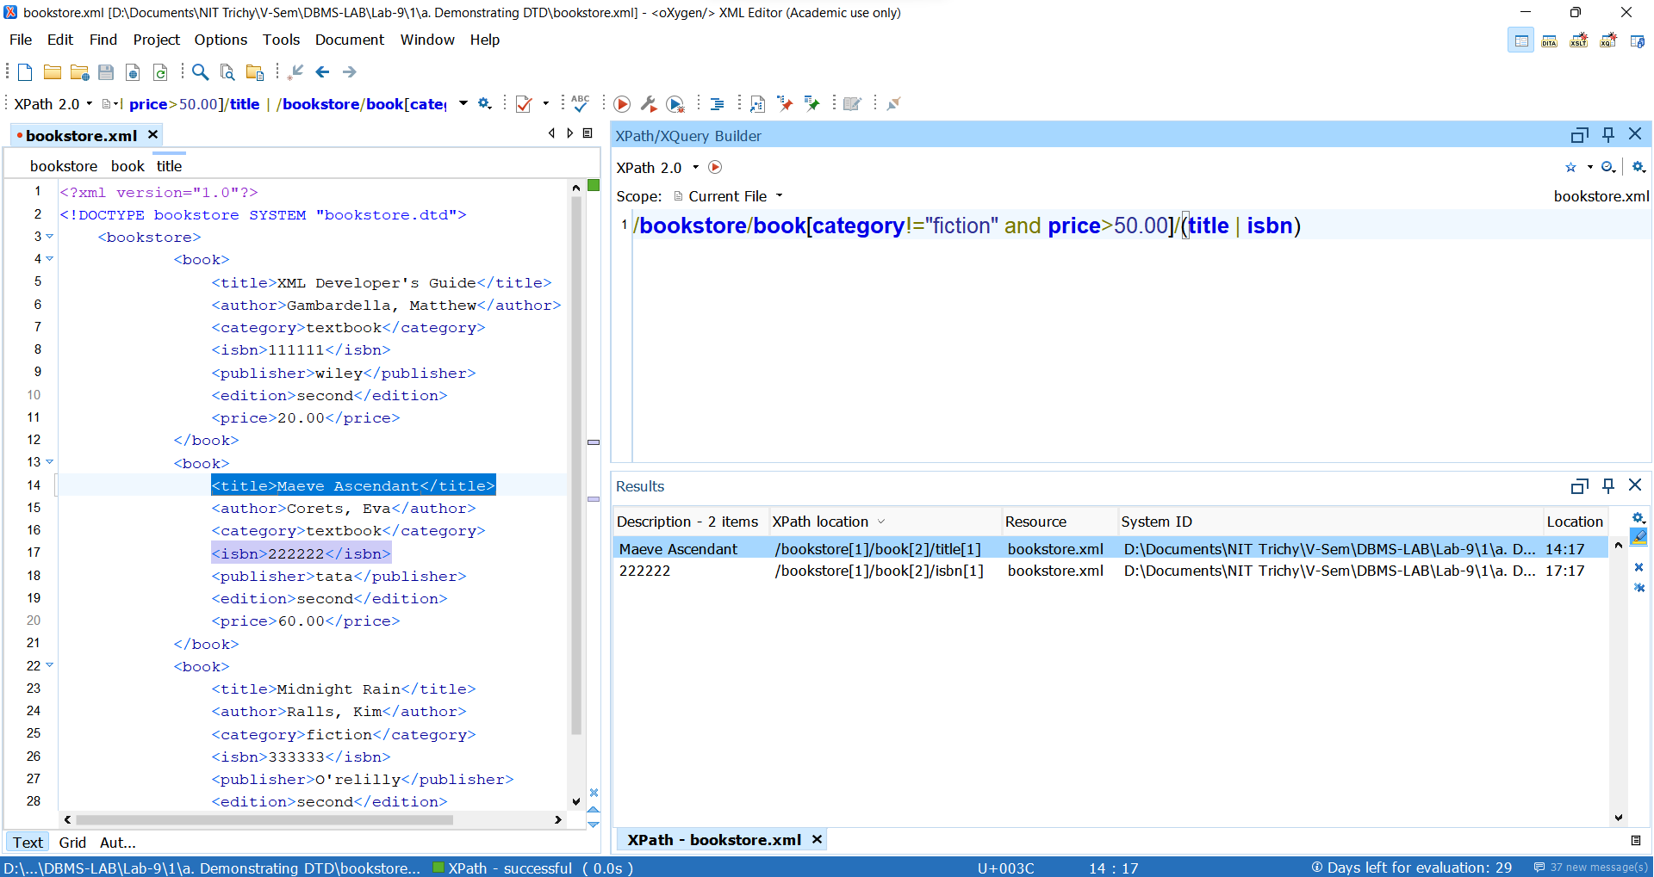

1. Find average price of textbooks

***Xpath query*** : *sum*(/**bookstore**/**book**[**category**="textbook"]/**price**/*number*(*text*())) div *count*(/**bookstore**/**book**[**category**="textbook"]/**price**)

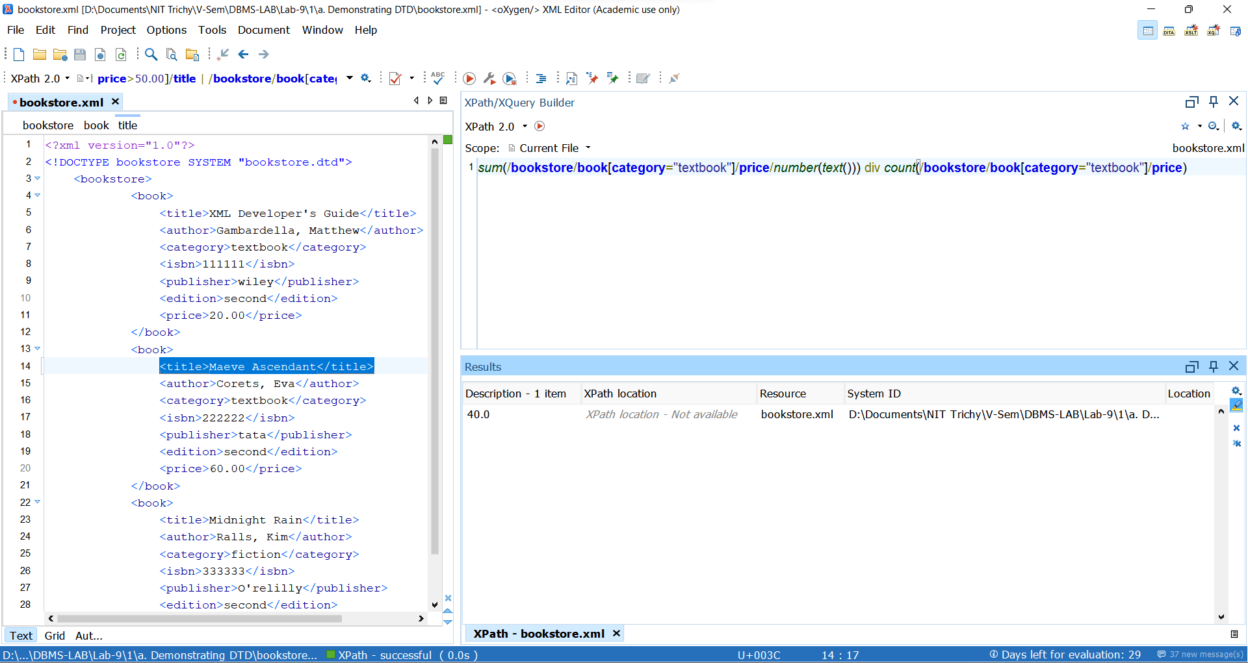

1. Find the titles of textbooks on XML

***Xpath query*** : /**bookstore**/**book**[**category**="textbook" and *contains*(**title**, "XML")]/**title**/*text*()

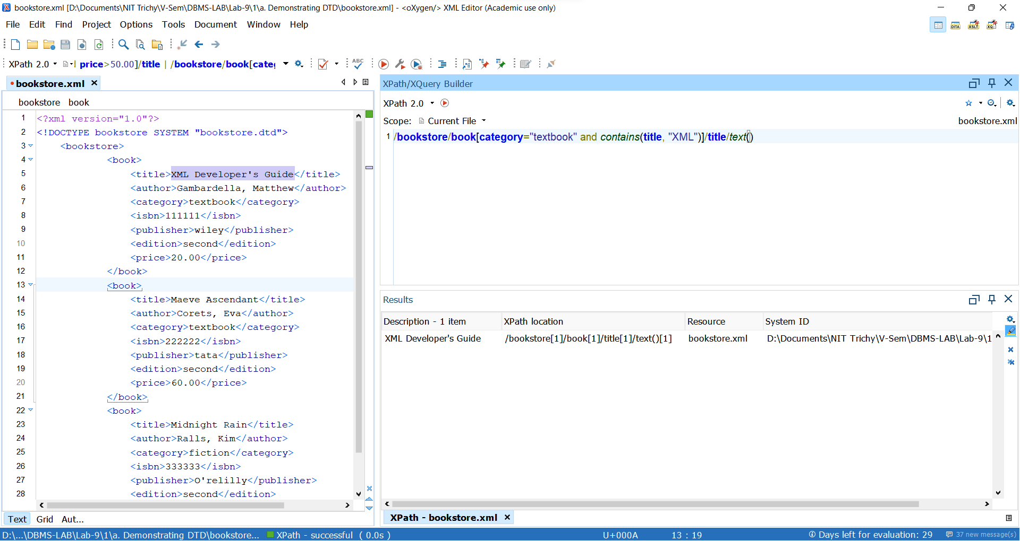

1. Perform the following queries using XQuery:
2. Create a new document which contain only the isbn and title of textbooks

***XQuery***

<textbook>  
 {  
 **for** **$book** **in** *doc*("bookstore.xml") // **book**   
 **where** **$book**[**category** = "textbook"]   
 **return** <textbook>{**$book**/**title**}{**$book**/**isbn**}</textbook>  
 }  
 </textbook>

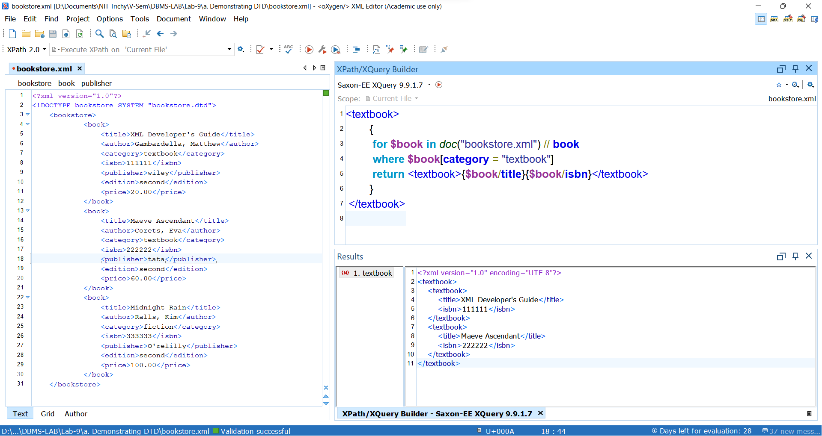

1. Find the title and price of the book with isbn “222222”.

***XQuery :***

**for** **$book** **in** *doc*("bookstore.xml") // **book** **where** **$book**[**isbn**="222222"]  
 **return** <book>{ **$book**/**title**, **$book**/**price**}</book>

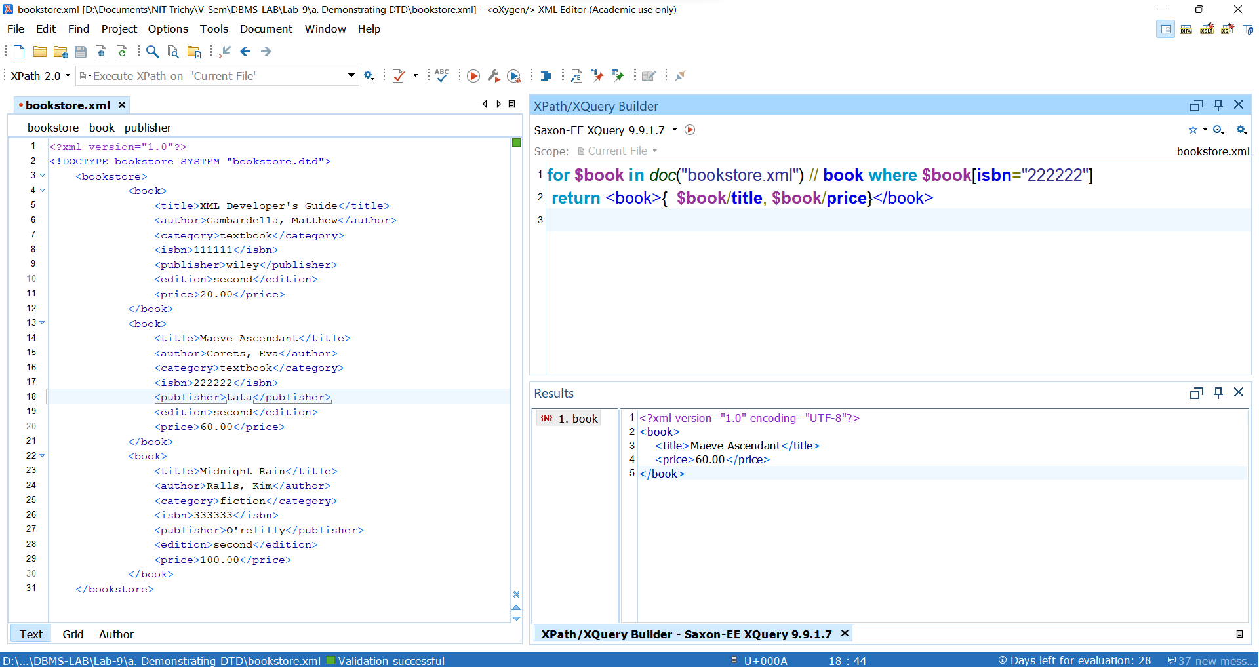

1. Produce a list of non-fictions with their title and price, sorted by price

***XQuery :***

<nonfiction-list>  
 {   
 **for** **$book** **in** *doc*("bookstore.xml")//**book**, **$title** **in** **$book**/**title**, **$price** **in** **$book**/**price**   
 **where** **$book**/**category**!="fiction" **order by** **$price**/*text*()   
 **return**  
 <nonfiction>{**$title**, **$price**}</nonfiction>  
 }  
</nonfiction-list>

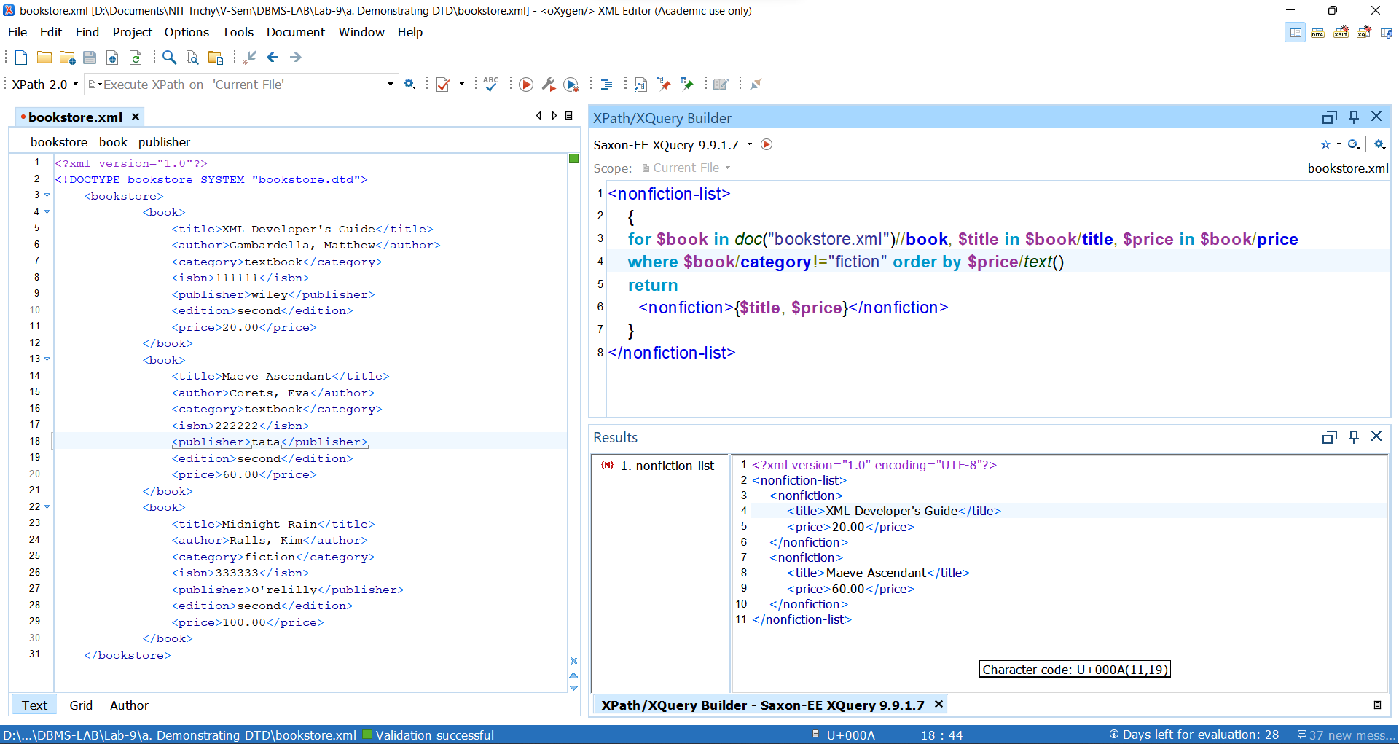

1. Find title of the textbook with highest price

***XQuery :***

<textbooks>  
 { **let** **$prices** := *doc*("bookstore.xml")// **book**[**category**="textbook"]/**price** **let** **$max** := *max*(**$prices**)  
 **return**  
 <max-price-textbook **price**=**"**{**$max**}**"**>  
 {**for** **$book** **in** *doc*("bookstore.xml")// **book** **where** **$book**/**price** = **$max** **return** **$book**/**title**}  
 </max-price-textbook>  
 }  
</textbooks>

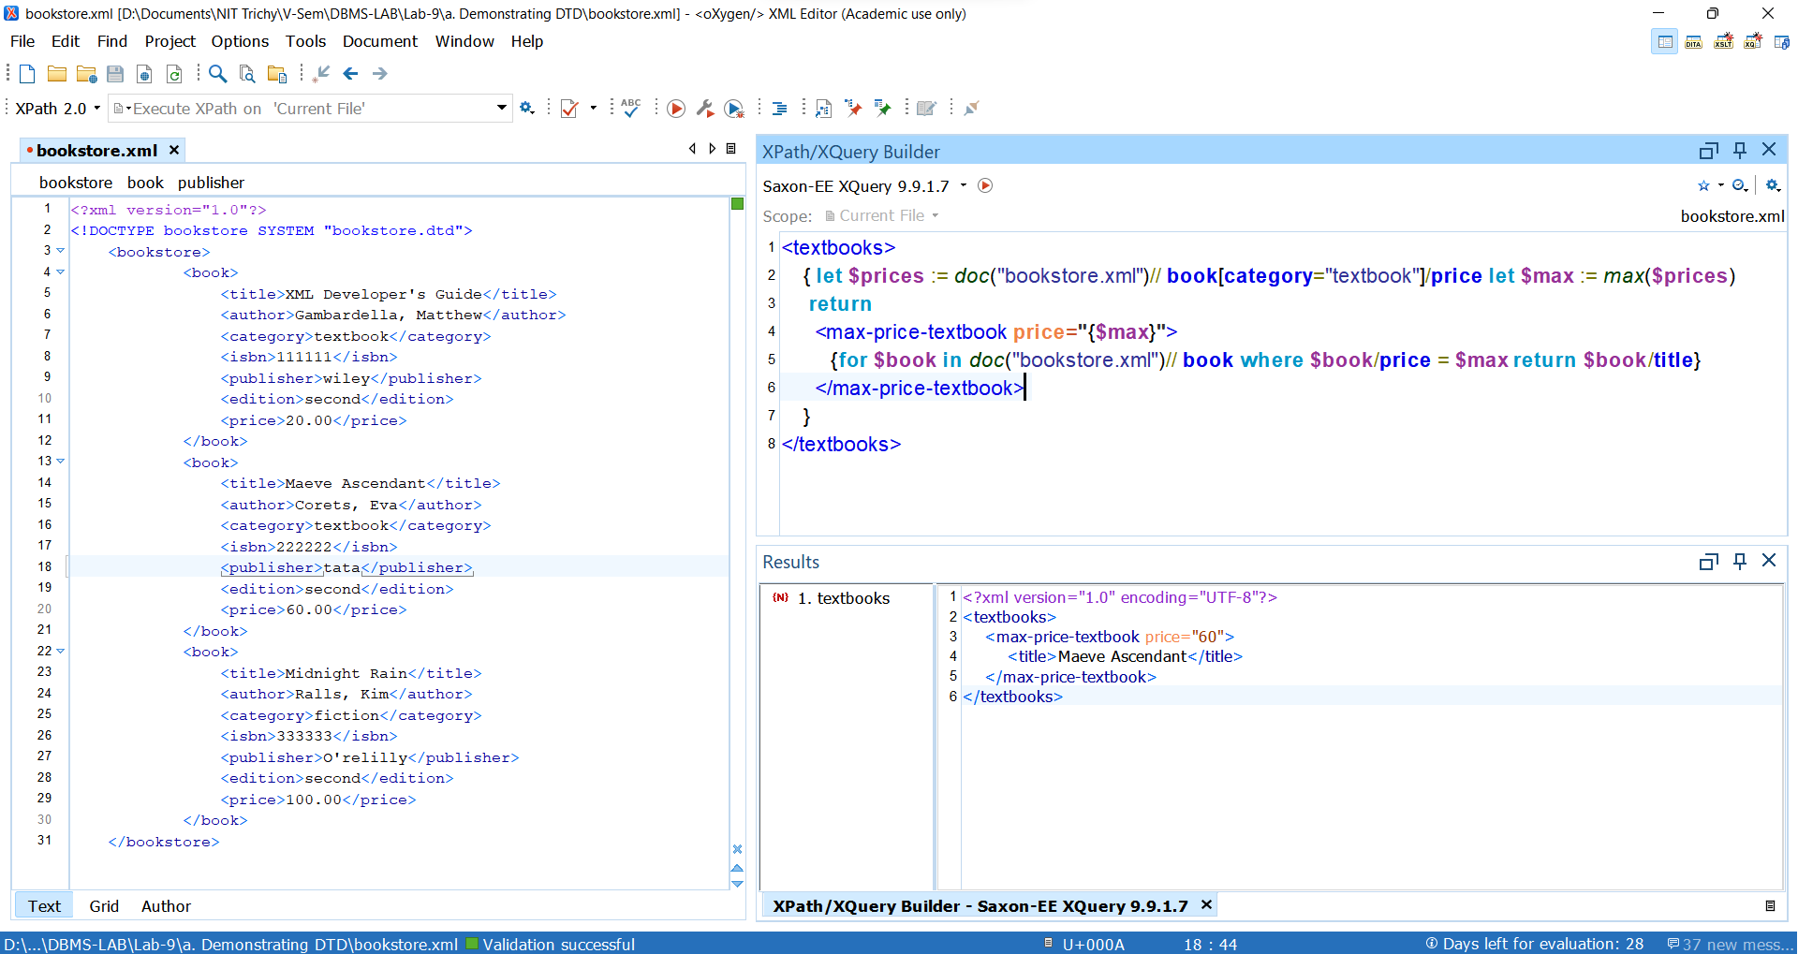

Ex. No.:  10               Date:   28-10-21                  Week:10

-- Create database EMP and Make Collection With name "EMPL" and Follow Queries

--Created Database

 use emp

 switched to DB emp

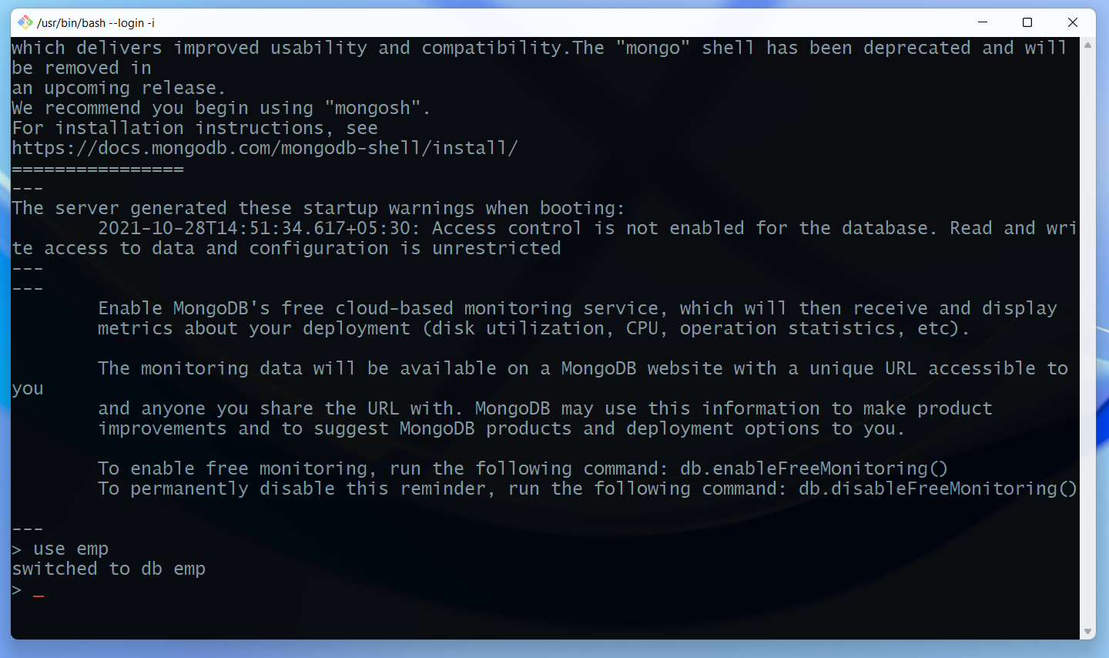

Database created :

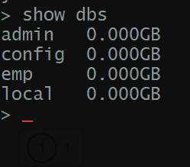

--Create Collection

 db.createCollection("empl")

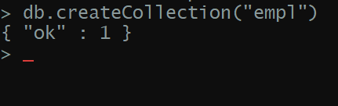

--Insert Records Into EMPL Collection

 db.empl.insert([

 {no:1,name:"ST",salary:2000,role:"OB"},

 {no:2,name:"MSD",salary:1500,role:"WK"},

 {no:3,name:"YS",salary:1000,role:"ALR"},

 {no:4,name:"RD",salary:1000,role:"MOB"},

 {no:5,name:"RS",salary:500,role:"OB"},

 {no:6,name:"BK",salary:500,role:"MOB"},

 {no:7,name:"VK",salary:300,role:"BW"},

 {no:8,name:"JB",salary:400,role:"BW"},

 {no:9,name:"HP",salary:400,role:"ALR"},

 {no:10,name:"VS",salary:300,role:"OB"}])

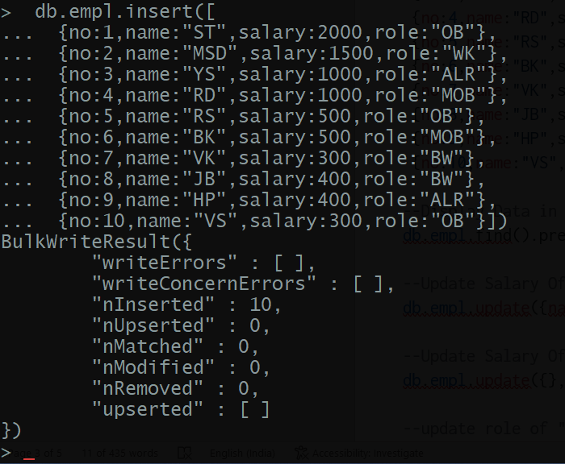

--Display Data in Proper Format

db.empl.find().pretty()

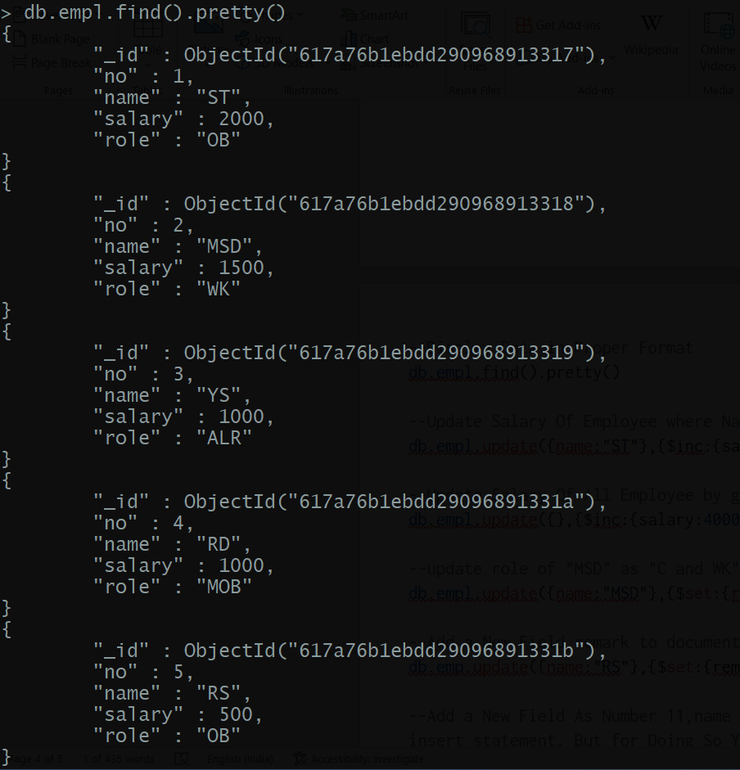

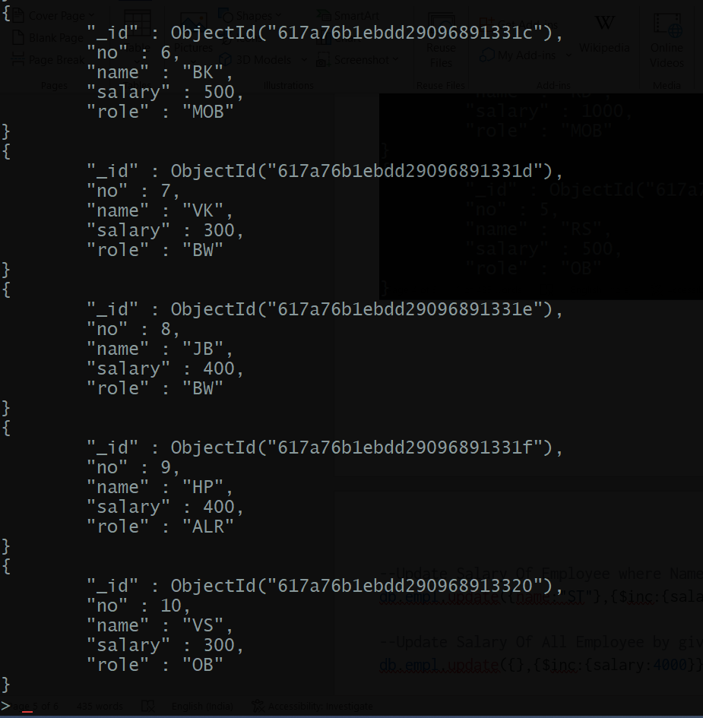

--Update Salary Of Employee where Name is "ST" by +8000

db.empl.update({name:"ST"},{$inc:{salary:8000}})



--Update Salary Of All Employee by giving an increment of +4000 each

db.empl.update({},{$inc:{salary:4000}},{multi:true})

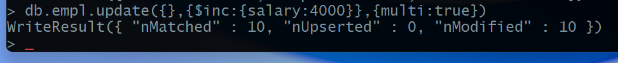

--update role of "MSD" as "C and WK"

db.empl.update({name:"MSD"},{$set:{role:"c and WK"}})

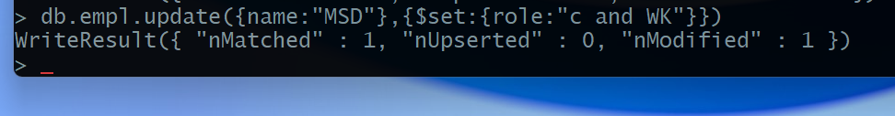

--Add a New Field remark to document with name "RS" set Remark as WC

db.empl.update({name:"RS"},{$set:{remark:"WC"}})

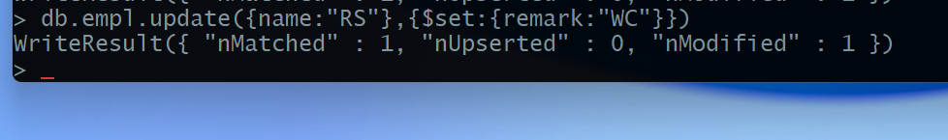

--Add a New Field As Number 11,name AK,Salary 10000,role coach without using insert statement. But for Doing So You should have a Record Added with number 11.

db.empl.update({no:11},{$set:{no:11,name:"AK",salary:10000,role:"coach"}},{upsert:true})

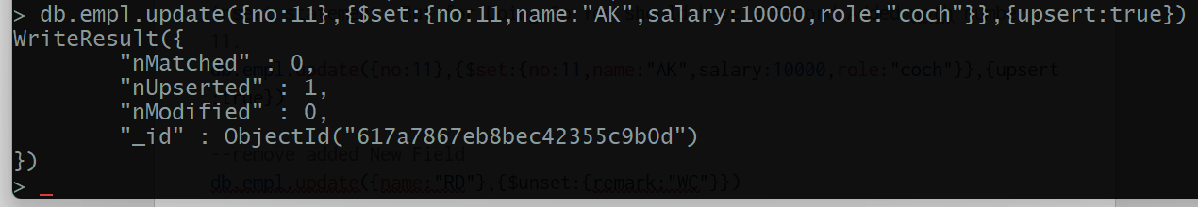

--remove added New Field

db.empl.update({name:"RS"},{$unset:{remark:"WC"}})

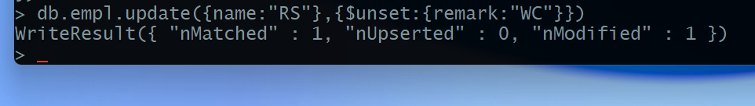

--Update the Field "RD" by multiplying with salary by 2

db.empl.update({name:"RD"},{$mul:{salary:2}})

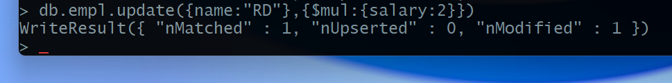

--To Find Document From the empl collection where name begins with S

db.empl.find({name:/^S/})

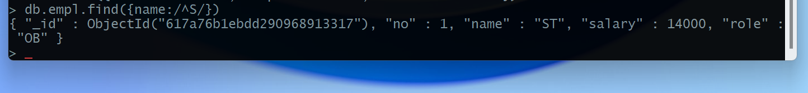

Database After all the query

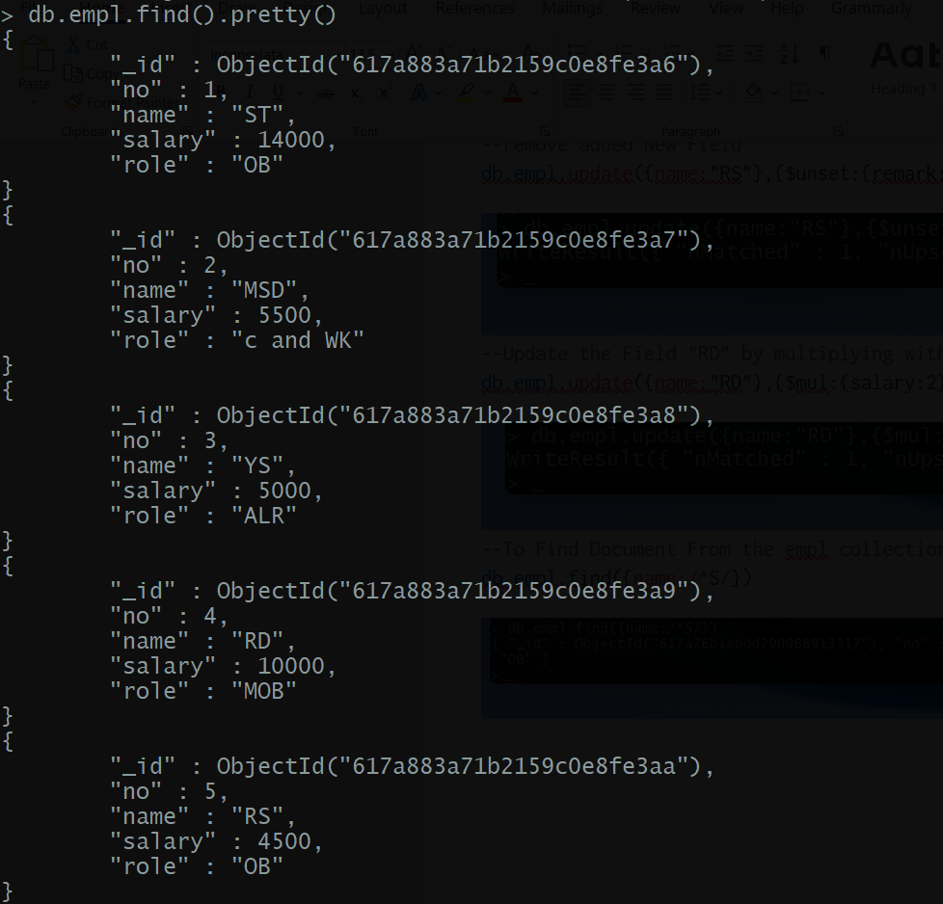

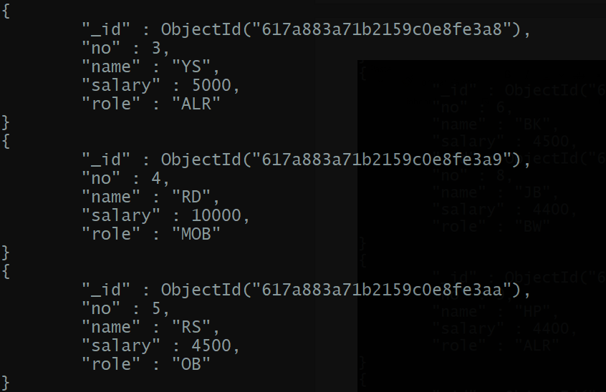

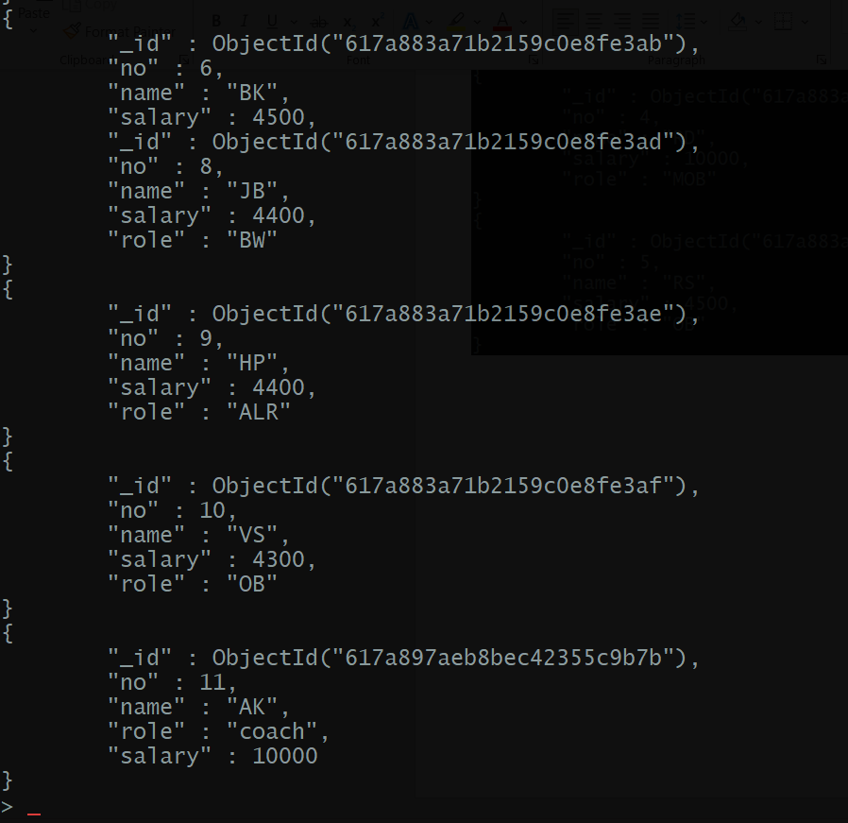

Ex. No.:  11               Date:   11-11-21                  Week: 11

SQL Data Base for Library Management System

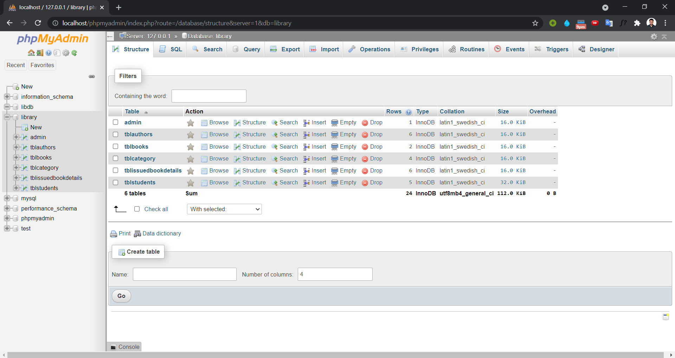

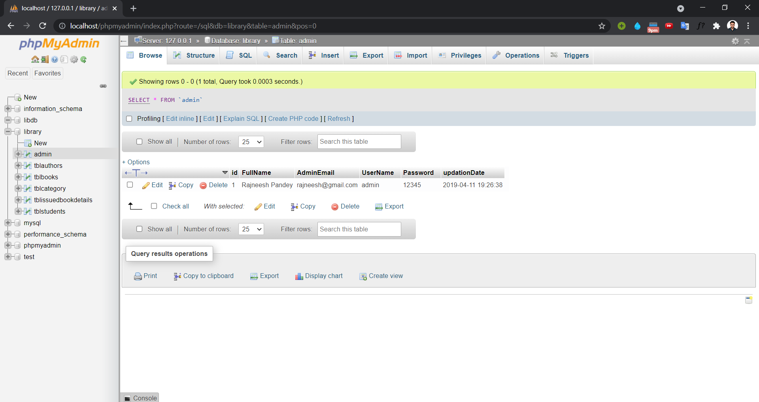

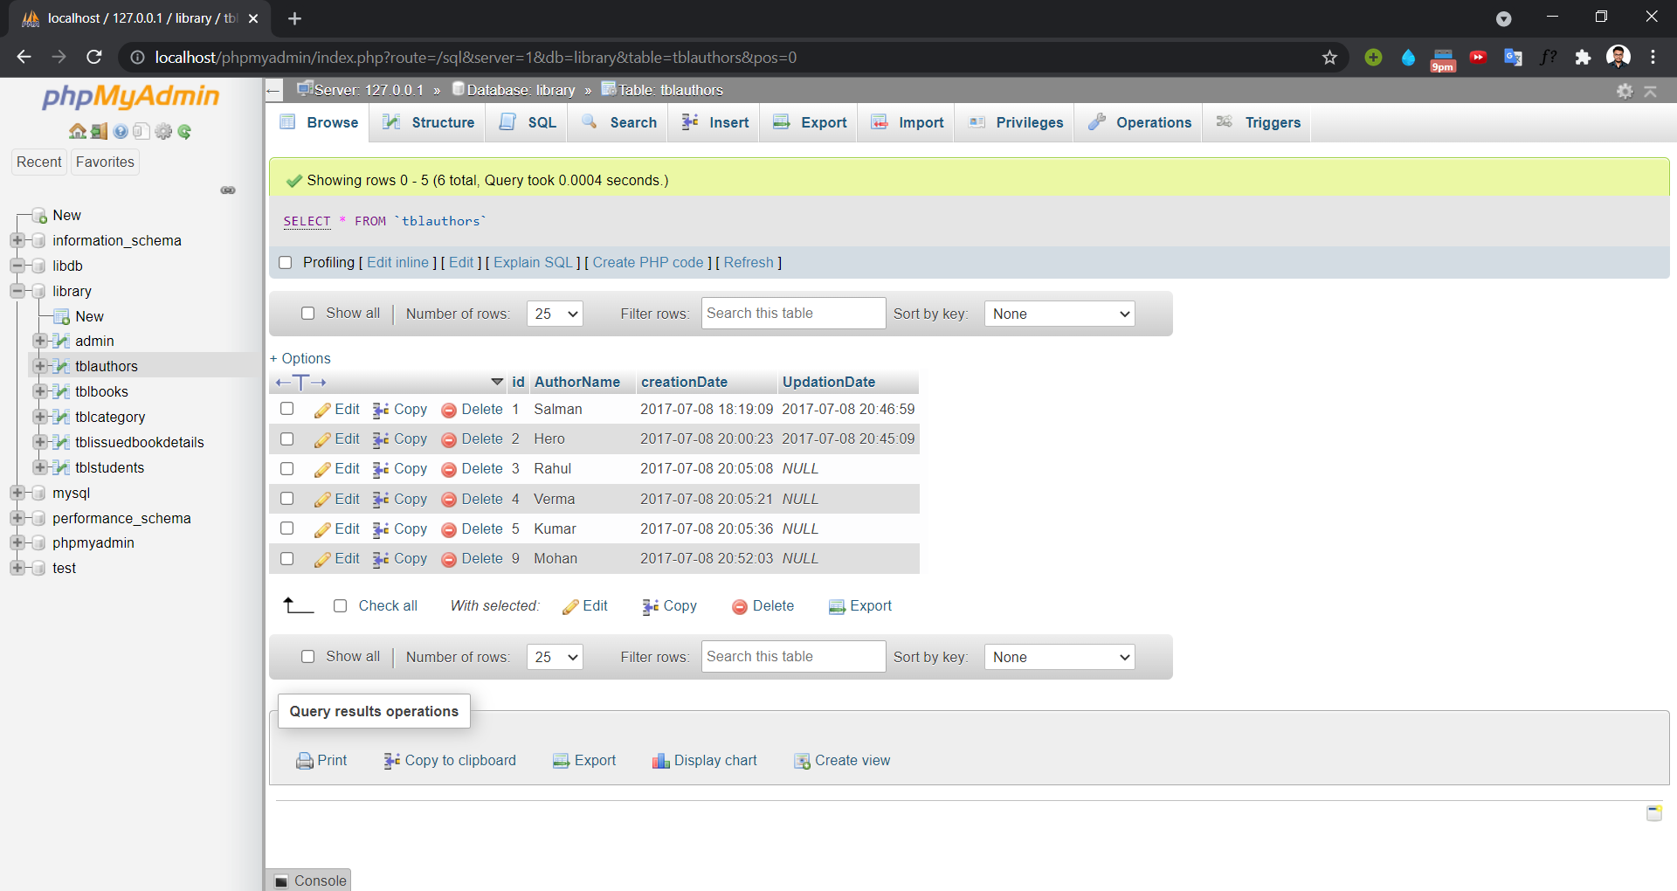

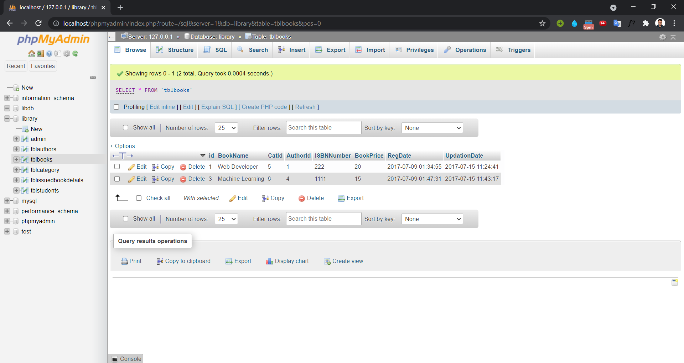

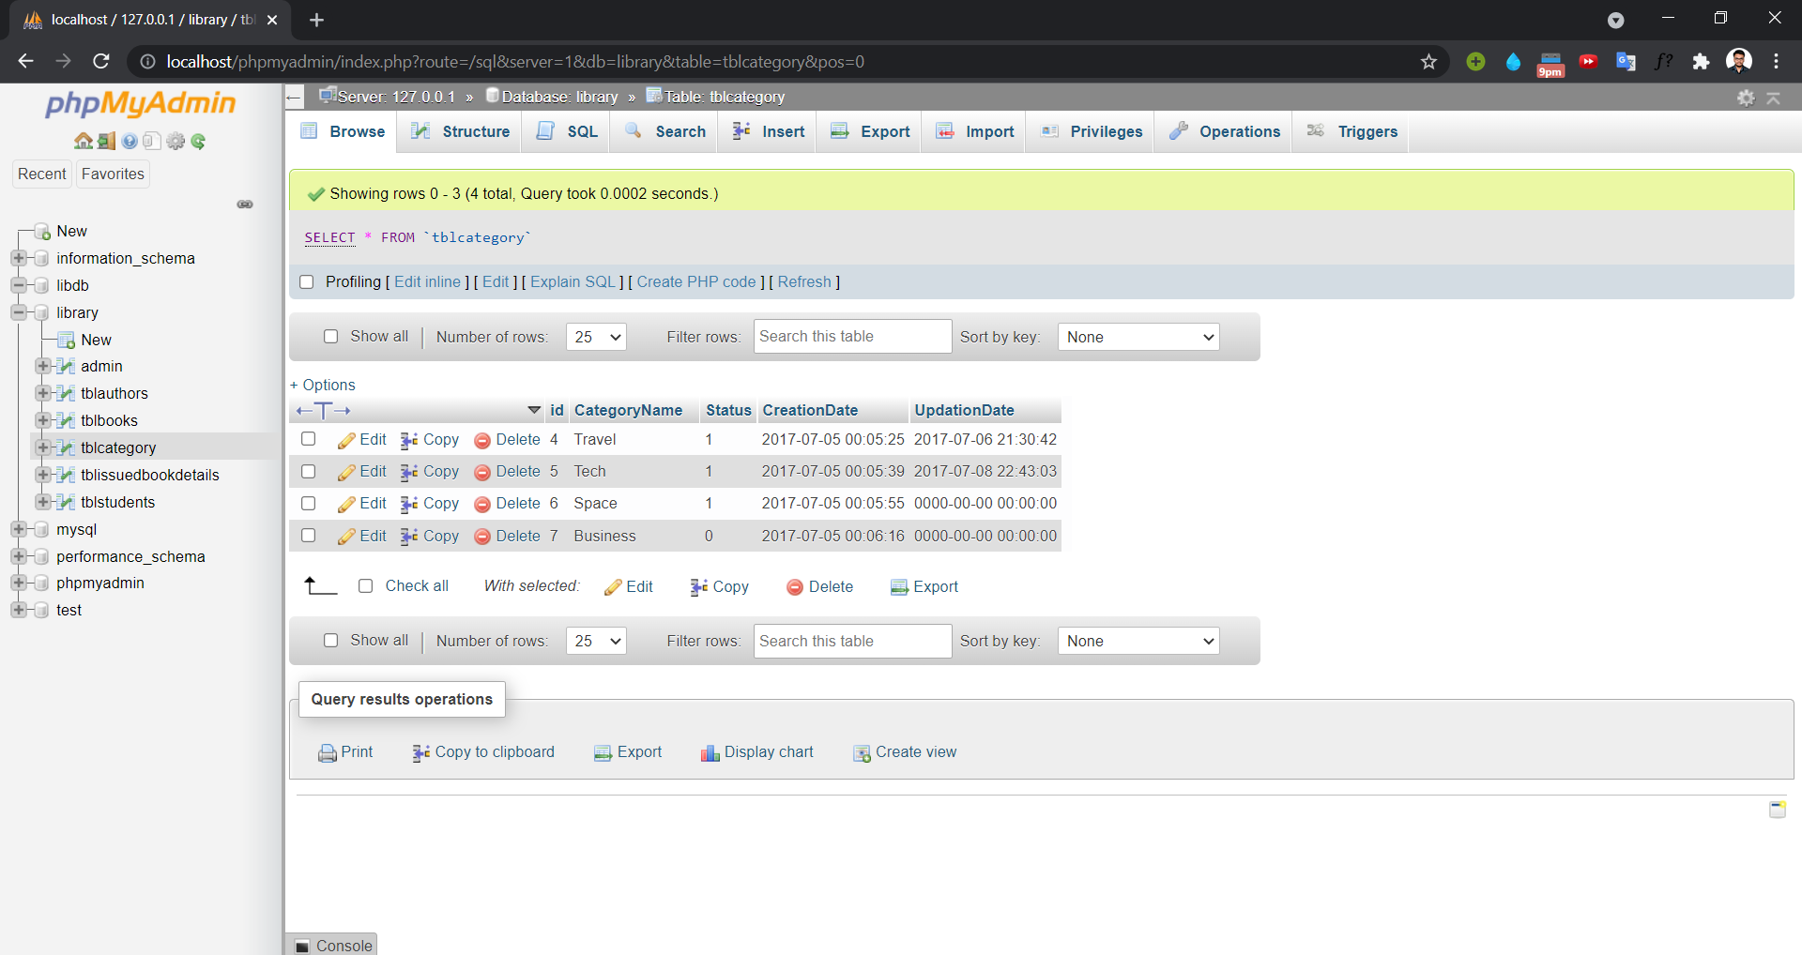

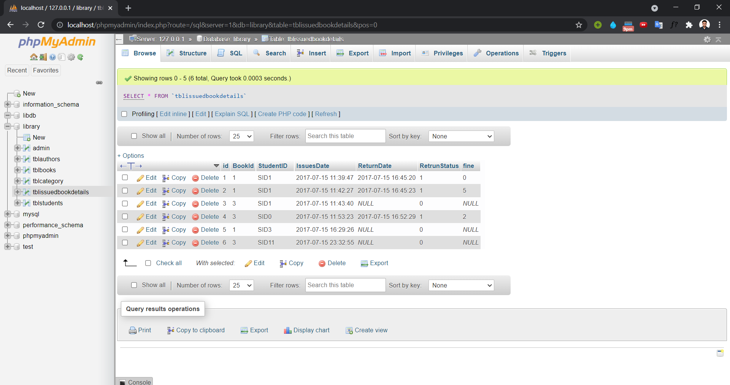

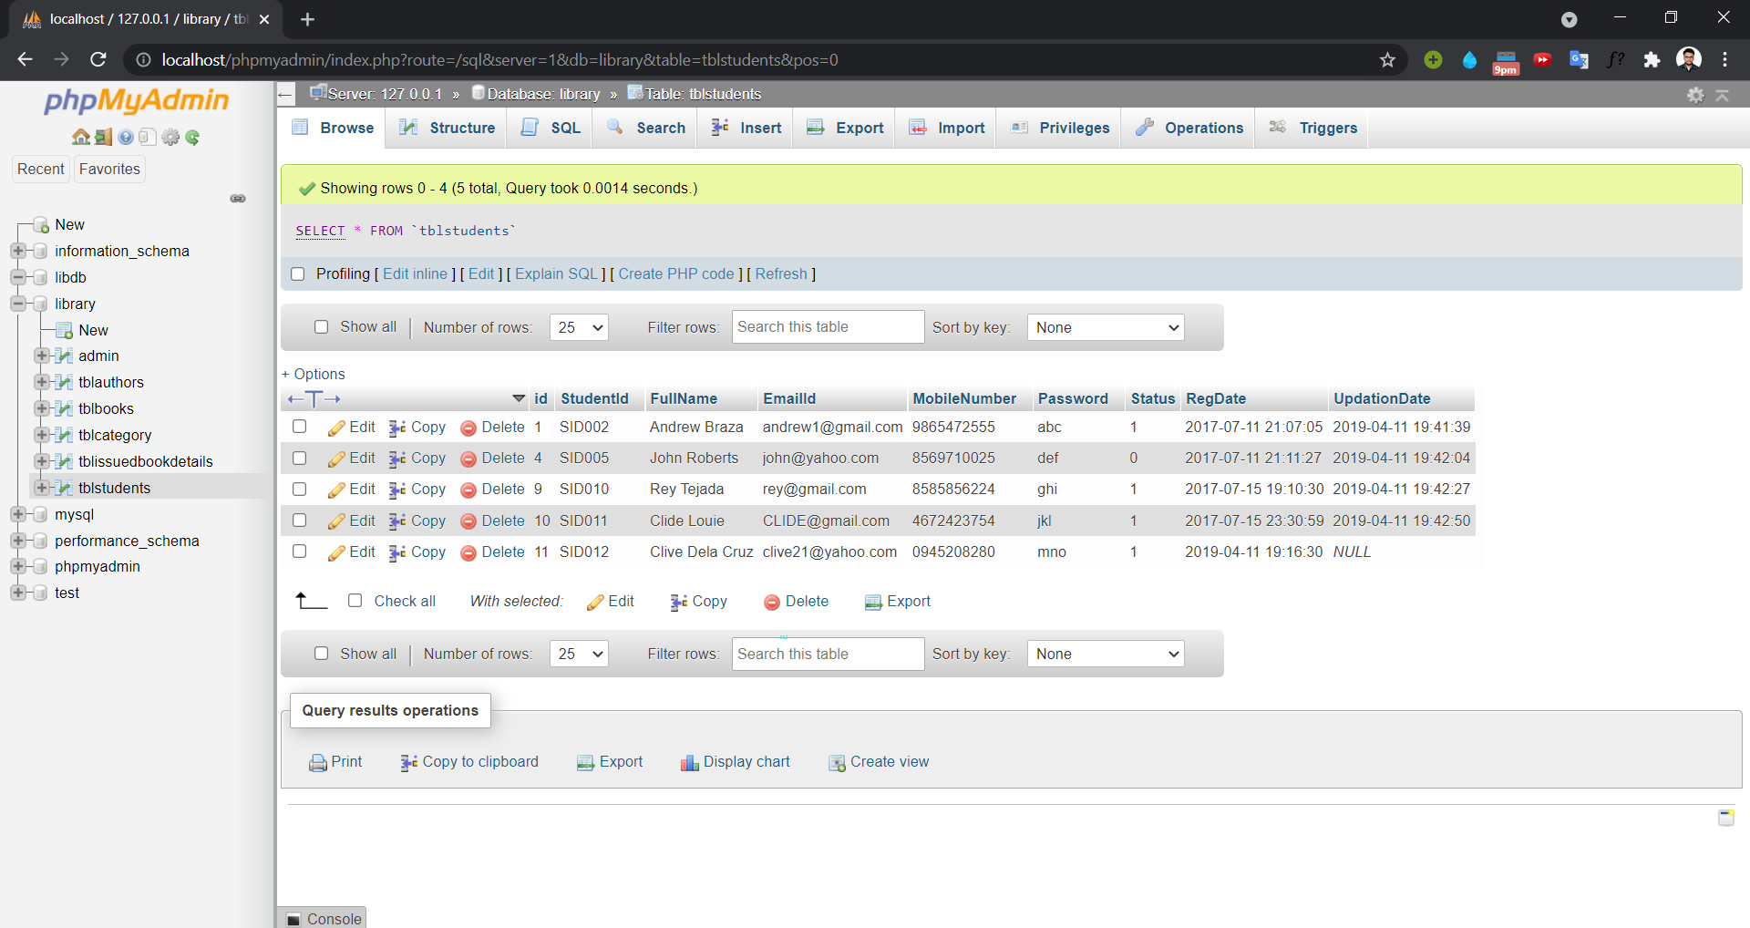

Code :

-- phpMyAdmin SQL Dump

-- version 4.8.4

-- https://www.phpmyadmin.net/

--

-- Host: 127.0.0.1

-- Generation Time: Apr 11, 2019 at 04:13 PM

-- Server version: 10.1.37-MariaDB

-- PHP Version: 7.3.0

SET SQL_MODE = "NO_AUTO_VALUE_ON_ZERO";

SET AUTOCOMMIT = 0;

START TRANSACTION;

SET time_zone = "+00:00";

/*!40101 SET @OLD_CHARACTER_SET_CLIENT=@@CHARACTER_SET_CLIENT */;

/*!40101 SET @OLD_CHARACTER_SET_RESULTS=@@CHARACTER_SET_RESULTS */;

/*!40101 SET @OLD_COLLATION_CONNECTION=@@COLLATION_CONNECTION */;

/*!40101 SET NAMES utf8mb4 */;

--

-- Database: `library`

--

CREATE database library;

USE library;

-- --------------------------------------------------------

--

-- Table structure for table `admin`

--

CREATE TABLE `admin` (

  `id` int(11) NOT NULL,

  `FullName` varchar(100) DEFAULT NULL,

  `AdminEmail` varchar(120) DEFAULT NULL,

  `UserName` varchar(100) NOT NULL,

  `Password` varchar(100) NOT NULL,

  `updationDate` timestamp NOT NULL DEFAULT '0000-00-00 00:00:00' ON UPDATE CURRENT_TIMESTAMP

) ENGINE=InnoDB DEFAULT CHARSET=latin1;

--

-- Dumping data for table `admin`

--

INSERT INTO `admin` (`id`, `FullName`, `AdminEmail`, `UserName`, `Password`, `updationDate`) VALUES

(1, 'Rajneesh Pandey', 'rajneesh@gmail.com', 'admin', '12345', '2019-04-11 13:56:38');

-- -------------------------------------------------------

-- Table structure for table `tblauthors`

CREATE TABLE `tblauthors` (

  `id` int(11) NOT NULL,

  `AuthorName` varchar(159) DEFAULT NULL,

  `creationDate` timestamp NULL DEFAULT CURRENT_TIMESTAMP,

  `UpdationDate` timestamp NULL DEFAULT NULL ON UPDATE CURRENT_TIMESTAMP

) ENGINE=InnoDB DEFAULT CHARSET=latin1;

--

-- Dumping data for table `tblauthors`

--

INSERT INTO `tblauthors` (`id`, `AuthorName`, `creationDate`, `UpdationDate`) VALUES

(1, 'Salman', '2017-07-08 12:49:09', '2017-07-08 15:16:59'),

(2, 'Hero', '2017-07-08 14:30:23', '2017-07-08 15:15:09'),

(3, 'Rahul', '2017-07-08 14:35:08', NULL),

(4, 'Verma', '2017-07-08 14:35:21', NULL),

(5, 'Kumar', '2017-07-08 14:35:36', NULL),

(9, 'Mohan', '2017-07-08 15:22:03', NULL);

-- --------------------------------------------------------

--

-- Table structure for table `tblbooks`

--

CREATE TABLE `tblbooks` (

  `id` int(11) NOT NULL,

  `BookName` varchar(255) DEFAULT NULL,

  `CatId` int(11) DEFAULT NULL,

  `AuthorId` int(11) DEFAULT NULL,

  `ISBNNumber` int(11) DEFAULT NULL,

  `BookPrice` int(11) DEFAULT NULL,

  `RegDate` timestamp NULL DEFAULT CURRENT_TIMESTAMP,

  `UpdationDate` timestamp NULL DEFAULT NULL ON UPDATE CURRENT_TIMESTAMP

) ENGINE=InnoDB DEFAULT CHARSET=latin1;

--

-- Dumping data for table `tblbooks`

--

INSERT INTO `tblbooks` (`id`, `BookName`, `CatId`, `AuthorId`, `ISBNNumber`, `BookPrice`, `RegDate`, `UpdationDate`) VALUES

(1, 'Web Developer', 5, 1, 222, 20, '2017-07-08 20:04:55', '2017-07-15 05:54:41'),

(3, 'Machine Learning', 6, 4, 1111, 15, '2017-07-08 20:17:31', '2017-07-15 06:13:17');

-- --------------------------------------------------------

--

-- Table structure for table `tblcategory`

--

CREATE TABLE `tblcategory` (

  `id` int(11) NOT NULL,

  `CategoryName` varchar(150) DEFAULT NULL,

  `Status` int(1) DEFAULT NULL,

  `CreationDate` timestamp NULL DEFAULT CURRENT_TIMESTAMP,

  `UpdationDate` timestamp NULL DEFAULT '0000-00-00 00:00:00' ON UPDATE CURRENT_TIMESTAMP

) ENGINE=InnoDB DEFAULT CHARSET=latin1;

--

-- Dumping data for table `tblcategory`

--

INSERT INTO `tblcategory` (`id`, `CategoryName`, `Status`, `CreationDate`, `UpdationDate`) VALUES

(4, 'Travel', 1, '2017-07-04 18:35:25', '2017-07-06 16:00:42'),

(5, 'Tech', 1, '2017-07-04 18:35:39', '2017-07-08 17:13:03'),

(6, 'Space', 1, '2017-07-04 18:35:55', '0000-00-00 00:00:00'),

(7, 'Business', 0, '2017-07-04 18:36:16', '0000-00-00 00:00:00');

-- --------------------------------------------------------

--

-- Table structure for table `tblissuedbookdetails`

--

CREATE TABLE `tblissuedbookdetails` (

  `id` int(11) NOT NULL,

  `BookId` int(11) DEFAULT NULL,

  `StudentID` varchar(150) DEFAULT NULL,

  `IssuesDate` timestamp NULL DEFAULT CURRENT_TIMESTAMP,

  `ReturnDate` timestamp NULL DEFAULT NULL ON UPDATE CURRENT_TIMESTAMP,

  `RetrunStatus` int(1) DEFAULT NULL,

  `fine` int(11) DEFAULT NULL

) ENGINE=InnoDB DEFAULT CHARSET=latin1;

--

-- Dumping data for table `tblissuedbookdetails`

--

INSERT INTO `tblissuedbookdetails` (`id`, `BookId`, `StudentID`, `IssuesDate`, `ReturnDate`, `RetrunStatus`, `fine`) VALUES

(1, 1, 'SID1', '2017-07-15 06:09:47', '2017-07-15 11:15:20', 1, 0),

(2, 1, 'SID1', '2017-07-15 06:12:27', '2017-07-15 11:15:23', 1, 5),

(3, 3, 'SID1', '2017-07-15 06:13:40', NULL, 0, NULL),

(4, 3, 'SID0', '2017-07-15 06:23:23', '2017-07-15 11:22:29', 1, 2),

(5, 1, 'SID3', '2017-07-15 10:59:26', NULL, 0, NULL),

(6, 3, 'SID11', '2017-07-15 18:02:55', NULL, 0, NULL);

-- --------------------------------------------------------

--

-- Table structure for table `tblstudents`

--

CREATE TABLE `tblstudents` (

  `id` int(11) NOT NULL,

  `StudentId` varchar(100) DEFAULT NULL,

  `FullName` varchar(120) DEFAULT NULL,

  `EmailId` varchar(120) DEFAULT NULL,

  `MobileNumber` char(11) DEFAULT NULL,

  `Password` varchar(120) DEFAULT NULL,

  `Status` int(1) DEFAULT NULL,

  `RegDate` timestamp NULL DEFAULT CURRENT_TIMESTAMP,

  `UpdationDate` timestamp NULL DEFAULT NULL ON UPDATE CURRENT_TIMESTAMP

) ENGINE=InnoDB DEFAULT CHARSET=latin1;

--

-- Dumping data for table `tblstudents`

--

INSERT INTO `tblstudents` (`id`, `StudentId`, `FullName`, `EmailId`, `MobileNumber`, `Password`, `Status`, `RegDate`, `UpdationDate`) VALUES

(1, 'SID002', 'Andrew Braza', 'andrew1@gmail.com', '9865472555', 'abc', 1, '2017-07-11 15:37:05', '2019-04-11 14:11:39'),

(4, 'SID005', 'John Roberts', 'john@yahoo.com', '8569710025', 'def', 0, '2017-07-11 15:41:27', '2019-04-11 14:12:04'),

(9, 'SID010', 'Rey Tejada', 'rey@gmail.com', '8585856224', 'ghi', 1, '2017-07-15 13:40:30', '2019-04-11 14:12:27'),

(10, 'SID011', 'Clide Louie', 'CLIDE@gmail.com', '4672423754', 'jkl', 1, '2017-07-15 18:00:59', '2019-04-11 14:12:50'),

(11, 'SID012', 'Clive Dela Cruz', 'clive21@yahoo.com', '0945208280', 'mno', 1, '2019-04-11 13:46:30', NULL);

--

-- Indexes for dumped tables

-

--

-- Indexes for table `admin`

--

ALTER TABLE `admin`

  ADD PRIMARY KEY (`id`);

--

-- Indexes for table `tblauthors`

--

ALTER TABLE `tblauthors`

  ADD PRIMARY KEY (`id`);

--

-- Indexes for table `tblbooks`

--

ALTER TABLE `tblbooks`

  ADD PRIMARY KEY (`id`);

--

-- Indexes for table `tblcategory`

ALTER TABLE `tblcategory`

  ADD PRIMARY KEY (`id`);

--

-- Indexes for table `tblissuedbookdetails`

--

ALTER TABLE `tblissuedbookdetails`

  ADD PRIMARY KEY (`id`);

-- Indexes for table `tblstudents`

--

ALTER TABLE `tblstudents`

  ADD PRIMARY KEY (`id`),

  ADD UNIQUE KEY `StudentId` (`StudentId`);

-- AUTO_INCREMENT for dumped tables

-- AUTO_INCREMENT for table `admin`

--

ALTER TABLE `admin`

  MODIFY `id` int(11) NOT NULL AUTO_INCREMENT, AUTO_INCREMENT=3;

--

-- AUTO_INCREMENT for table `tblauthors`

--

ALTER TABLE `tblauthors`

  MODIFY `id` int(11) NOT NULL AUTO_INCREMENT, AUTO_INCREMENT=10;

--

-- AUTO_INCREMENT for table `tblbooks`

--

ALTER TABLE `tblbooks`

  MODIFY `id` int(11) NOT NULL AUTO_INCREMENT, AUTO_INCREMENT=4;

--

-- AUTO_INCREMENT for table `tblcategory`

--

ALTER TABLE `tblcategory`

  MODIFY `id` int(11) NOT NULL AUTO_INCREMENT, AUTO_INCREMENT=8;

--

-- AUTO_INCREMENT for table `tblissuedbookdetails`

--

ALTER TABLE `tblissuedbookdetails`

  MODIFY `id` int(11) NOT NULL AUTO_INCREMENT, AUTO_INCREMENT=7;

--

-- AUTO_INCREMENT for table `tblstudents`

--

ALTER TABLE `tblstudents`

  MODIFY `id` int(11) NOT NULL AUTO_INCREMENT, AUTO_INCREMENT=12;

COMMIT;

/*!40101 SET CHARACTER_SET_CLIENT=@OLD_CHARACTER_SET_CLIENT */;

/*!40101 SET CHARACTER_SET_RESULTS=@OLD_CHARACTER_SET_RESULTS */;

/*!40101 SET COLLATION_CONNECTION=@OLD_COLLATION_CONNECTION */;

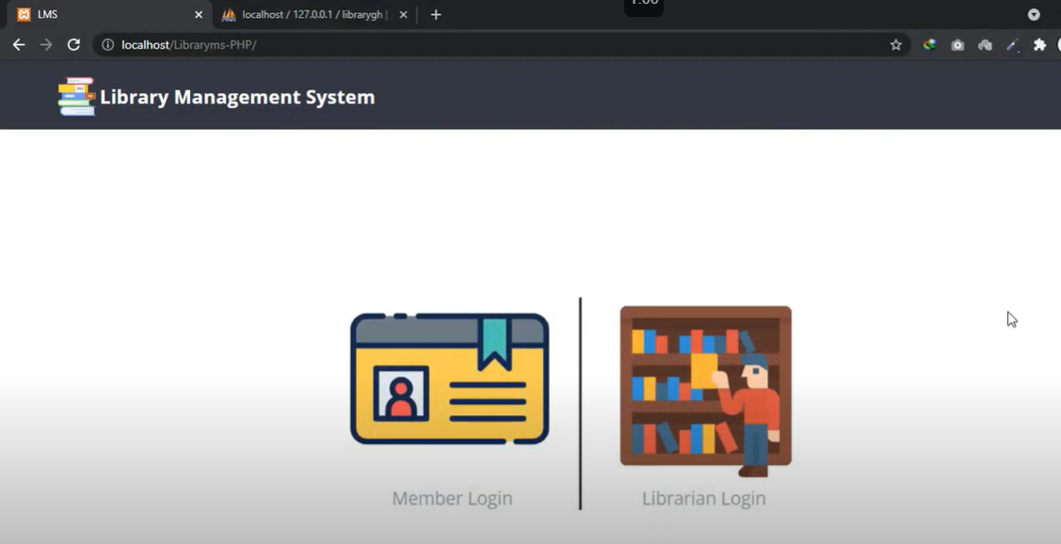

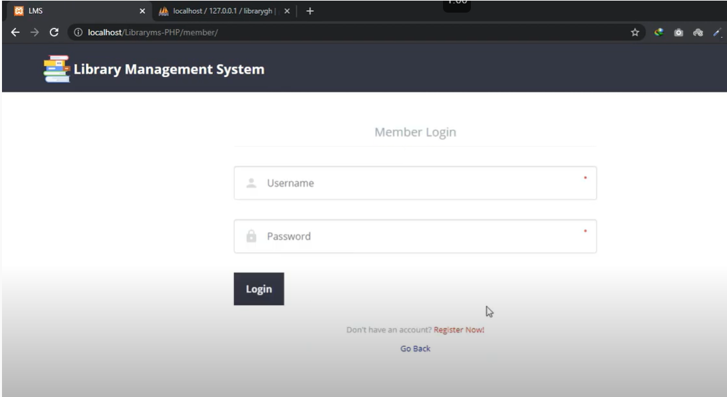

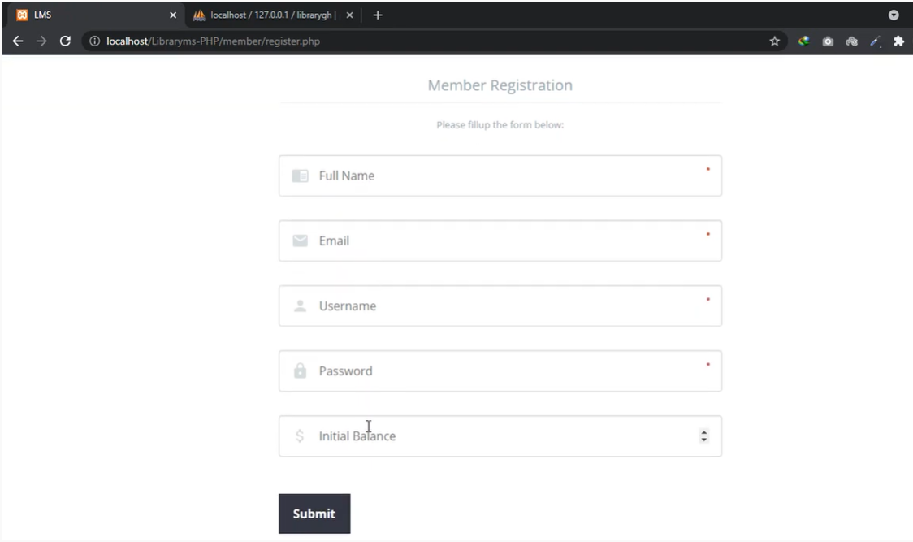

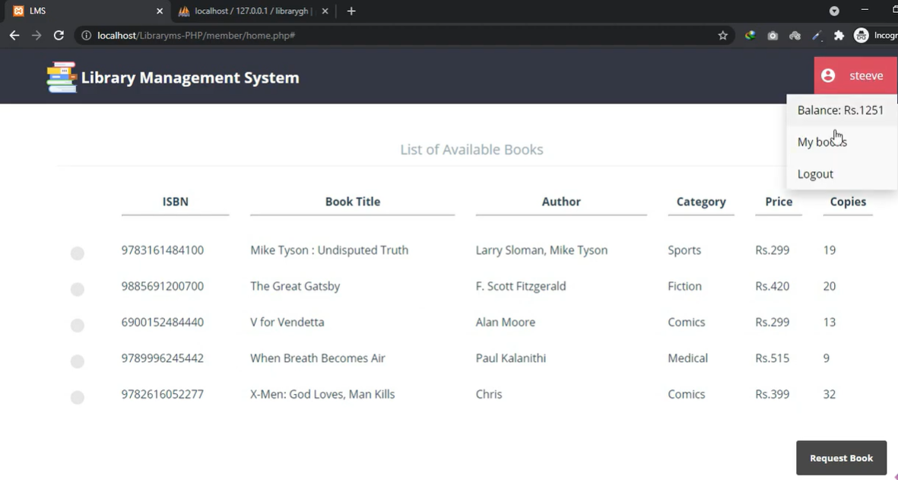

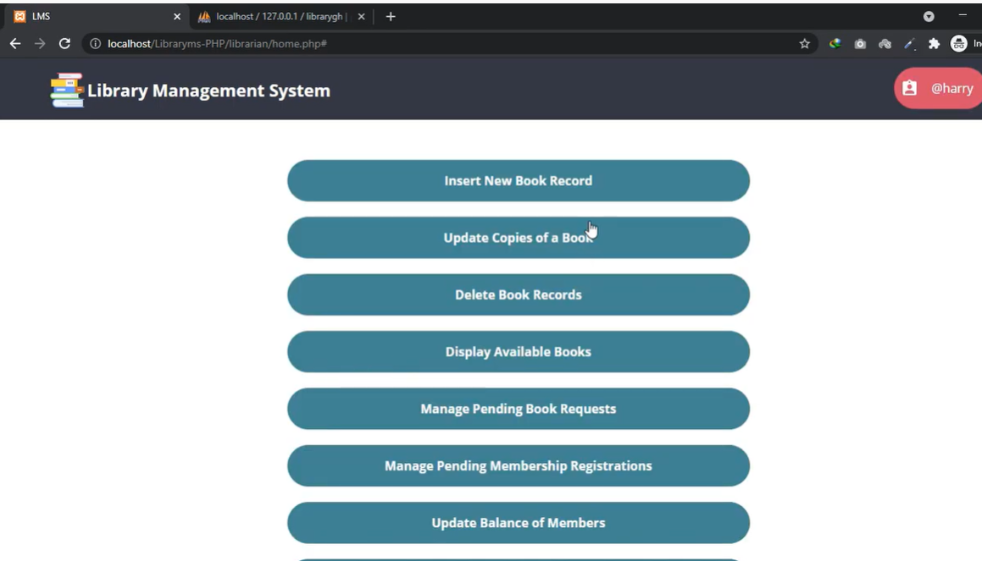

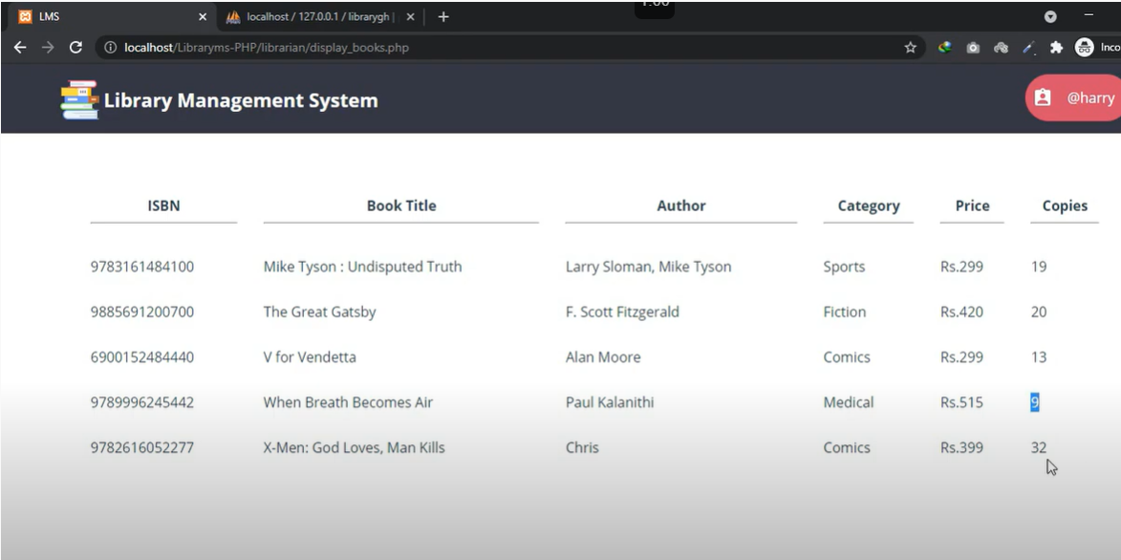

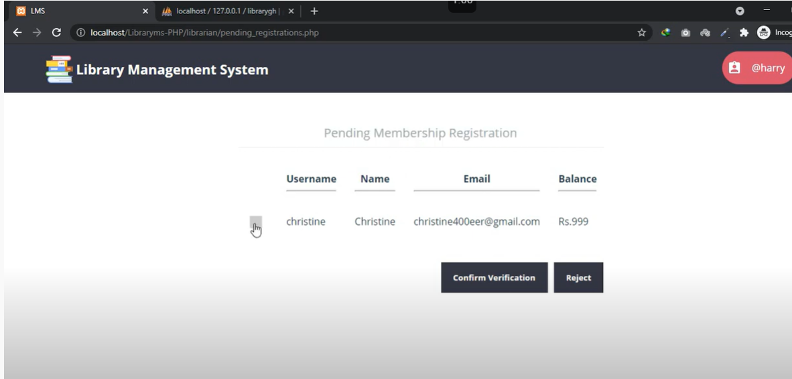

Ex. No.:  12               Date:   18-11-21                  Week:12

----------------------------------------------------------------------------

ER Diagram :

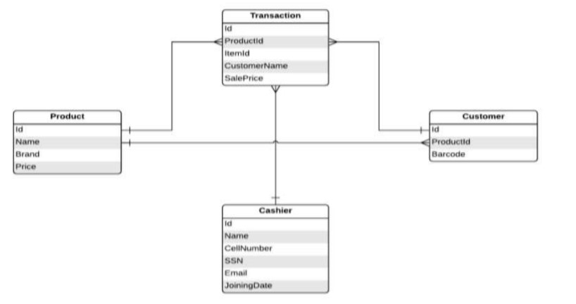

Billing Portal

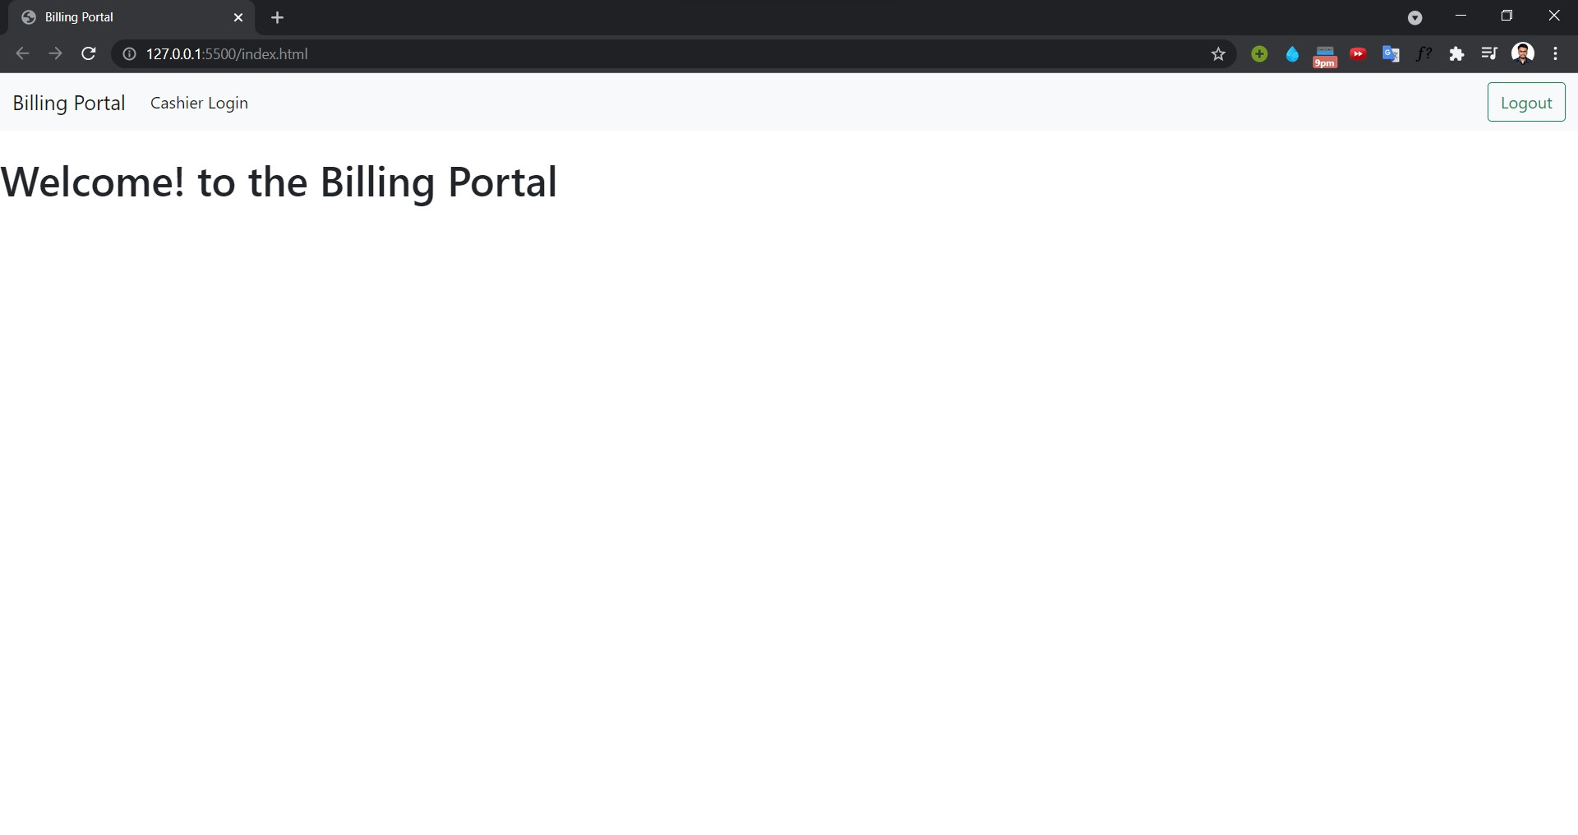

1. Login page for login.php

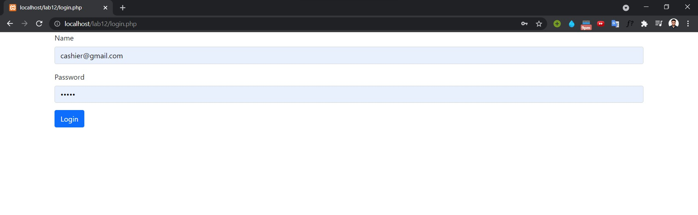

On Successfull Sign in Redirected to home.php

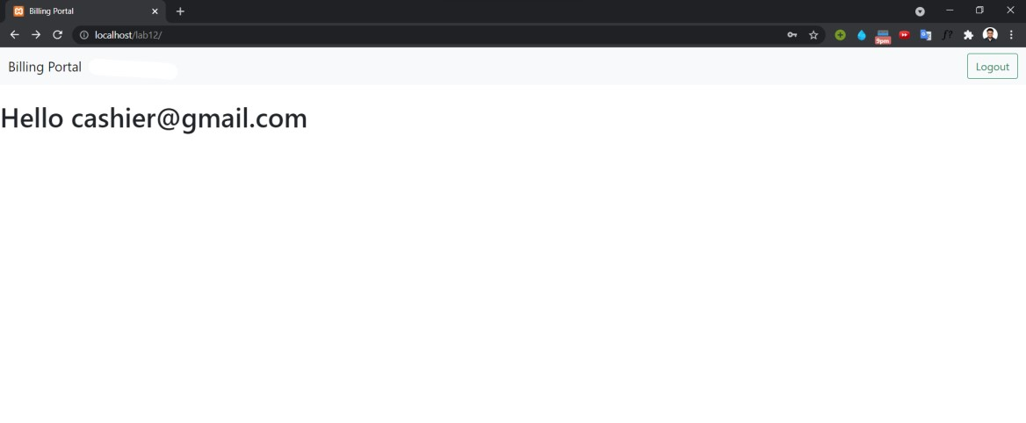

Logout.php

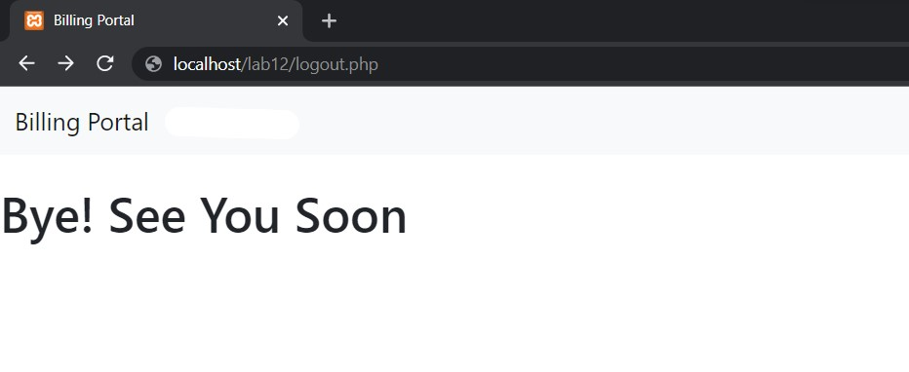

1. Page for the cashier to add products to the table.

DB Before:

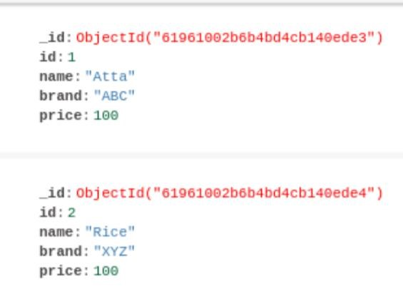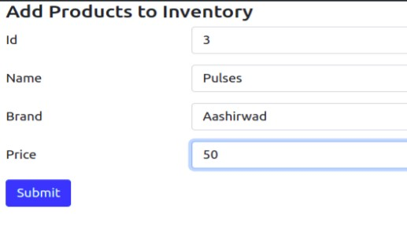

DB after:

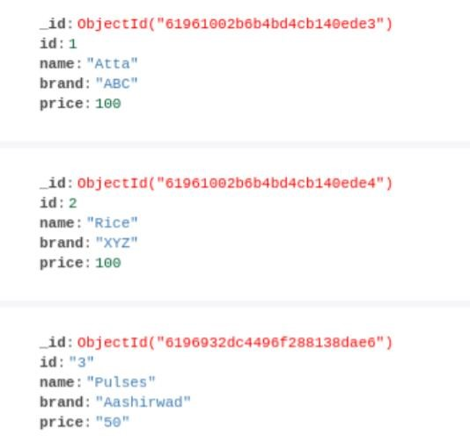

3.Transaction page for cashier for billing the products.

Bill.php (real-time total bill calculation)

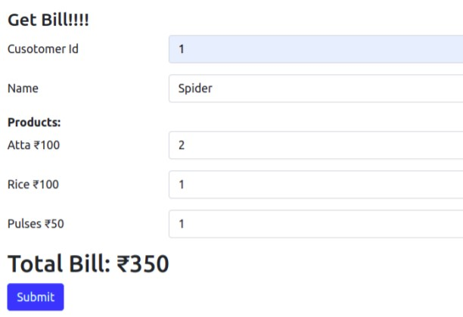

Updated in the DB:

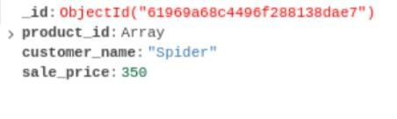

|  |  |  |  |  |  |  |  |  |
| --- | --- | --- | --- | --- | --- | --- | --- | --- |
|  | | | | | | | | |
|  | | Thankyou | | | | |  | |
|  |  | | | | | | |  |
|  | | | |  |  | | | |
|  | | | | Roll no. : 106119100Name : Rajneesh PandeySection : CSE-B --------------------------End of Record File----------------------- |  | | | |
|  | | |  | | |  | | |